**Module 8 Assignment: Final Project**

Sanket Gawade

Arizona State University

IFT 598: Middleware Programming & Database Security

Professor. Dinesh Sthapit

December 03, 2022

**Requirements**

**A: User Interface**

1. **Create New User**

Flow diagram of creating new user

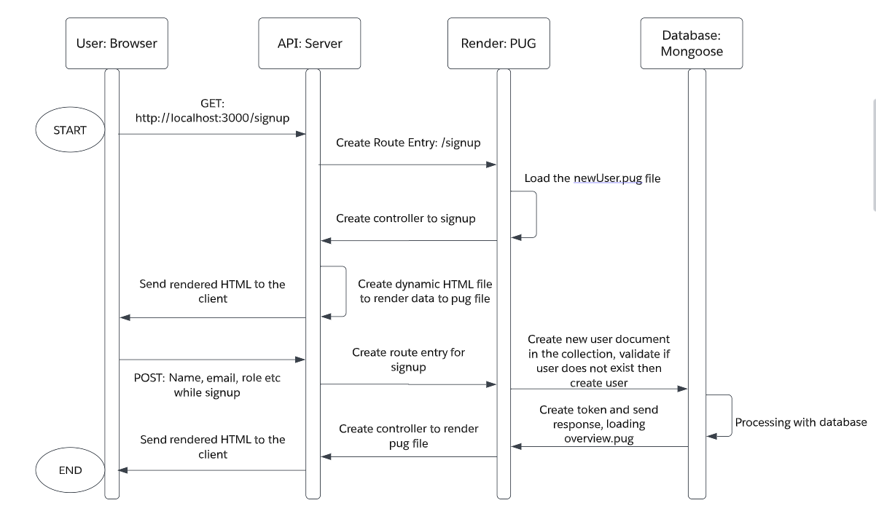

PUG file of newUser.pug

**Code:**

extends baseTemplate

block content

  main.main

    .card-container

      .card

        .card__header

        .card__details

          h4.card__sub-heading New User

          p.card__text

            | Please enter the following Details

          .card__data

            svg.card__icon

              use(xlink:href='img/icons.svg#icon-map-pin')

            form(action='/api/v1/users/signup' method='post')

              label(for='name') Full name:

              input#name(type='text' name='name')

              br

              br

              label(for='email') Email:

              input#email(type='email' name='email')

              br

              br

              label(for='role') Role:

              br

              input#html(type='radio' name='role' value='user')

              label(for='role') User

              br

              input#html(type='radio' name='role' value='staff')

              label(for='role') Staff

              br

              input#html(type='radio' name='role' value='student')

              label(for='role') Student

              br

              input#html(type='radio' name='role' value='admin')

              label(for='role') Admin

              br

              br

              label(for='password') Password:

              input#password(type='password' name='password')

              br

              br

              label(for='passwordConfirm') Confirm Password:

              input#passwordConfirm(type='password' name='passwordConfirm')

              br

              br

              input.card__sub-heading(type='submit' value='Submit')

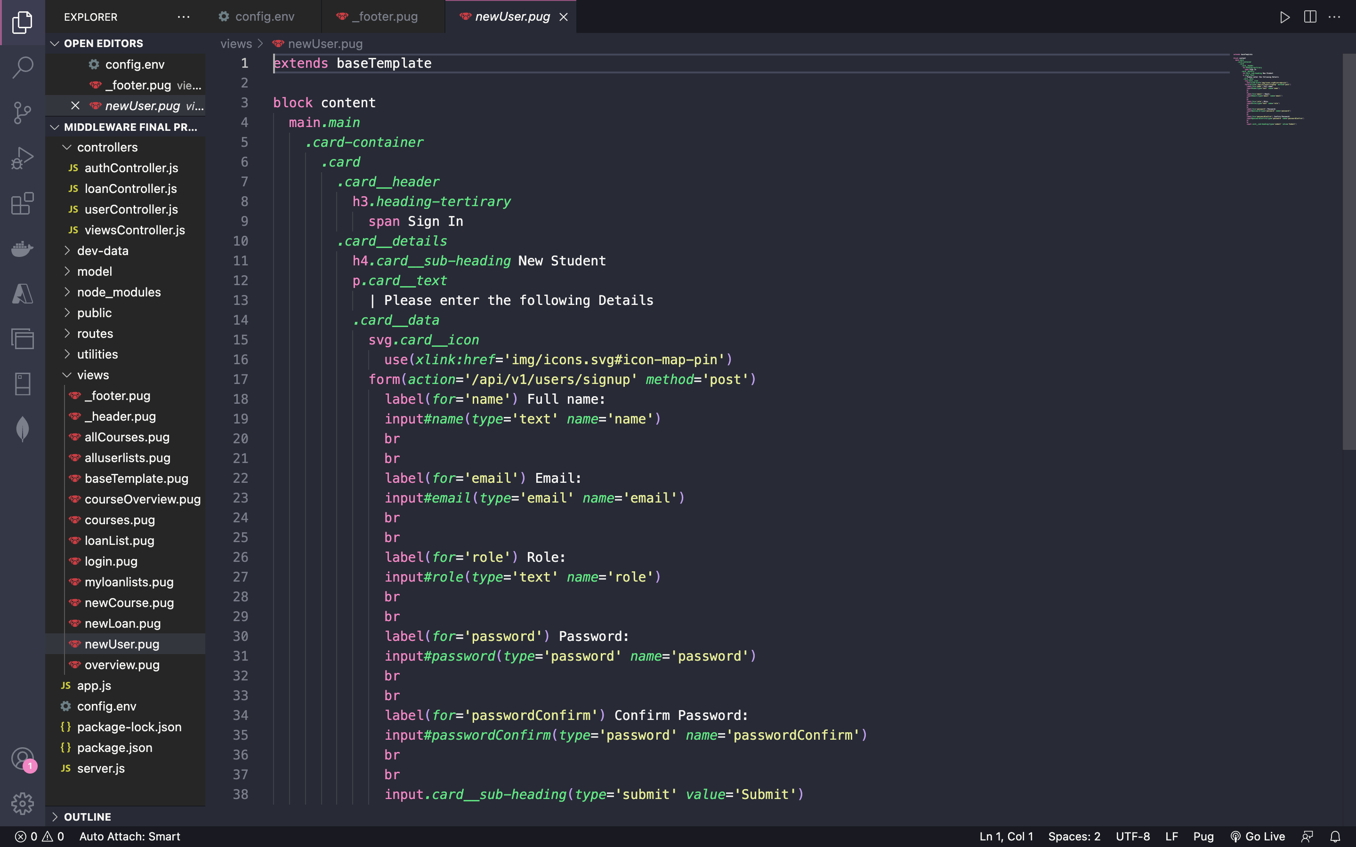

Screenshot showing the user interface on the browser for new user sign up

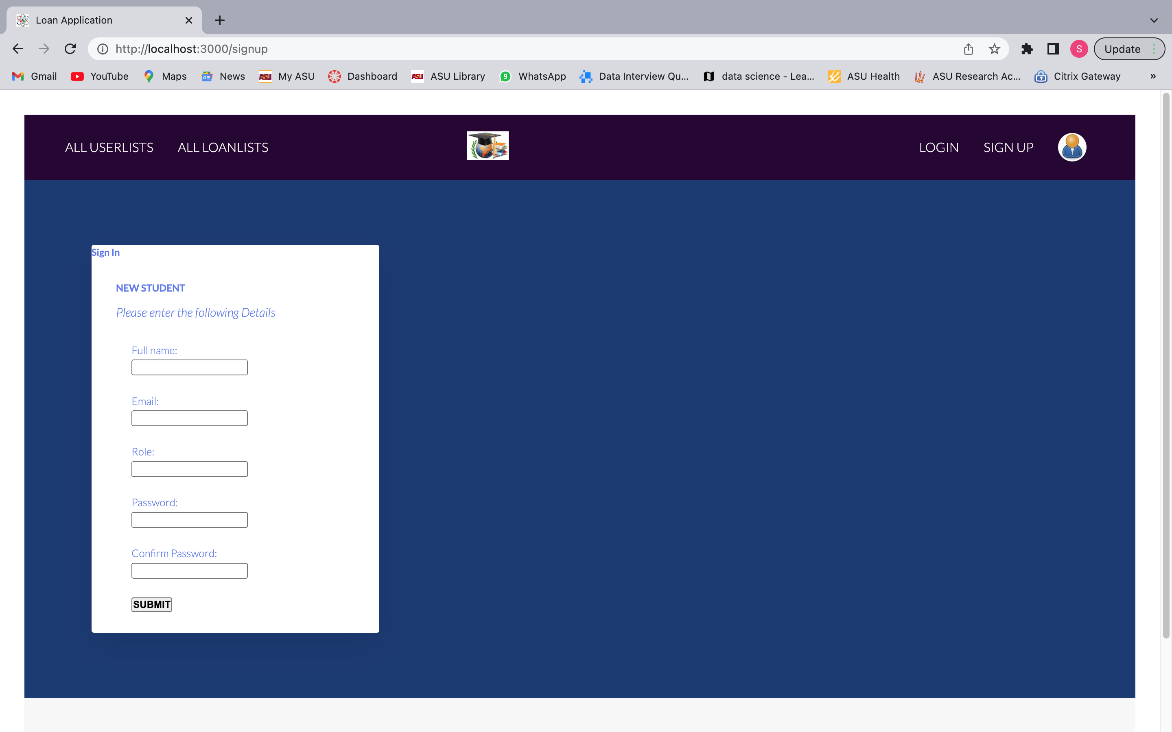

1. **LogIn Current User**

Flow diagram of creating logging in the user

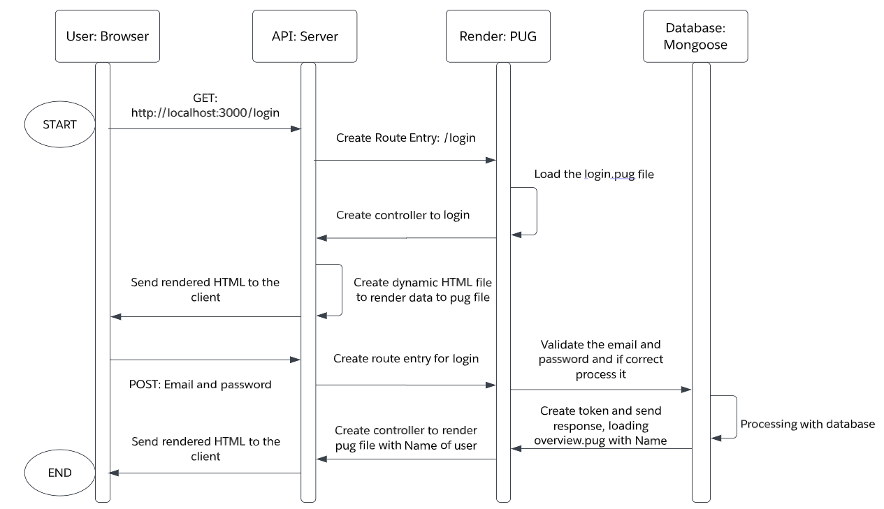

PUG file of login.pug

**Code:**

extends baseTemplate

block content

    // LOGIN FORM

    main.main

      .card-container

        .card

          .card__header

            .card__details

              h1 Login

              p.card__text Please enter the following details

              .card__data

              form(action='/api/v1/users/login/' method='post')

                label(for='email') Email:br

                input(type='text' id='email' name='email')br br

                label(for='password') Password:br

                input(type='password' id='password' name='password')brbr

                input.card__sub-heading( type='submit' value='Log In')

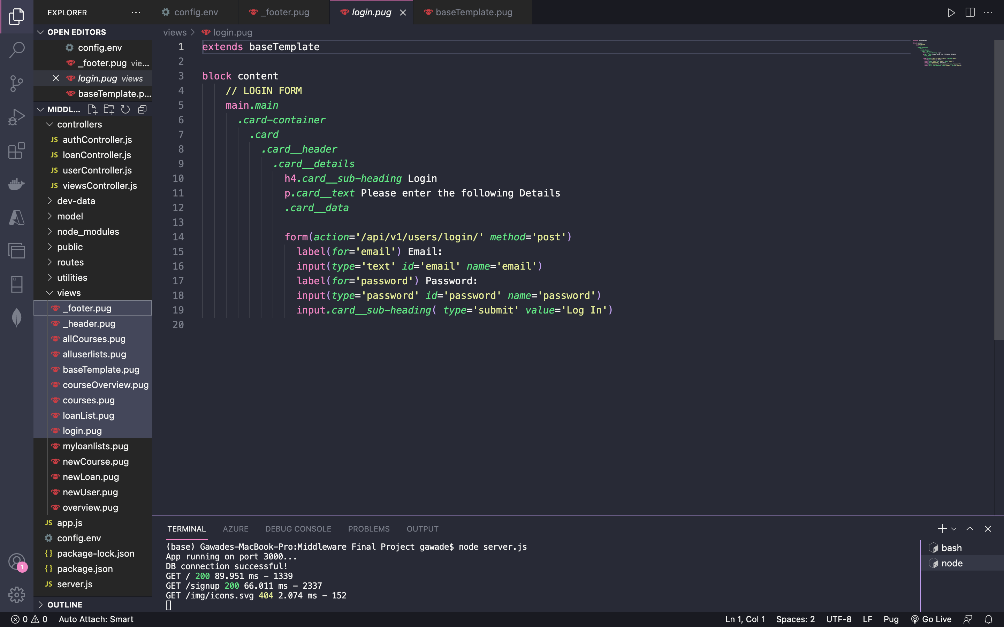

Screenshot showing the user interface on the browser for login

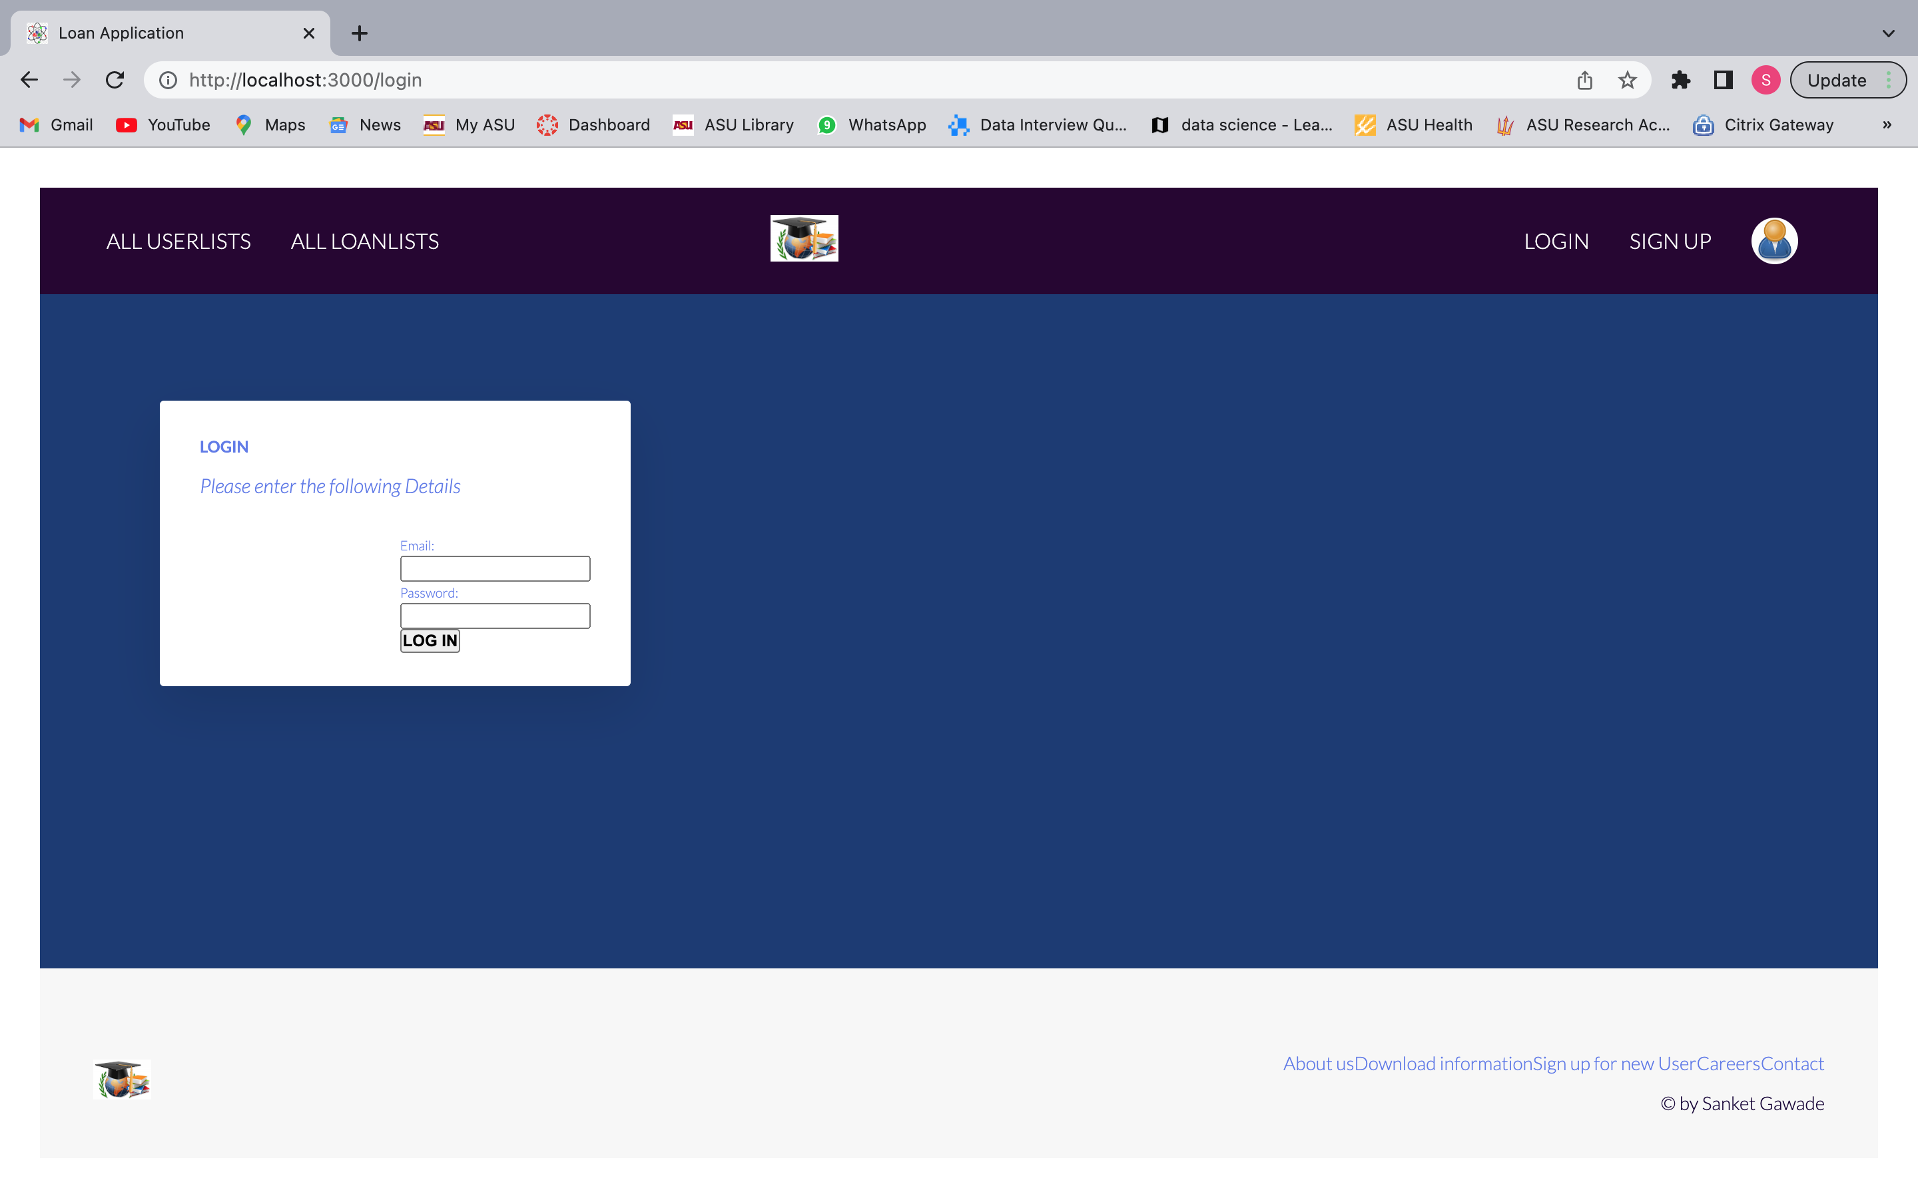

1. **Create New Loans**

Flow diagram showing the creation of new loan

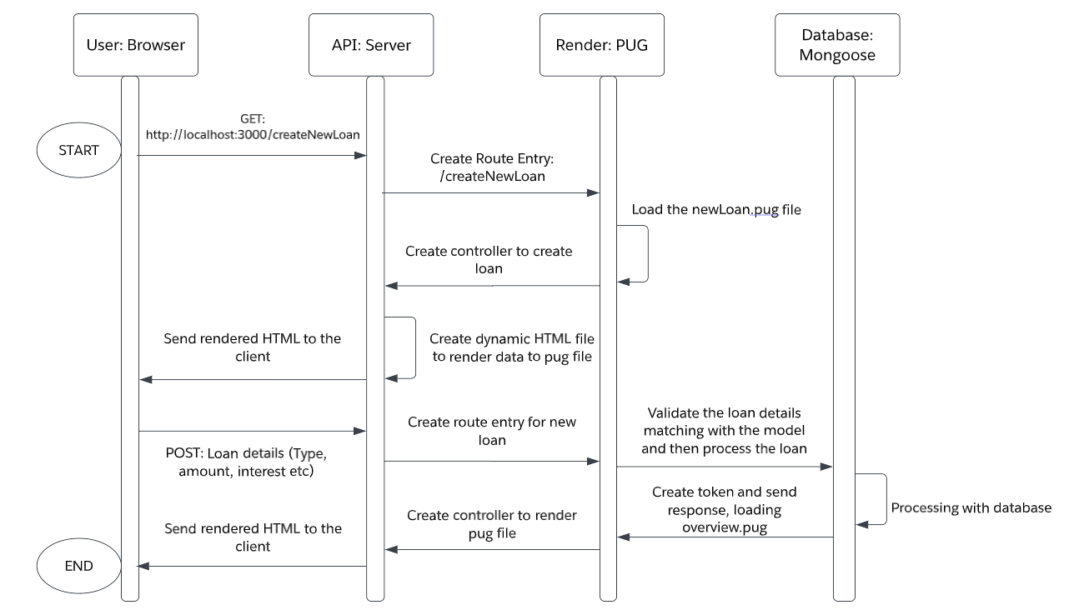

PUG file showing code for newLoan.pug (Figure 8)

**Code:**

extends baseTemplate

block content

  h1 Create new loan

  main.main

    .card-container

      .card

        .card__header

          h3.heading-tertirary

            span Create a new loan

        .card__details

          h4.card__sub-heading New Loan information

          p.card__text

          |   Please enter the following Details

          .card__data

            svg.card__icon

              use(xlink:href='img/icons.svg#icon-map-pin')

            form(action='/api/v1/loans/' method='post')

              label(for='name') Name:

              input#name(type='text' name='name')

              br

              br

              label(for='loanType') Loan Type:

              br

              input#html(type='radio' name='loanType' value='Car')

              label(for='loanType') Car

              br

              input#html(type='radio' name='loanType' value='Home')

              label(for='loanType') Home

              br

              input#html(type='radio' name='loanType' value='Personal')

              label(for='loanType') Personal

              br

              input#html(type='radio' name='loanType' value='Education')

              label(for='loanType') Education

              br

              br

              label(for='startDate') startDate:

              input#startDate(type='text' name='startDate')

              br

              br

              label(for='loanTermYears') loanTermYears:

              input#loanTermYears(type='text' name='loanTermYears')

              br

              br

              label(for='phoneNumber') Phone Number:

              input#phoneNumber(type='text' name='phoneNumber')

              br

              br

              label(for='loanAmount') Amount:

              input#loanAmount(type='text' name='loanAmount')

              label(for='interest') interestRate:

              input#interest(type='text' name='interest')

              br

              br

              input.card__sub-heading(type='submit' value='Submit')

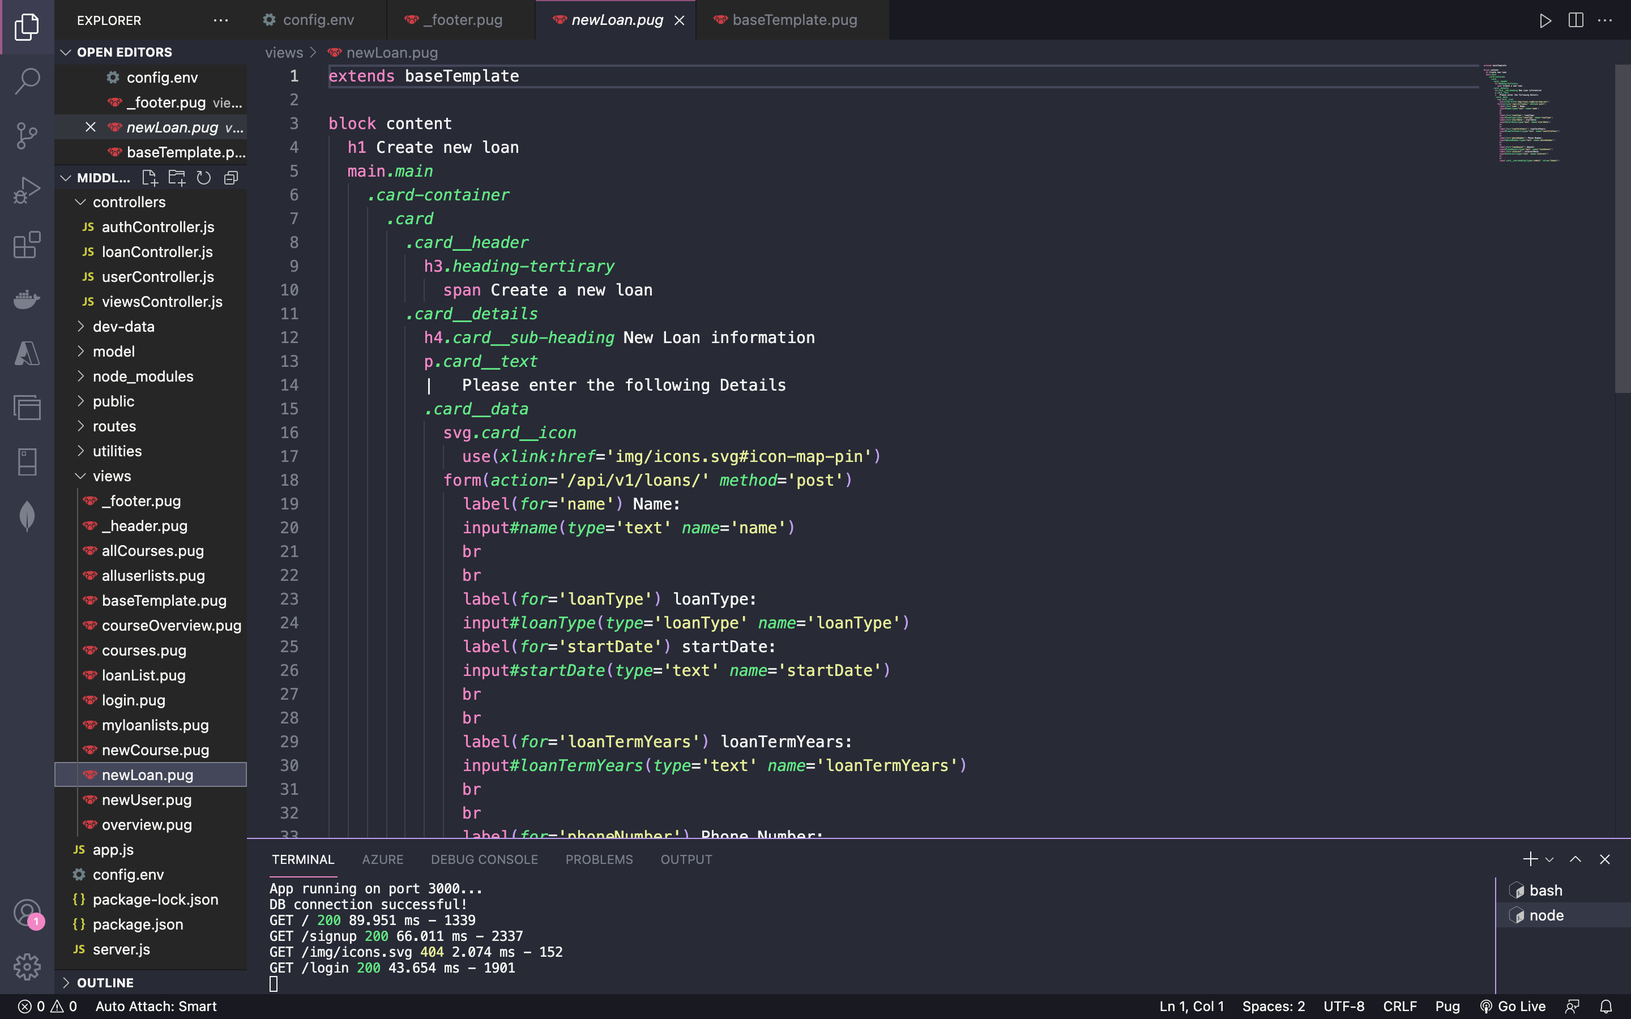

Screenshot showing the user interface of new loan creation page

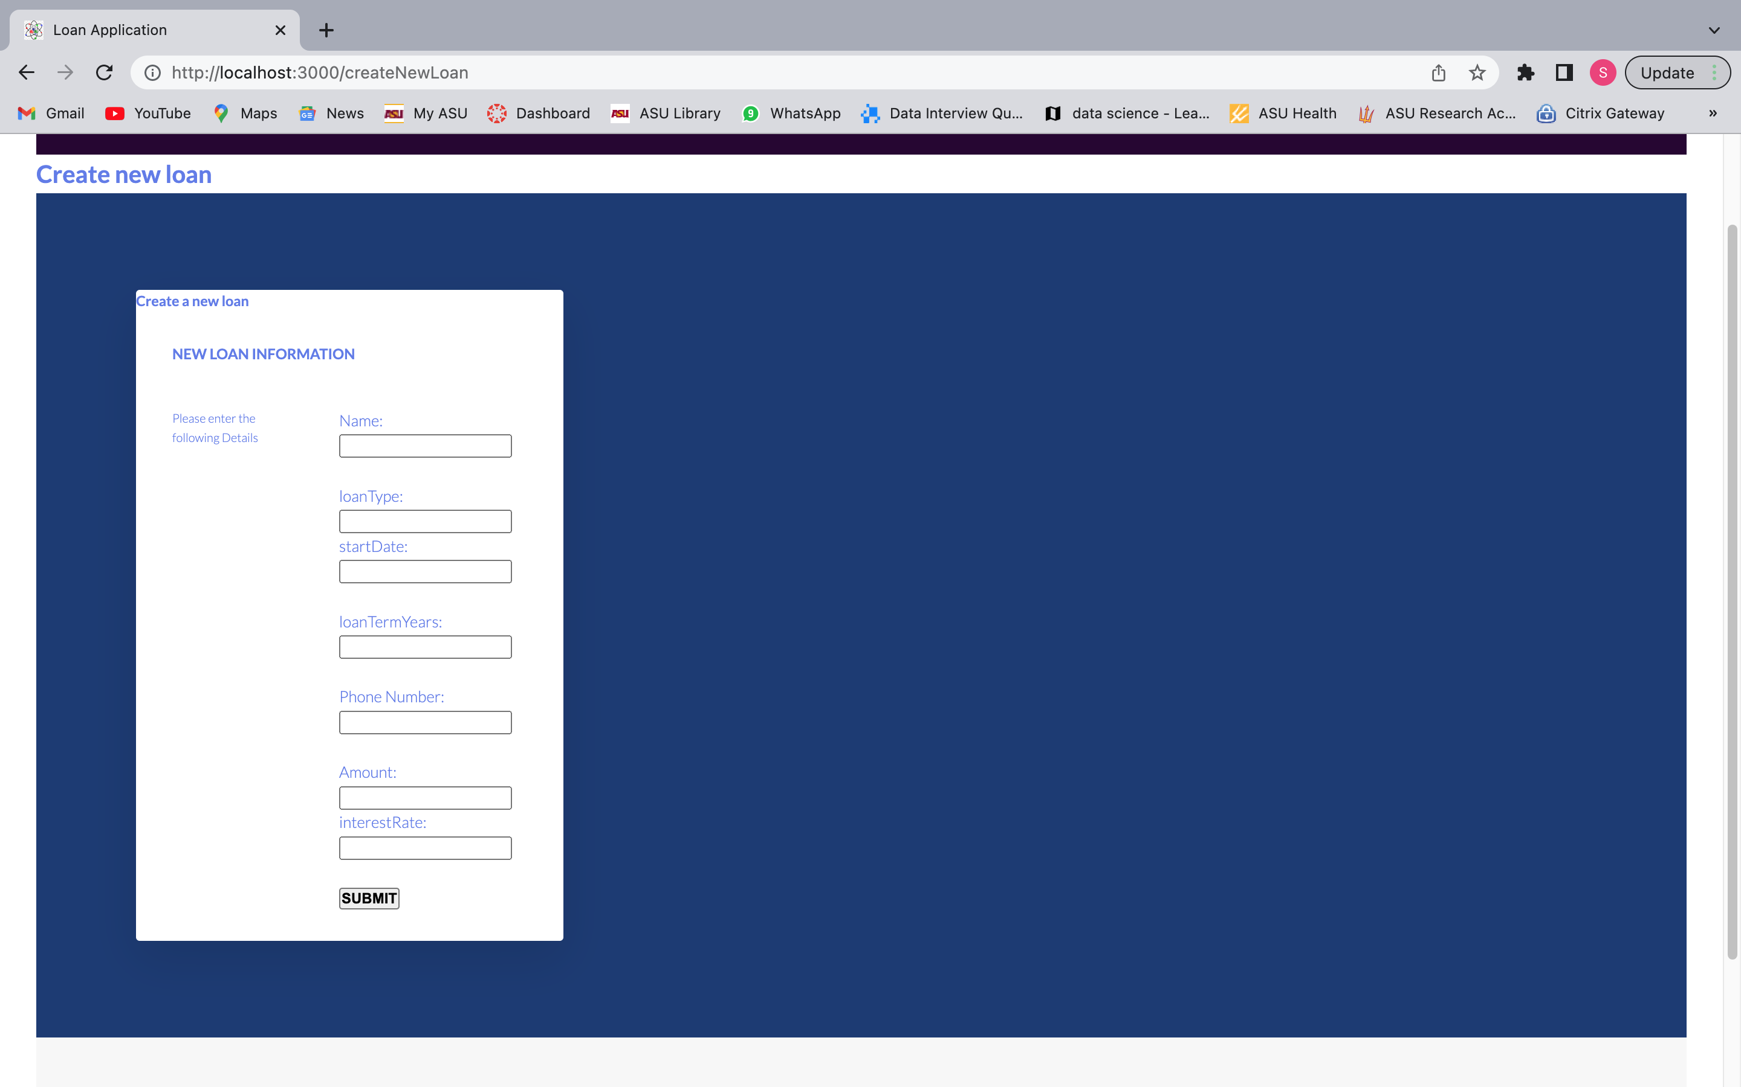

1. **List Loan Details**

Flow diagram showing list of all loans

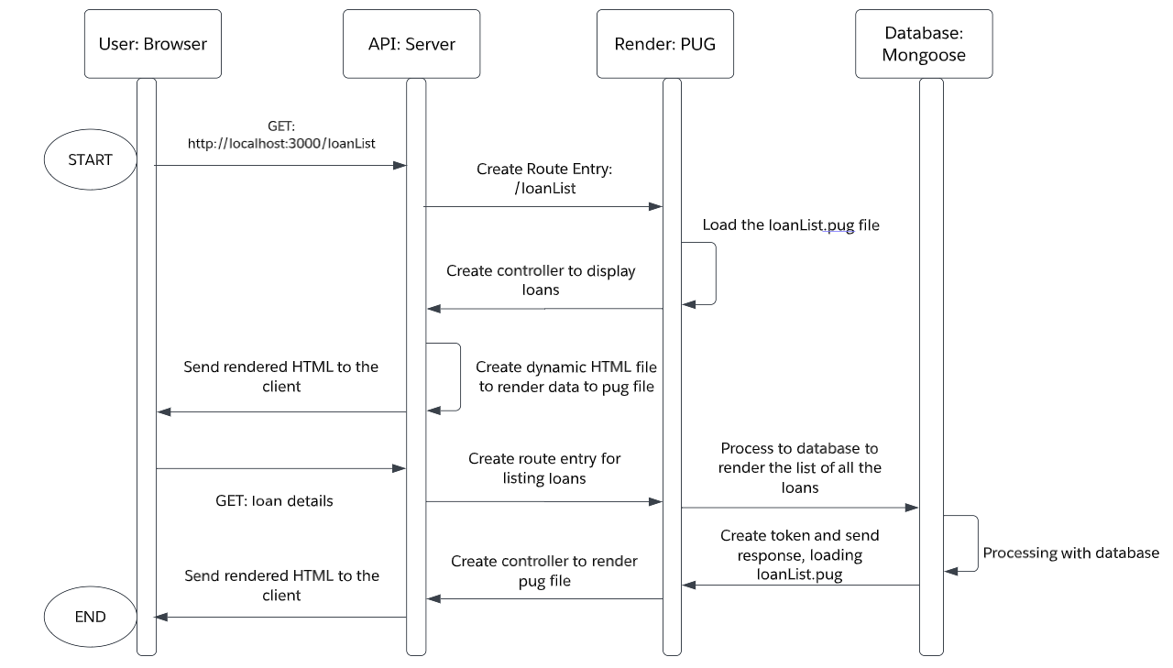

PUG file of UI code for listing all the loans

**Code:**

extends baseTemplate

block content

  h1

    span List of Loans

  table.table-header

    thead

      tr

        th(scope='col') Name

        th(scope='col') Type of Loan

        th(scope='col') Phone Number

        th(scope='col') Amount

        th(scope='col') Interest Rate (%)

        th(scope='col') Term (Yrs)

    tbody

      each loan in loans

        tr.table-secondary

          td=loan.name

          td=loan.loanType

          td=loan.phoneNumber

          td=loan.loanAmount

          td=loan.interest

          td=loan.loanTermYears

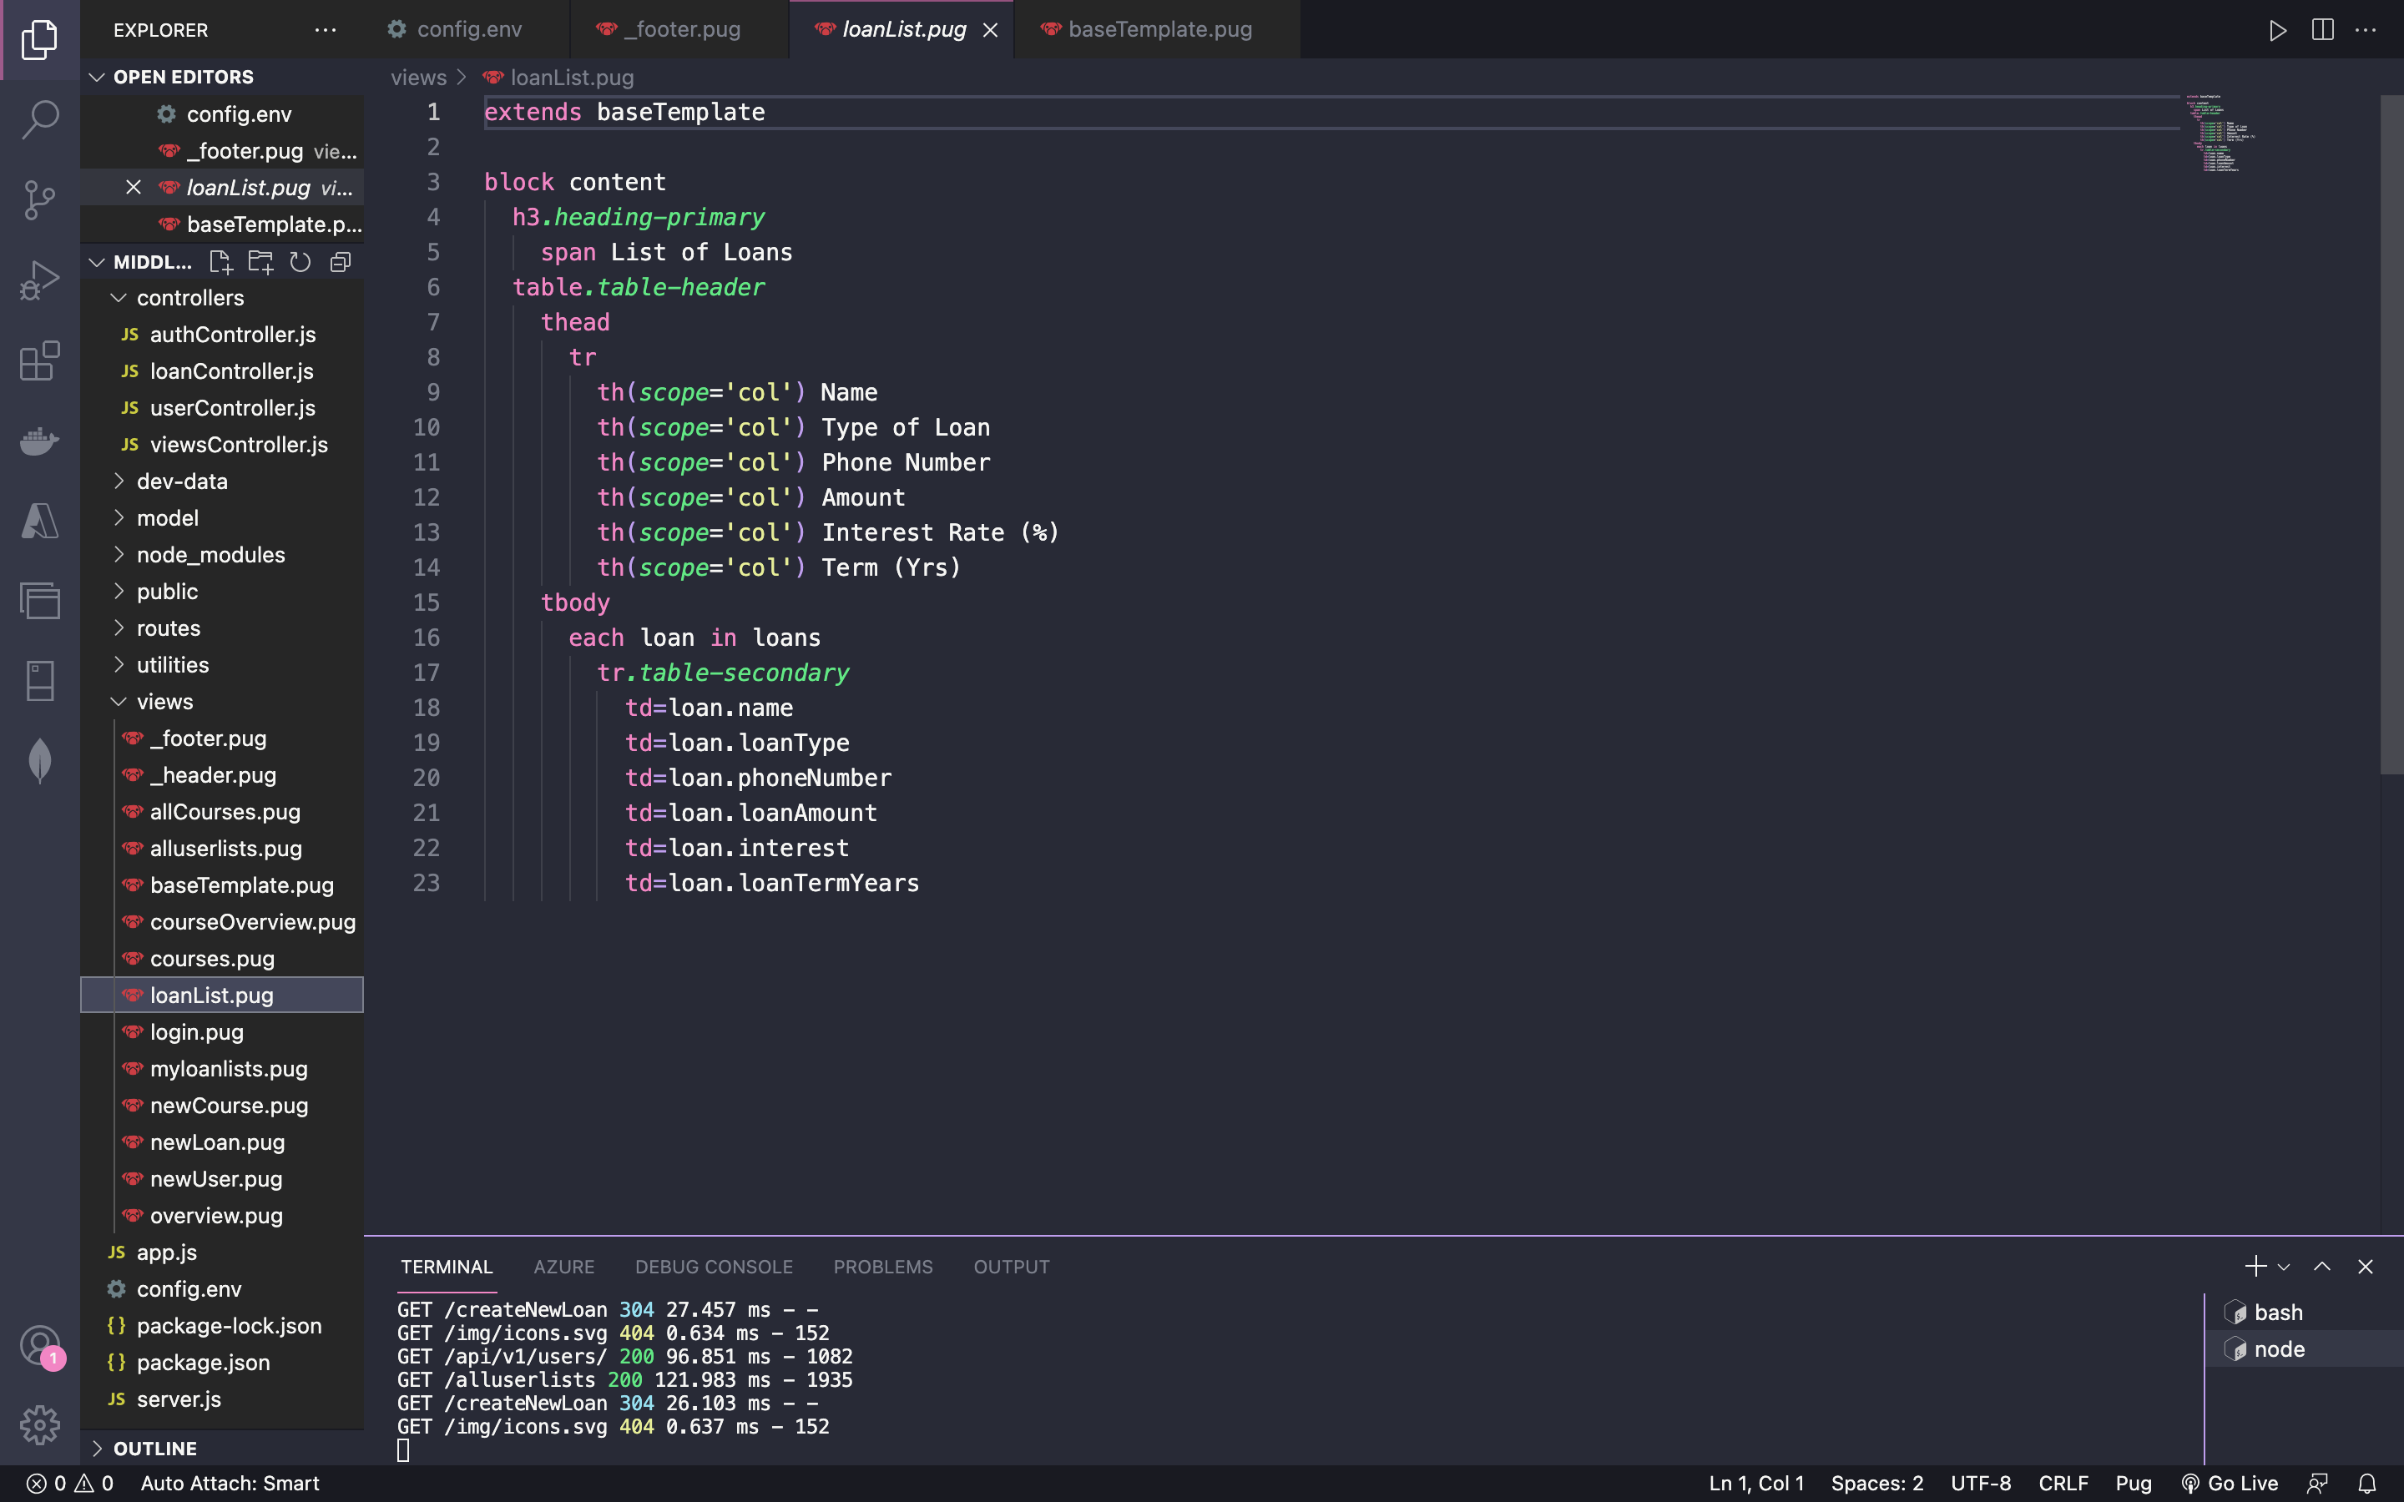

Screenshot showing user interface of listing all the loans from the database

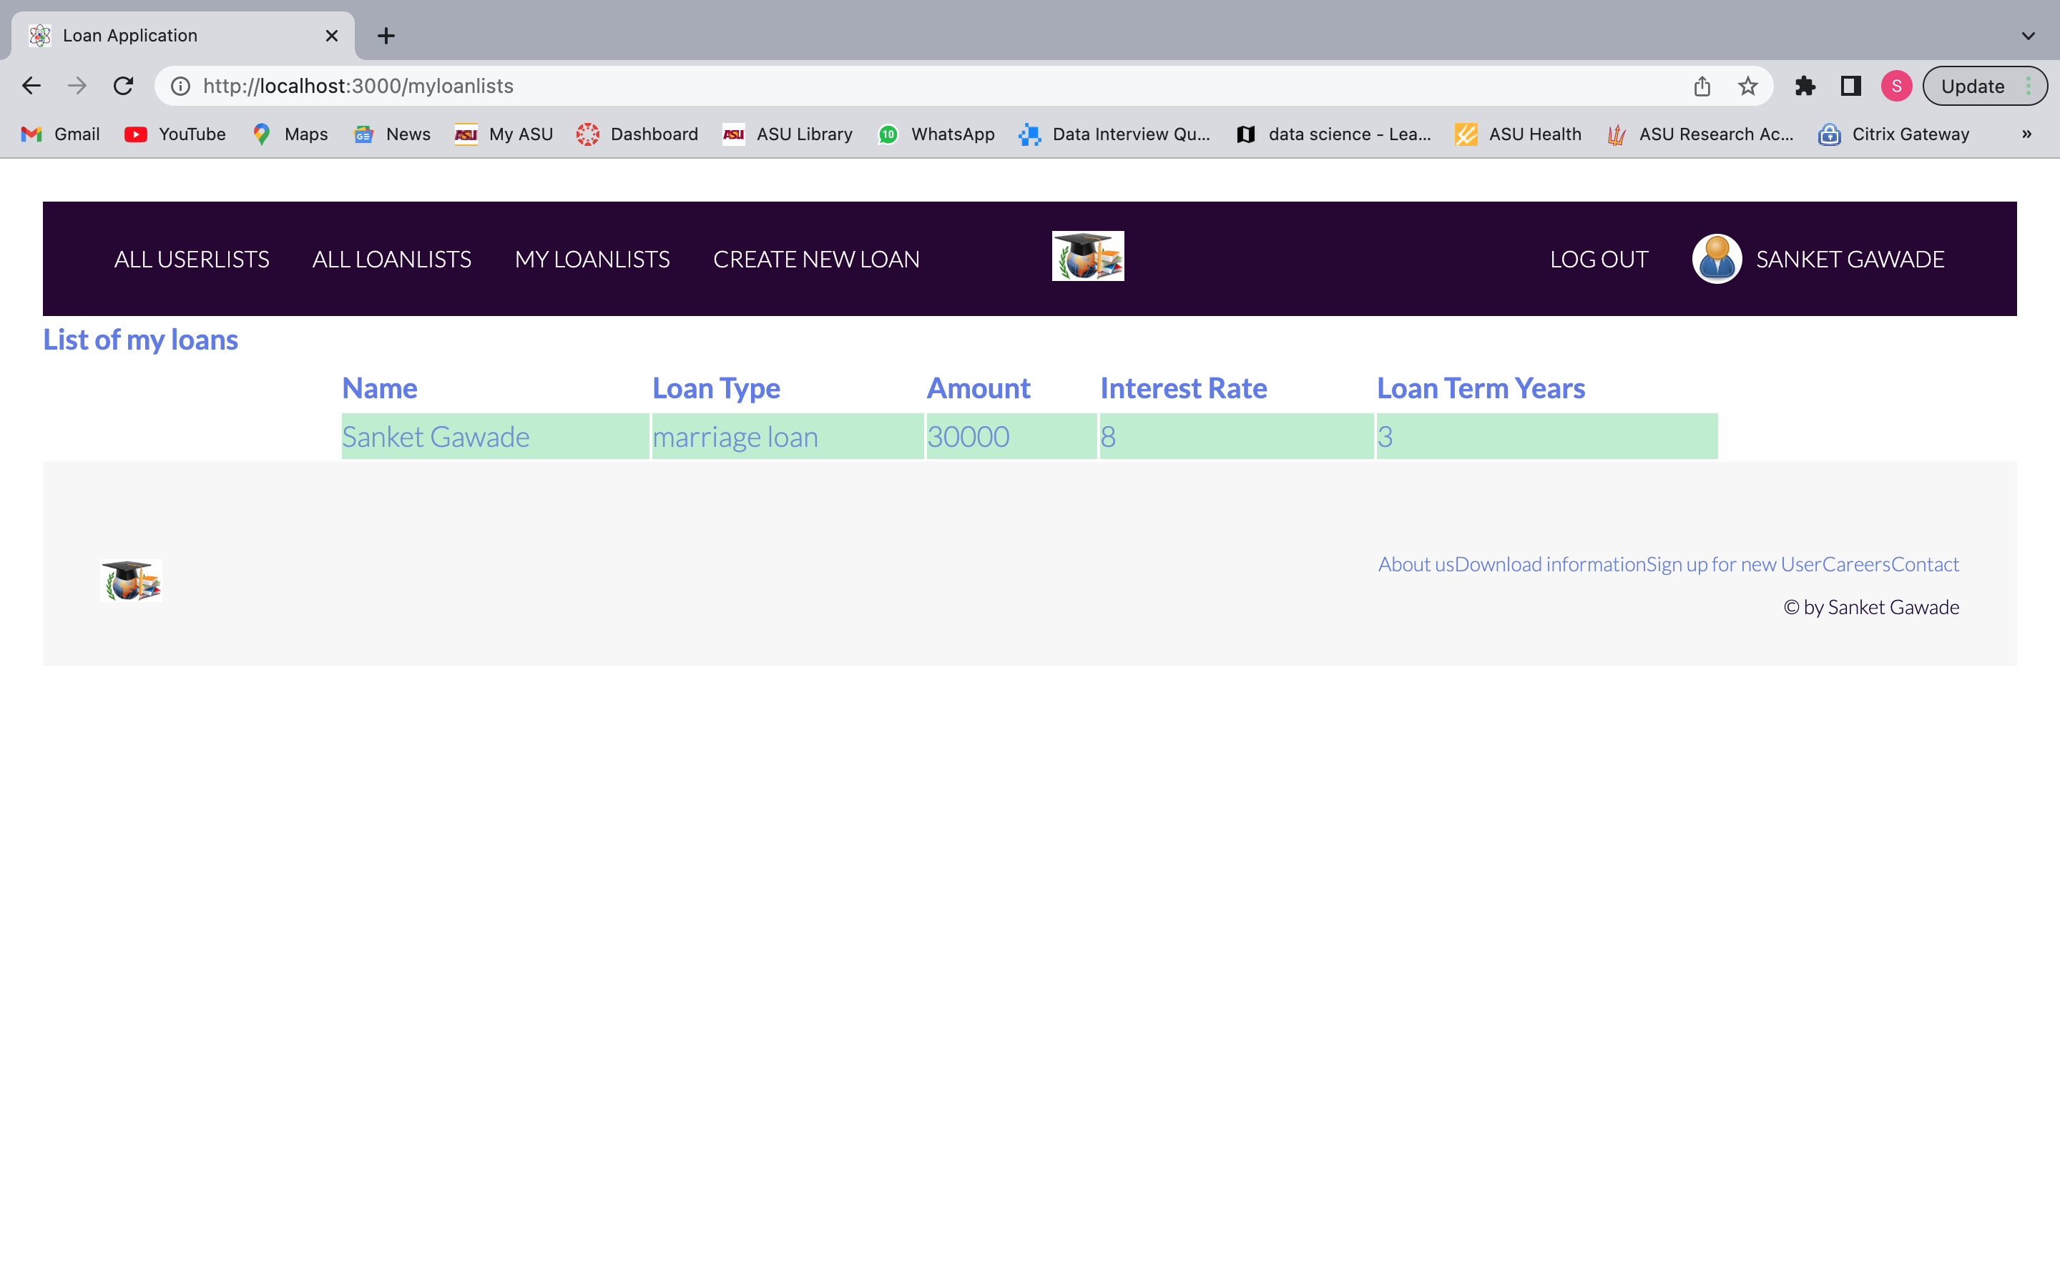

**B: Middleware API**

1. **Create New User**

viewRoutes.js file showing the route for signing up the new user

**Code:**

const express = require('express');

const viewsController = require('../controllers/viewsController');

const router = express.Router();

router.get('/', viewsController.home);

router.get('/myloanlists', viewsController.getMyLoan);

router.get('/allloanlists', viewsController.getLoan);

router.get('/createNewLoan', viewsController.CreateNewLoan);

router.get('/loanList', viewsController.getMyLoan);

router.get('/logout', viewsController.logout);

router.get('/login', viewsController.getLoginForm);

router.get('/signup', viewsController.getSignInForm);

module.exports = router;

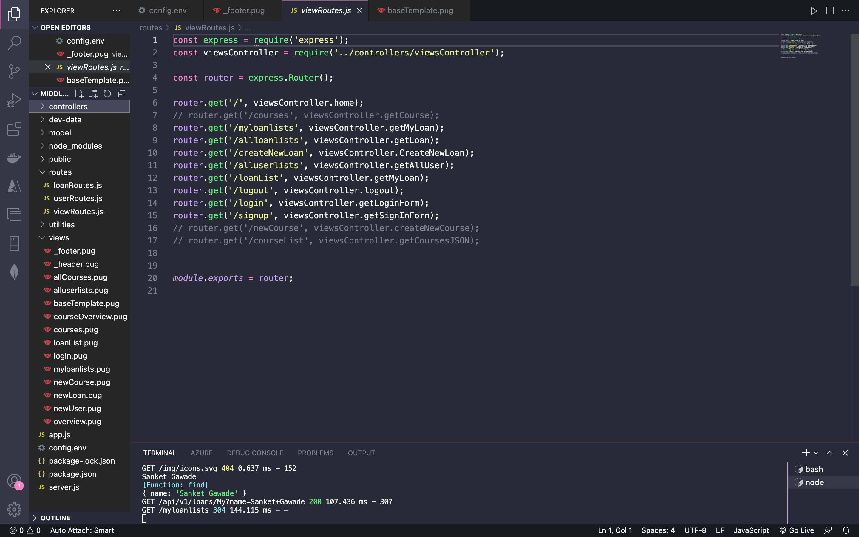

viewController.js

const axios = require('axios');

const User = require('./../model/userModel');

exports.getLoginForm = (req, res) => {

  res.status(200).render('login', {

    title: 'Log into your account'

  });

};

exports.getSignInForm = (req, res) => {

  res.status(200).render('newUser', {

    title: 'Sign in New User'

  });

};

exports.getCourse = async (req, res) => {

  res.status(200).render('courses', {

    title: `Get Course`

  });

};

exports.createNewCourse = async (req, res) => {

  res.status(200).render('newCourse', {

    title: `Create New Course`

  });

};

// adding the loan list for the views

exports.getLoan = async (req, res) => {

  const query = await axios.get('http://localhost:3000/api/v1/loans')

  console.log(query.data.loans)

  res.status(200).render('loanlist', {

    title: `Get loanlists`,

    "loans": query.data.loans

  });

};

exports.getCoursesJSON = async (req, res) => {

  res.status(200).render('allCourses', {

    title: `Get courses from JSON`,

    "courses": courses

  });

};

exports.home = async (req, res) => {

  if (req.session.userId){

    User.findById(req.session.userId)

    .exec(function (error, user) {

      console.log(user)

      if (error) {

        res.status(200).render('overview', {

          title: `Over View`

        });

      } else {

        return res.render('overview', { title: 'Over View', name: user.name});

      }

      req.session.name = user.name

    });

  }

  else {

    res.status(200).render('overview', {

    title: `Over View`

  });

  }

};

exports.getMyLoan = async (req, res) => {

  // console.log(req.session)

  const query = await axios.get('http://localhost:3000/api/v1/loans/My',{params:{name:req.session.name}})

  // console.log(query.data.loans)

  res.status(200).render('myloanlists', {

    title: `Get loanlists`,

    "loans": query.data.loans,

    name: req.session.name

  });

};

exports.CreateNewLoan = (req, res) => {

  res.status(200).render('newLoan', {

    title: 'Create New Loan',

    name: req.session.name

  });

};

exports.logout = (req, res) => {

  if (req.session) {

    // delete session object

    req.session.destroy(function(err) {

      if(err) {

        return next(err);

      } else {

        return res.redirect('/');

      }

    });

  }

};

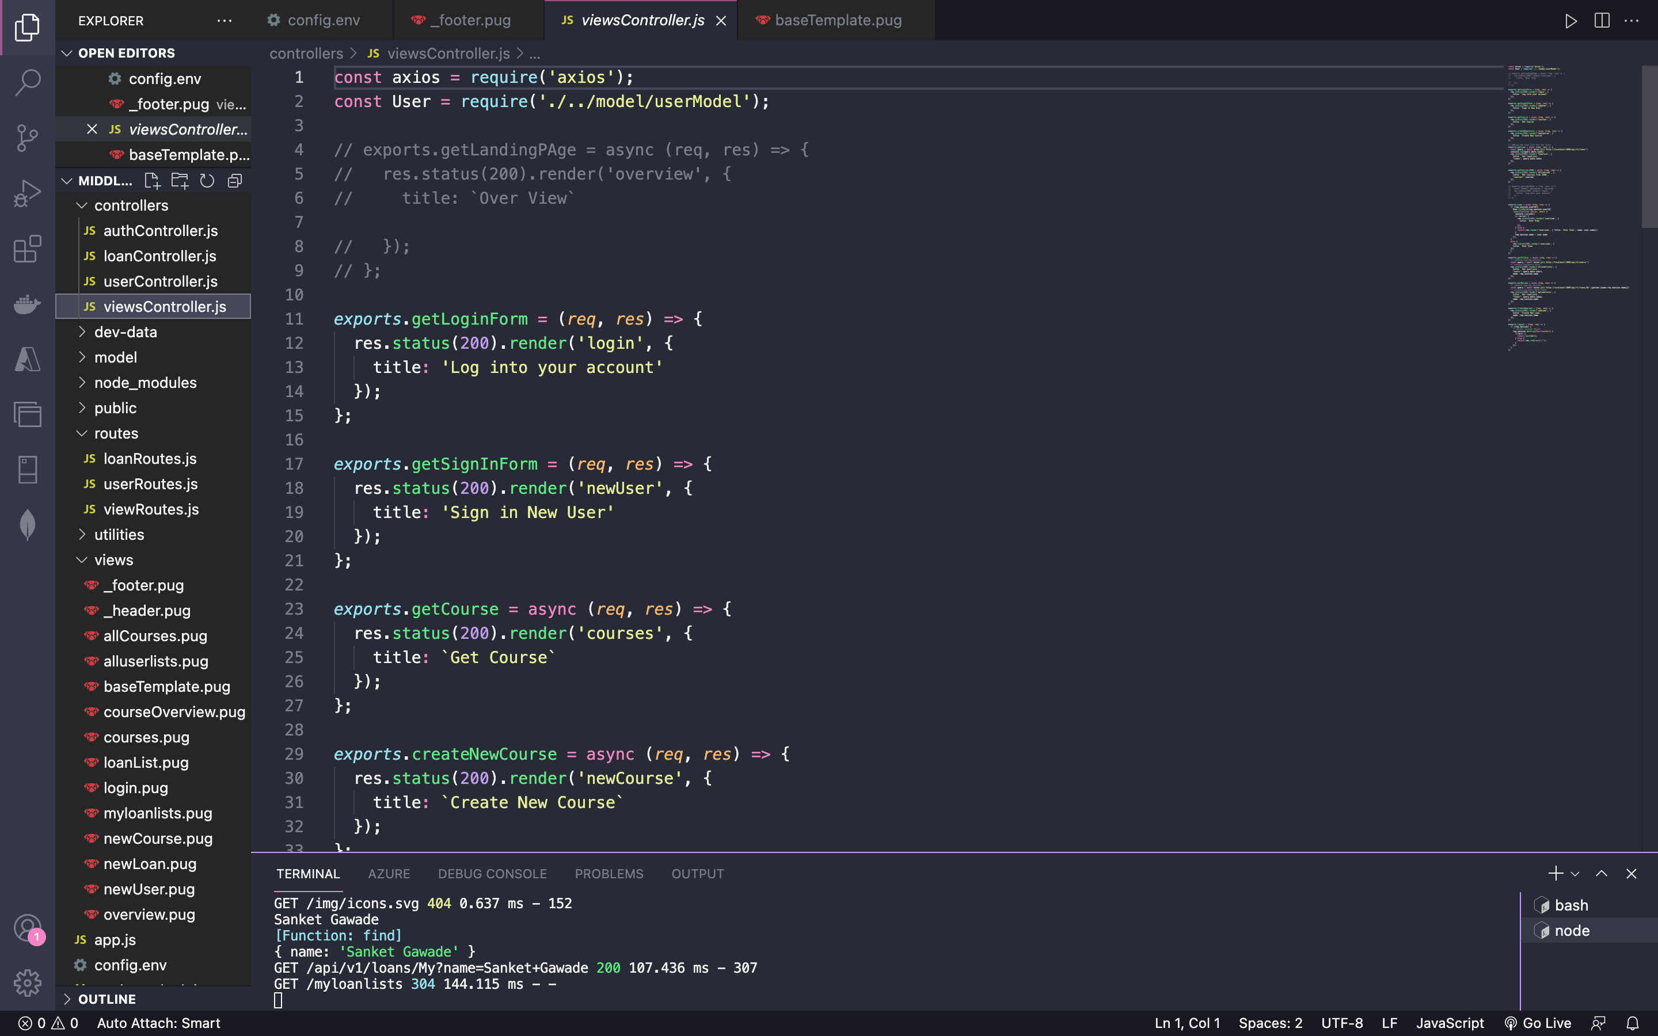

userRoutes.js

**Code:**

const express = require('express');

const userController = require('./../controllers/userController');

const authController = require('./../controllers/authController');

const router = express.Router();

router.post('/login', authController.login);

router.post('/signup', authController.signup);

router.get('/logout', authController.logout);

router

  .route('/')

  .post(userController.createUser);

//  .get(userController.getAllUsers)

router

  .route('/:id')

  .get(userController.getUser)

  .patch(userController.updateUser);

module.exports = router;

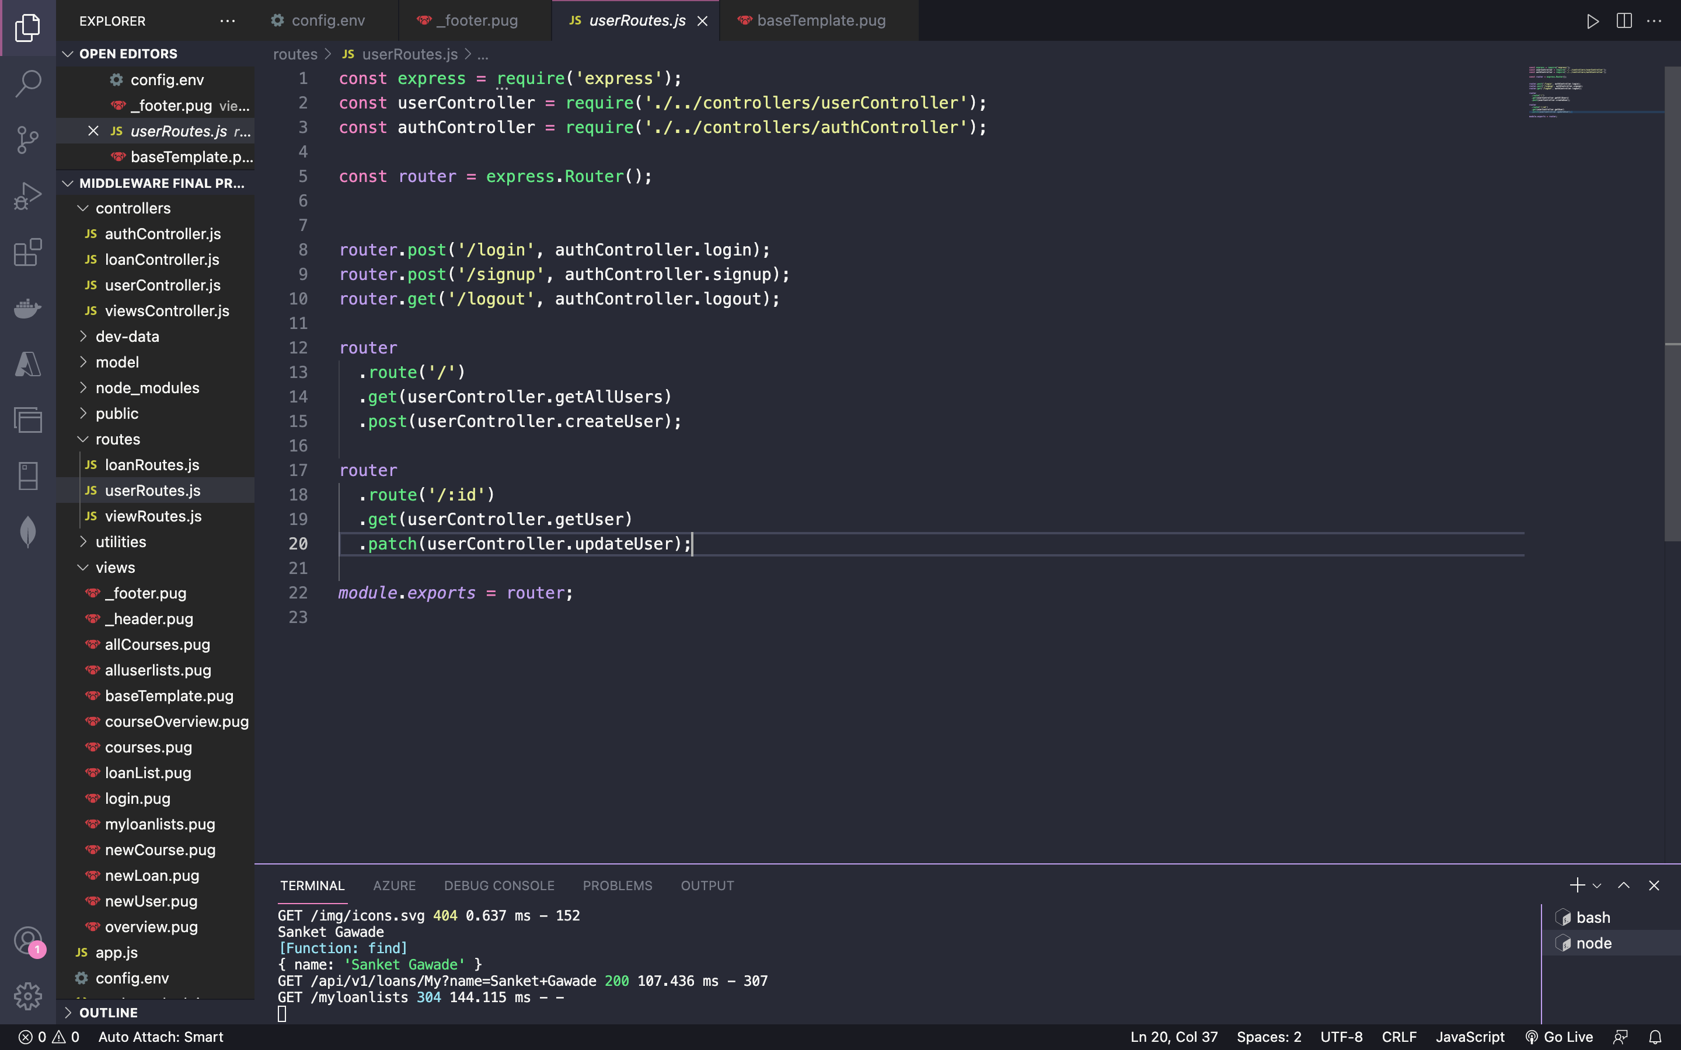

Authentication file showing the functionality for signing up new user

**Code:**

const crypto = require('crypto');

const jwt = require('jsonwebtoken');

const User = require('./../model/userModel');

const AppError = require('./../utilities/appError');

const util = require('util');

const express = require('express');

const alert =require('alert')

require('util.promisify').shim();

const signToken = id => {

  return jwt.sign({ id }, process.env.JWT_SECRET, {

    expiresIn: process.env.JWT_EXPIRES_IN

  });

};

const createSendToken = (user, statusCode, res) => {

  const token = signToken(user._id);

  const cookieOptions = {

    expires: new Date(

      Date.now() + process.env.JWT_COOKIE_EXPIRES_IN * 24 * 60 * 60 * 1000

    ),

    httpOnly: true

  };

  if (process.env.NODE_ENV === 'production') {

    cookieOptions.secure = true;

  }

  res.cookie('jwt', token, cookieOptions);

  // Remove password from output

  user.password = undefined;

};

exports.signup = async (req, res, next) => {

  console.log(req.body)

  const newUser = await User.create({

    name: req.body.name,

    email: req.body.email,

    password: req.body.password,

    passwordConfirm: req.body.passwordConfirm,

    role: req.body.role

  });

  createSendToken(newUser, 201, res);

  console.log('sign up successfully')

  req.session.email = newUser.email

  req.session.name = newUser.name

  req.session.userId = newUser._id;

  res.redirect('/')

};

exports.login = async (req, res, next) => {

  const { email, password } = req.body;

  // 1) Check if email and password exist

  if (!email || !password) {

    return next(new AppError('Please provide email and password!', 400));

  }

  //authentication

  // 2) Check if user exists && password is correct

  const user = await User.findOne({ email }).select('+password');

  if (!user || !(user.correctPassword(password, user.password))) {

    return next(new AppError('Incorrect email or password', 401));

  }

  //end of authentication

  // 3) If everything ok, send token to client

  createSendToken(user, 200, res);

  req.session.email = user.email

  req.session.name = user.name

  req.session.userId = user._id;

  alert("successfully!!!")

  res.redirect('/')

};

exports.logout = (req, res) => {

  res.cookie('jwt', 'loggedout', {

    expires: new Date(Date.now() + 10 * 1000),

    httpOnly: true

  });

  res.status(200).json({ status: 'success' });

};

exports.protect = async (req, res, next) => {

  // 1) Getting token and check of it's there

  let token;

  if (

    req.headers.authorization &&

    req.headers.authorization.startsWith('Bearer')

  ) {

    token = req.headers.authorization.split(' ')[1];

  } else if (req.cookies.jwt) {

    token = req.cookies.jwt;

  }

  if (!token) {

    return next(

      new AppError('You are not logged in! Please log in to get access.', 401)

    );

  }

  // 2) Verification token

  const decoded = await util.promisify(jwt.verify)(token, process.env.JWT_SECRET);

  // 3) Check if user still exists

  const currentUser = await User.findById(decoded.id);

  if (!currentUser) {

    return next(

      new AppError(

        'The user belonging to this token does no longer exist.',

        401

      )

    );

  }

  // 4) Check if user changed password after the token was issued

  if (currentUser.changedPasswordAfter(decoded.iat)) {

    return next(

      new AppError('User recently changed password! Please log in again.', 401)

    );

  }

  // GRANT ACCESS TO PROTECTED ROUTE

  req.user = currentUser;

  res.locals.user = currentUser;

  next();

  res.status(201).json({

    status: 'success',

    token,

    data: {

      currentUser

    }

  });

};

// Only for rendered pages, no errors!

exports.isLoggedIn = async (req, res, next) => {

  if (req.cookies.jwt) {

    try {

      // 1) verify token

      const decoded = await promisify(jwt.verify)(

        req.cookies.jwt,

        process.env.JWT_SECRET

      );

      // 2) Check if user still exists

      const currentUser = await User.findById(decoded.id);

      if (!currentUser) {

        return next();

      }

      // 3) Check if user changed password after the token was issued

      if (currentUser.changedPasswordAfter(decoded.iat)) {

        return next();

      }

      // THERE IS A LOGGED IN USER

      res.locals.user = currentUser;

      return next();

    } catch (err) {

      return next();

    }

  }

  next();

};

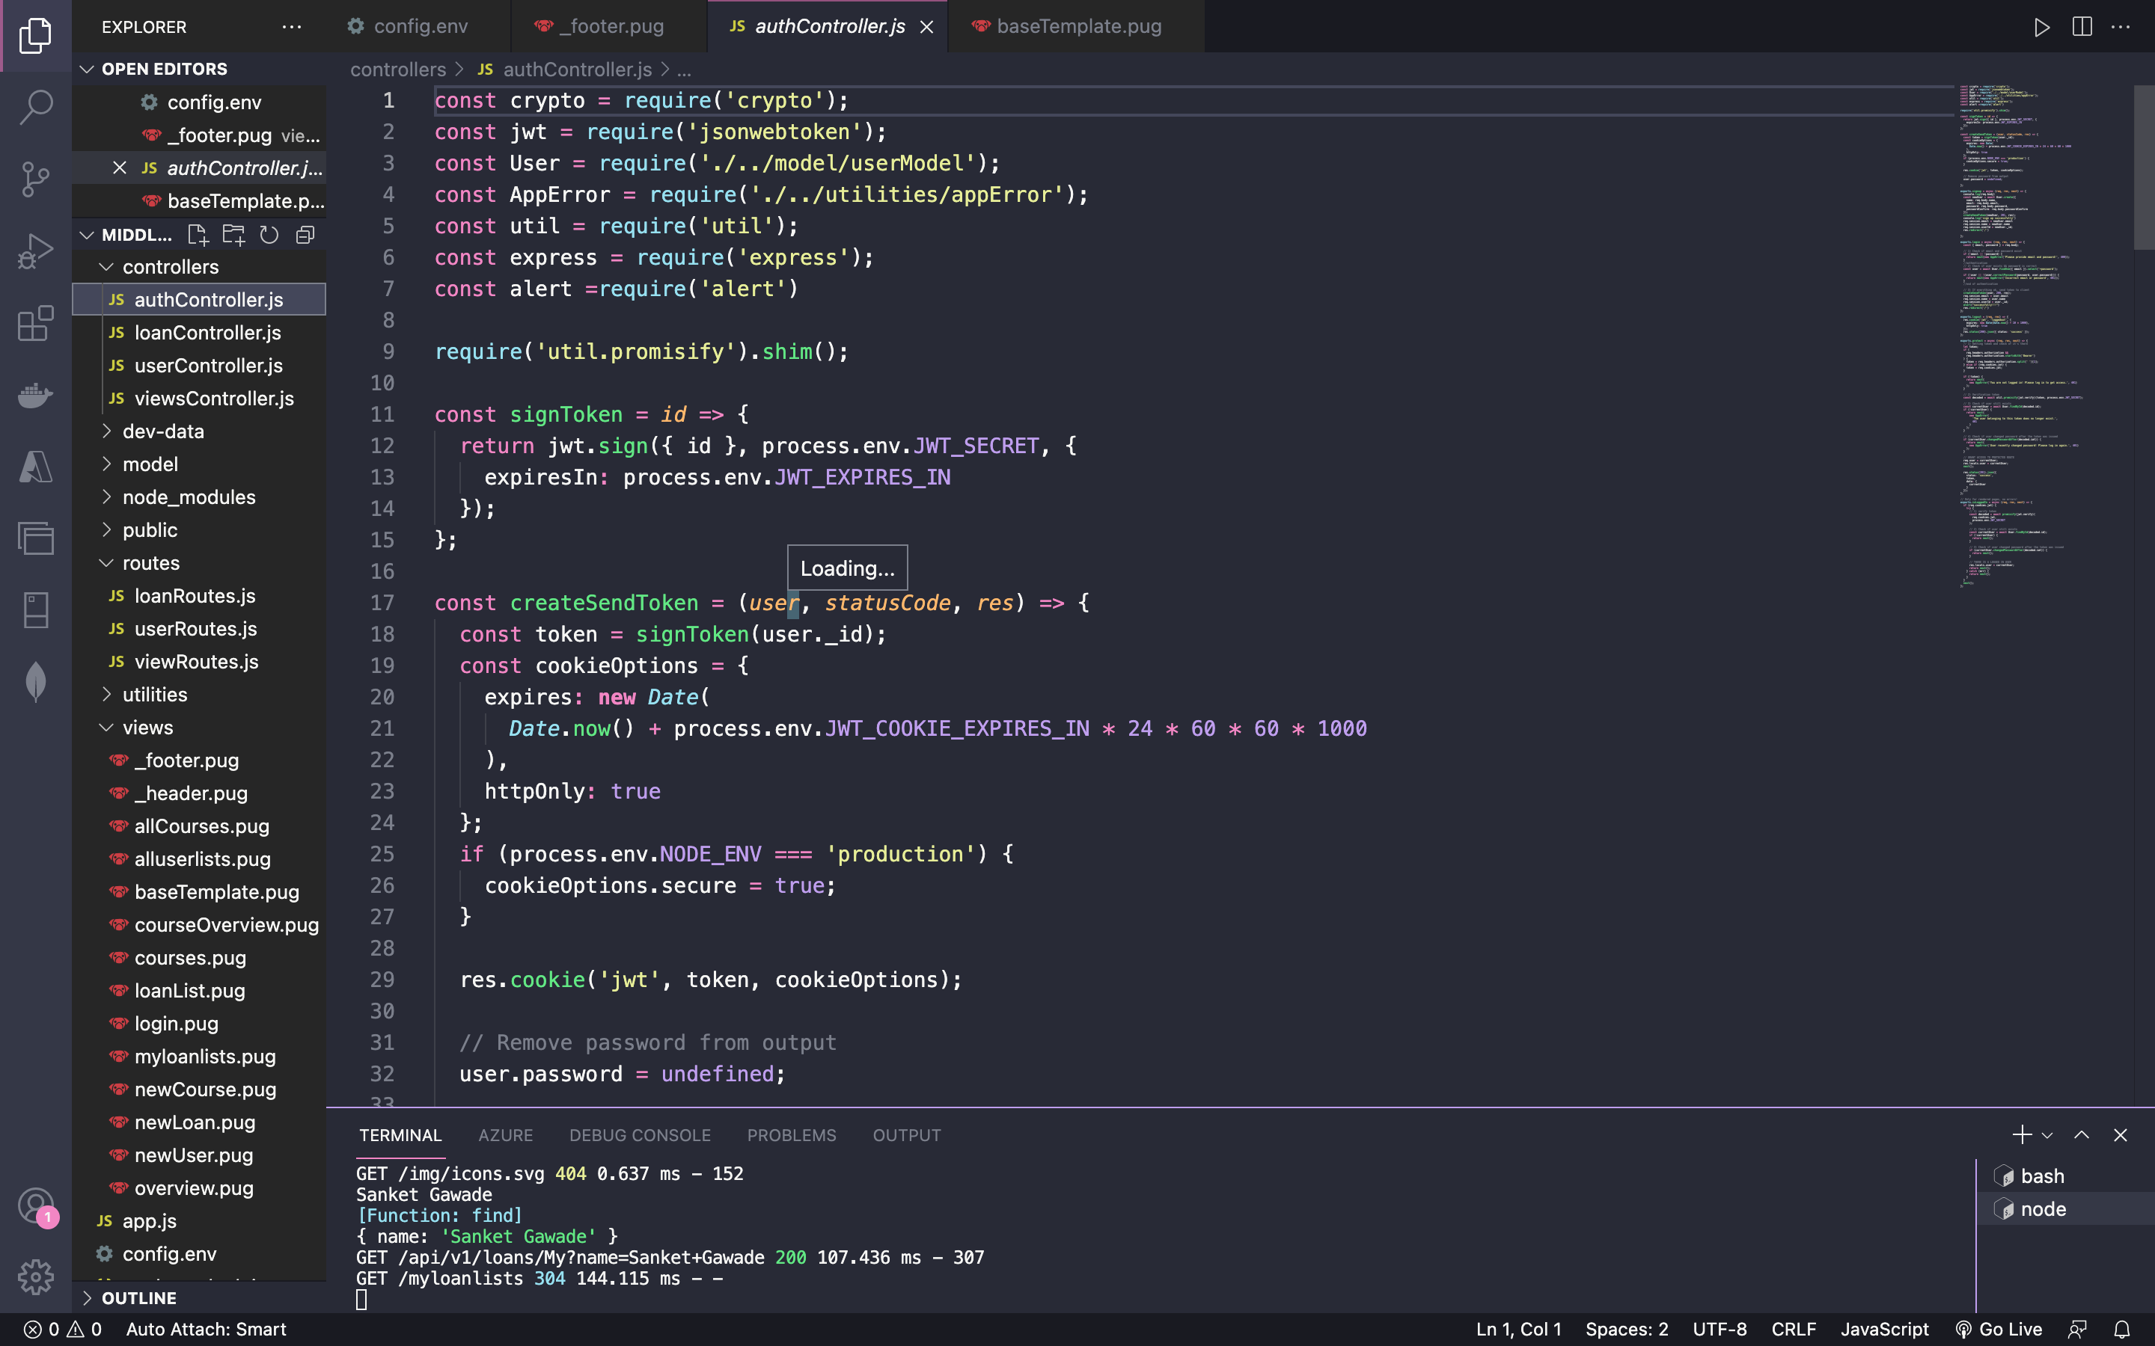

1. **LogIn Current User**

viewRoutes.js

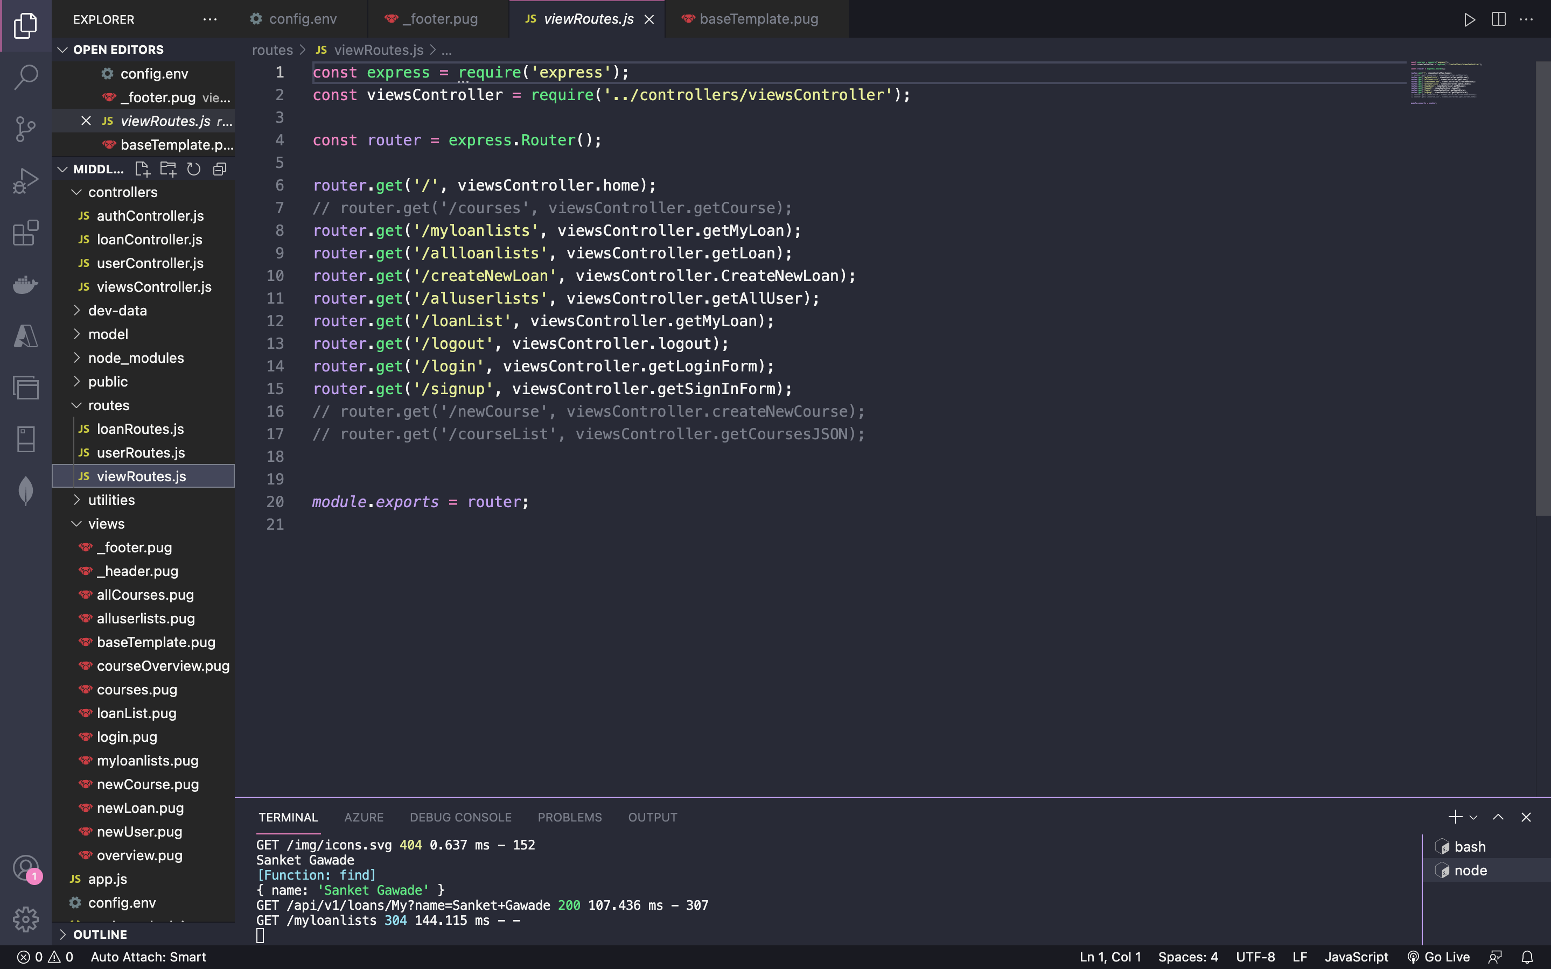

viewController.js



userRoutes.js

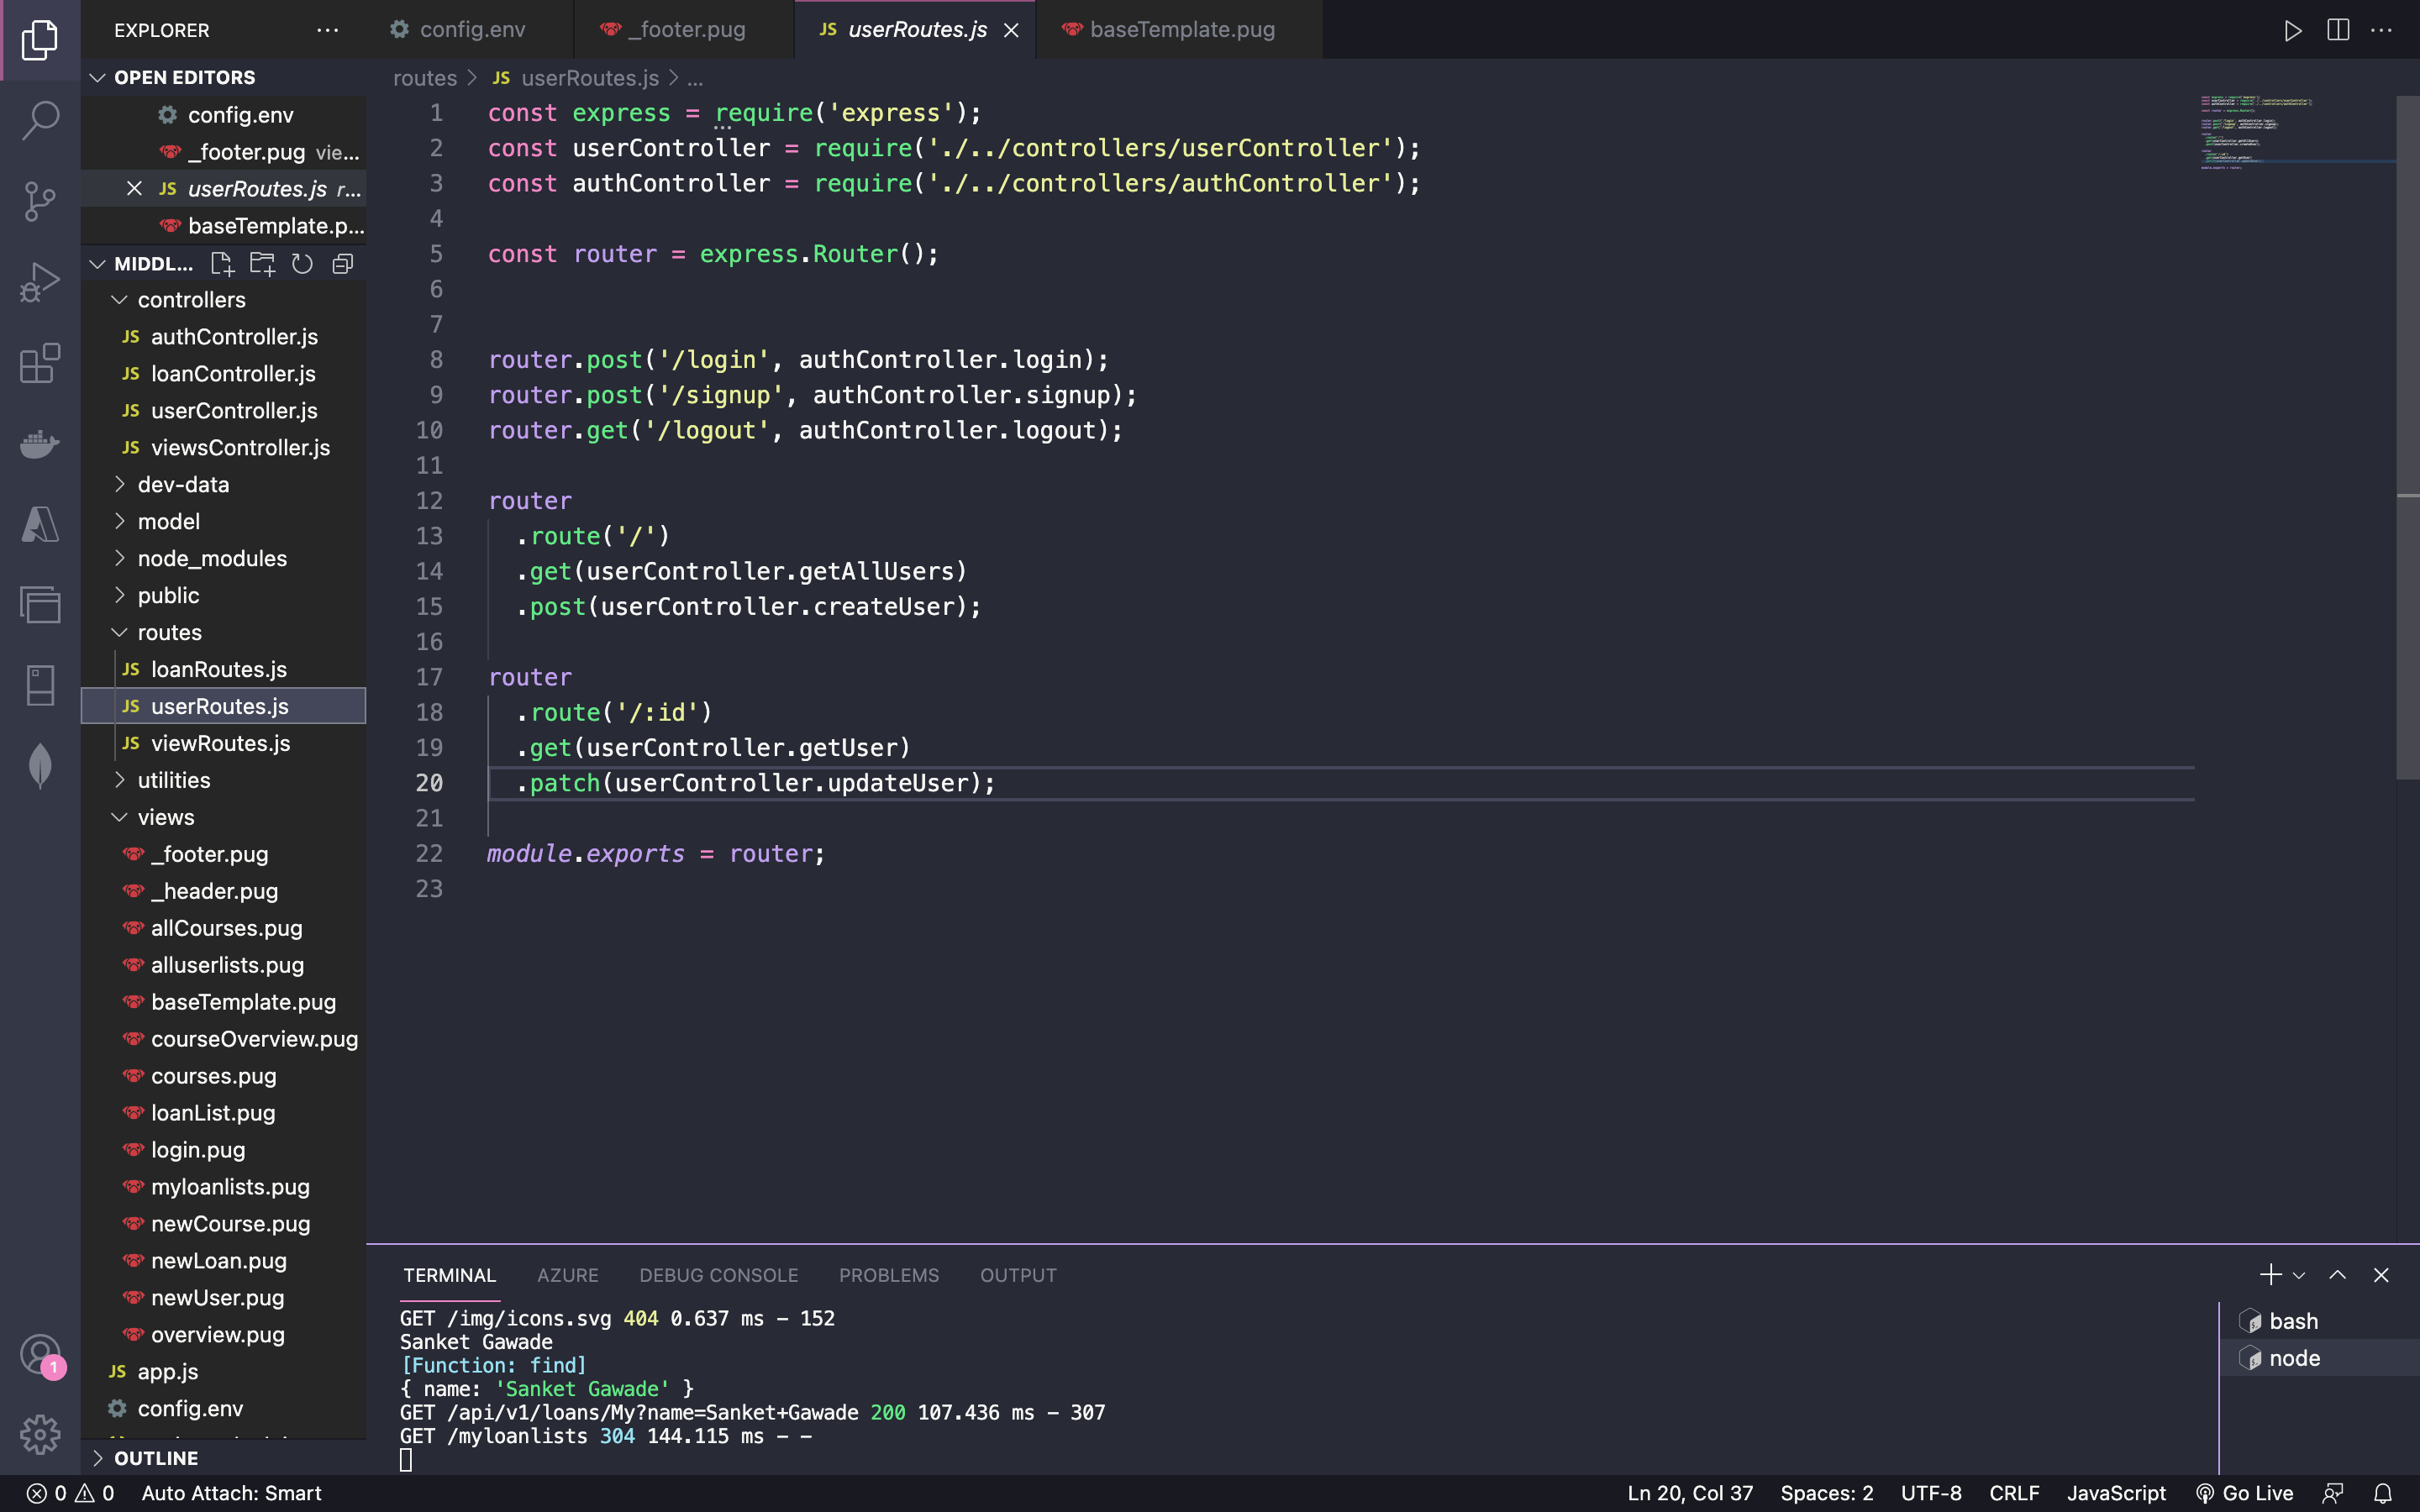

authController.js

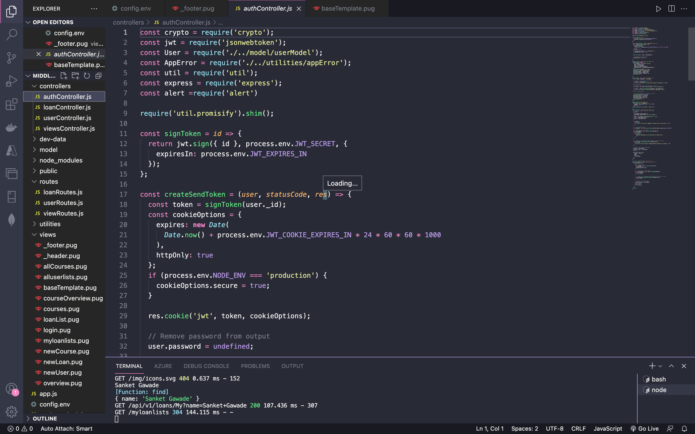

1. **Create New Loans**

viewRoutes.js



viewController.js

implementing the route fromiewRoute.js

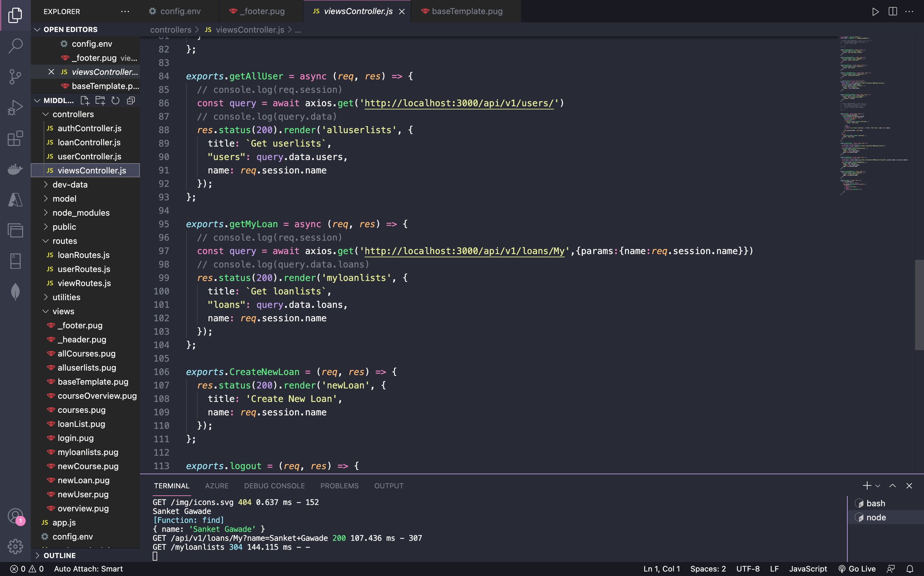

loanRoute.js

const express = require('express');

const loanController = require('../controllers/loanController');

const router = express.Router();

router

  .route('/')

  .get(loanController.getAllLoans)

  .post(loanController.createLoan, function(req, res){

    res.redirect('/');

});

router

  .route('/My')

  .get(loanController.getMyLoans)

  // .post(loanController.createLoan);

router

  .route('/:id')

  .get(loanController.getloan)

module.exports = router;

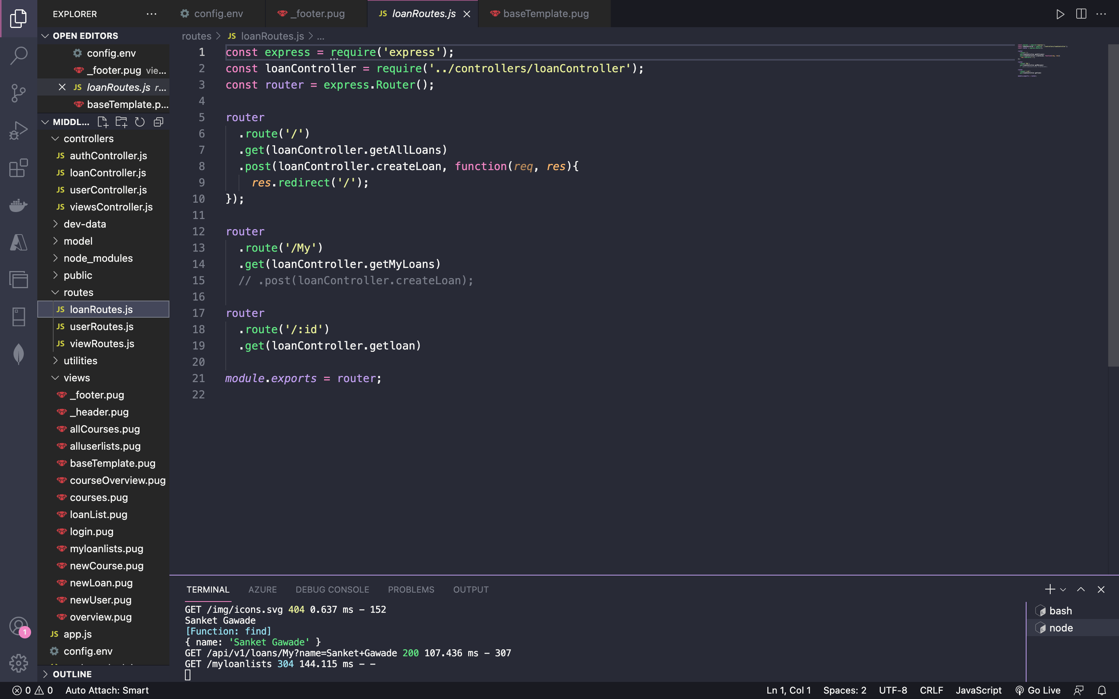

loanController.js

**Code:**

const Loan = require('../model/loanModel');

const APIFeatures = require('../utilities/loanDbContext');

const alert =require('alert')

exports.getAllLoans =   async (req, res) => {

  console.log(req.query.name)

  try {

    // EXECUTE QUERY

    const features = new APIFeatures(Loan.find(), req.query)

      .filter()

      .sort()

      .limitFields()

      .paginate();

    const loans = await features.query;

    // SEND RESPONSE

    res.status(200).json({

      status: 'success',

      results: loans.length,

      loans

    });

  } catch (err) {

    res.status(404).json({

      status: 'fail',

      message: err

    });

  }

};

exports.getMyLoans =   async (req, res) => {

  console.log(req.query.name)

  try {

    // EXECUTE QUERY

    const features = new APIFeatures(Loan.find(), req.query)

      .filter(Loan => Loan.Name = req.query.name)

      .sort()

      .limitFields()

      .paginate();

    console.log(Loan.find);

    console.log(req.query);

    const loans = await features.query;

    // SEND RESPONSE

    res.status(200).json({

      status: 'success',

      results: loans.length,

      loans

    });

  } catch (err) {

    res.status(404).json({

      status: 'fail',

      message: err

    });

  }

};

exports.getloan = async (req, res) => {

  try {

    const loans = await Loan.find();

    //Loan.findOne({ _id: req.params.id })

    res.status(200).json({

      status: 'success',

      results: loans.length,

      data: {

        loans

      }

    });

  } catch (err) {

    res.status(404).json({

      status: 'fail',

      message: err

    });

  }

};

exports.createLoan = async  (req, res) => {

  try {

    const newLoan = await Loan.create(req.body);

    res.redirect('/')

    // res.status(201).json({

    //   status: 'success',

    //   data: {

    //     loan: newLoan

    //   }

    // })

  } catch (err) {

    res.status(400).json({

      status: 'fail',

      message: err

    });

  }

};

exports.updateLoan = async (req, res) => {

  try {

    const loan = await Loan.findByIdAndUpdate(req.params.id, req.body, {

      new: true,

      runValidators: true

    });

    res.status(200).json({

      status: 'success',

      data: {

        loan

      }

    });

  } catch (err) {

    res.status(404).json({

      status: 'fail',

      message: err

    });

  }

};

exports.deleteLoan = async (req, res) => {

  try {

    await Loan.findByIdAndDelete(req.params.id);

    res.status(200).json({

      status: 'success',

      data: null

    });

  } catch (err) {

    res.status(404).json({

      status: 'fail',

      message: err

    });

  }

};

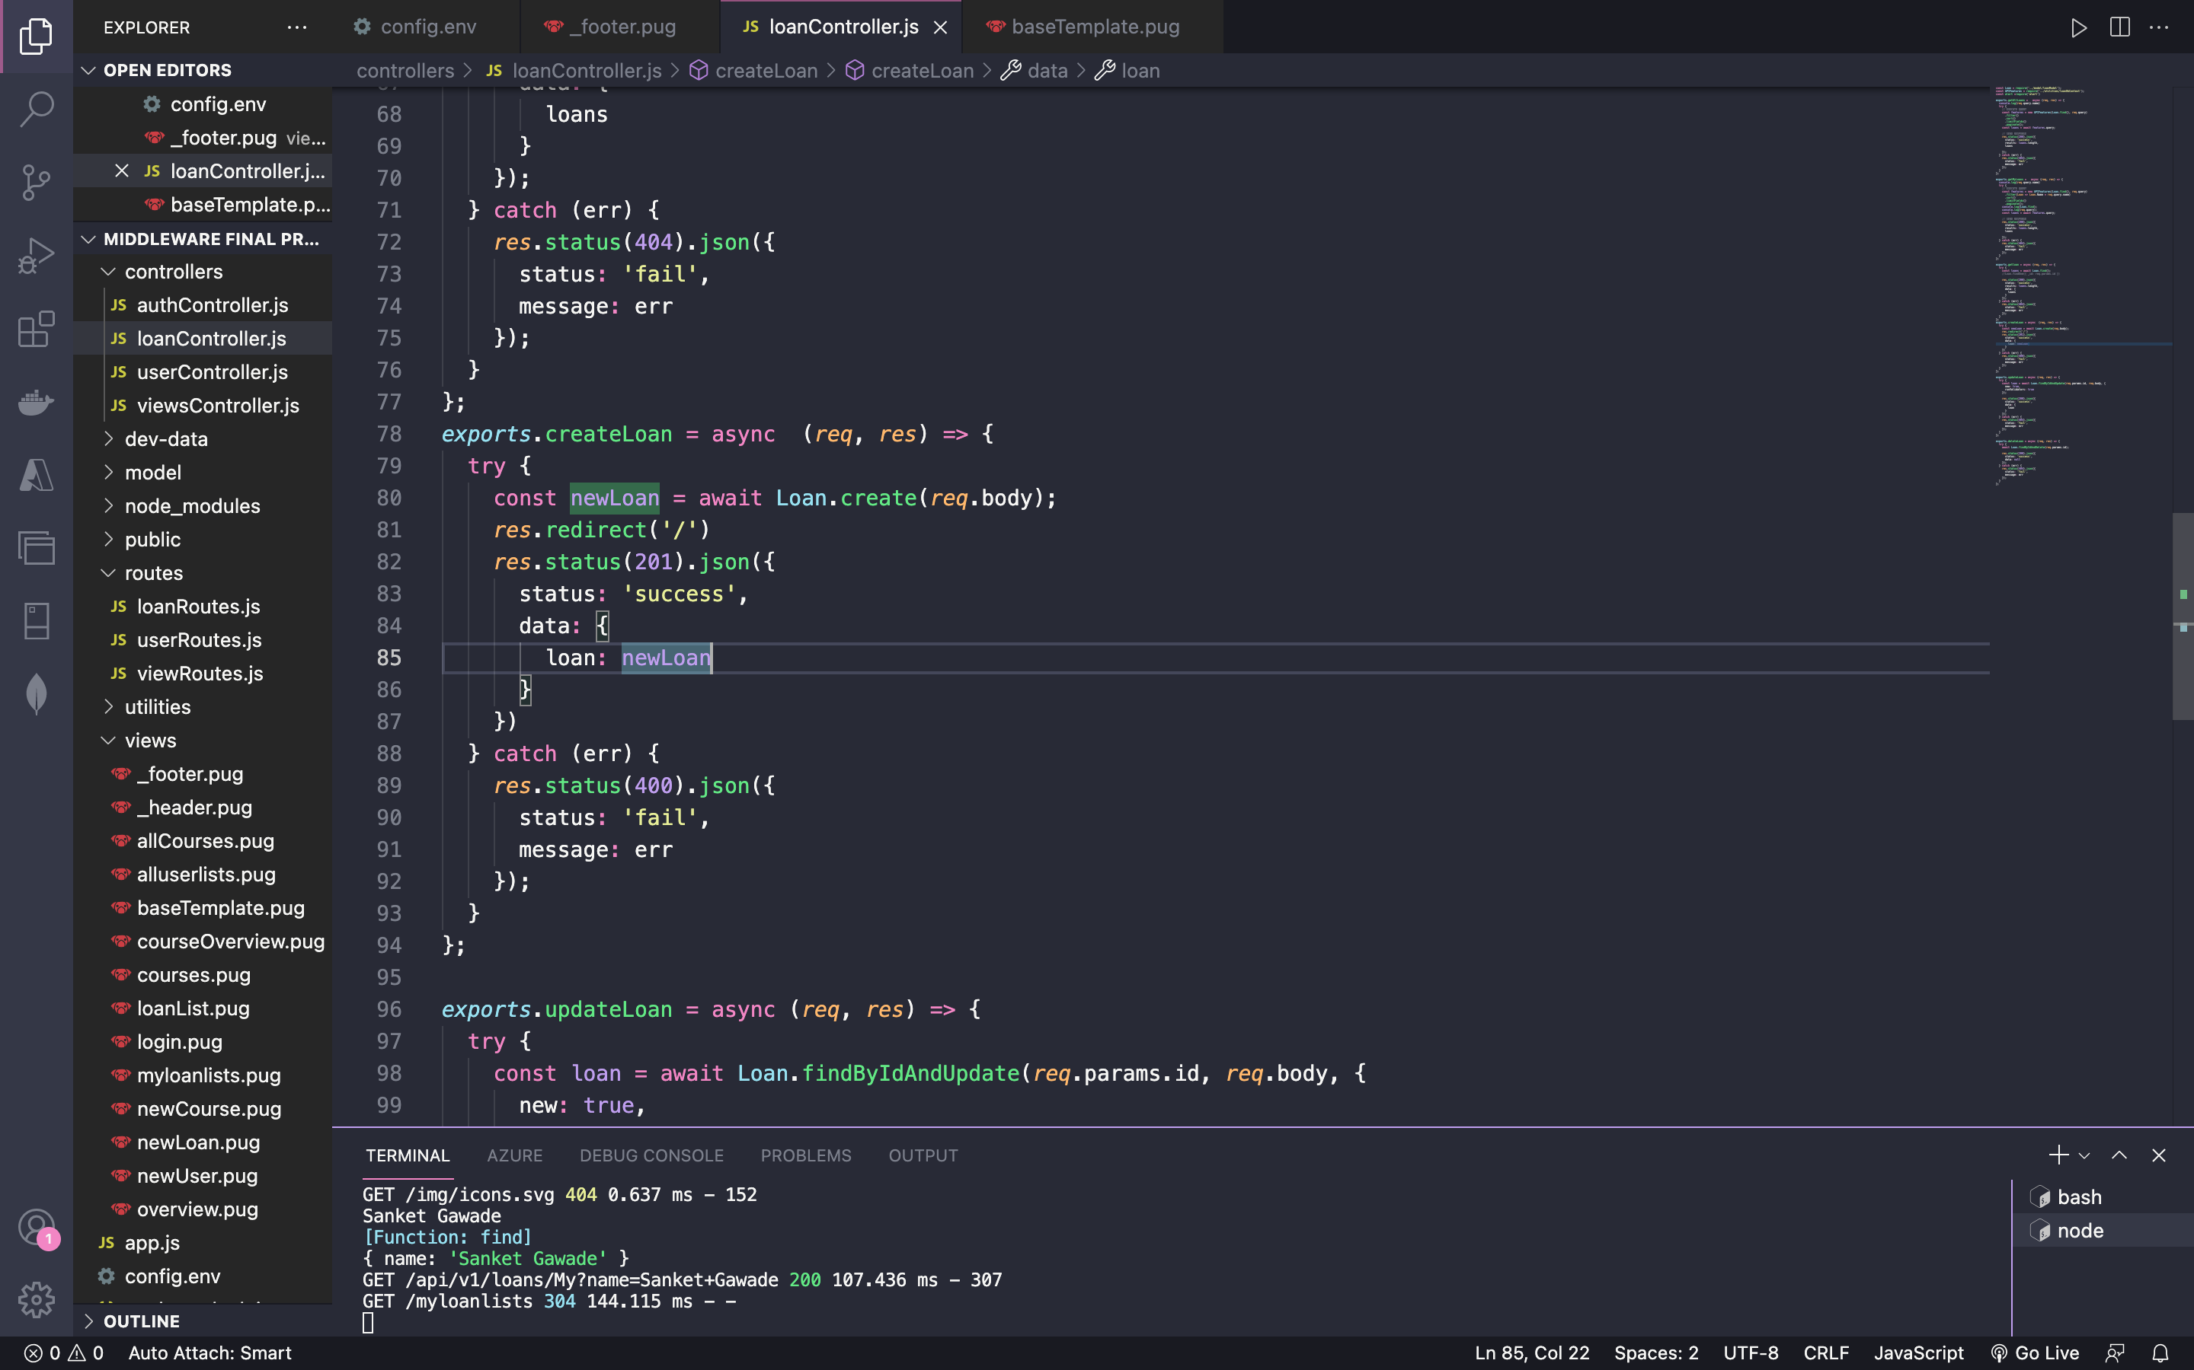

1. **List Loan Details**

viewRoutes.js file for listing loans

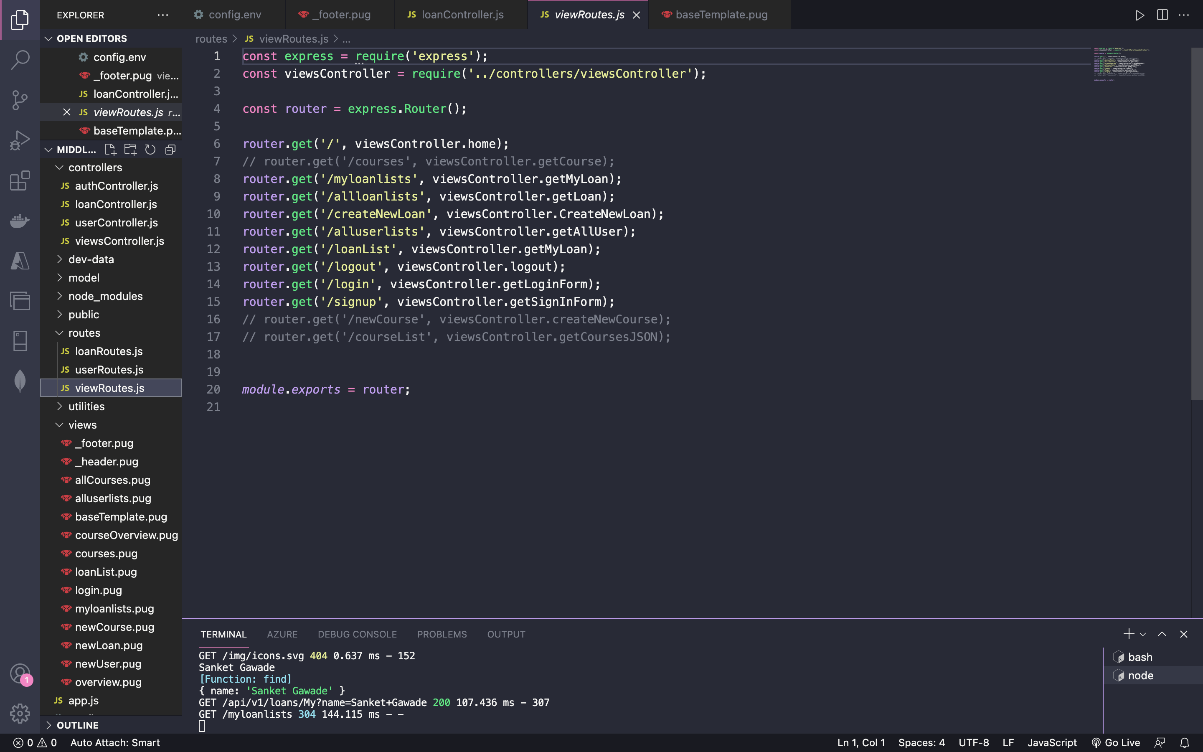

viewController.js file for listing the loans

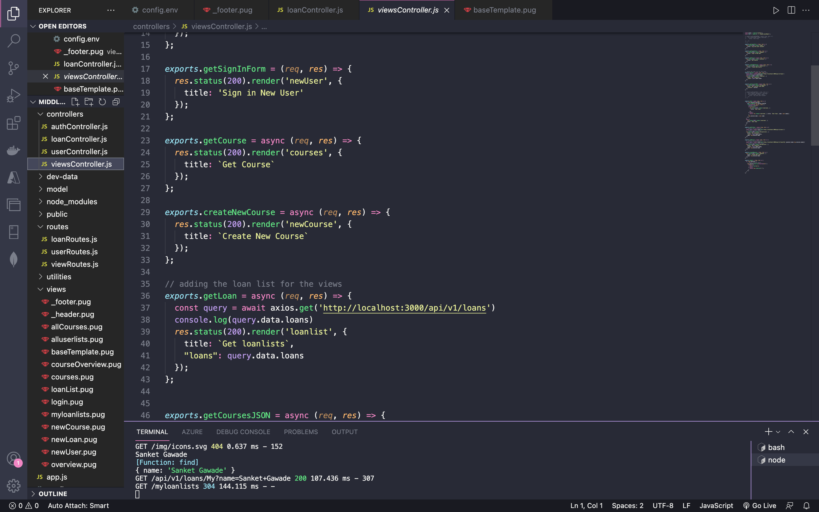

loanRoutes.js

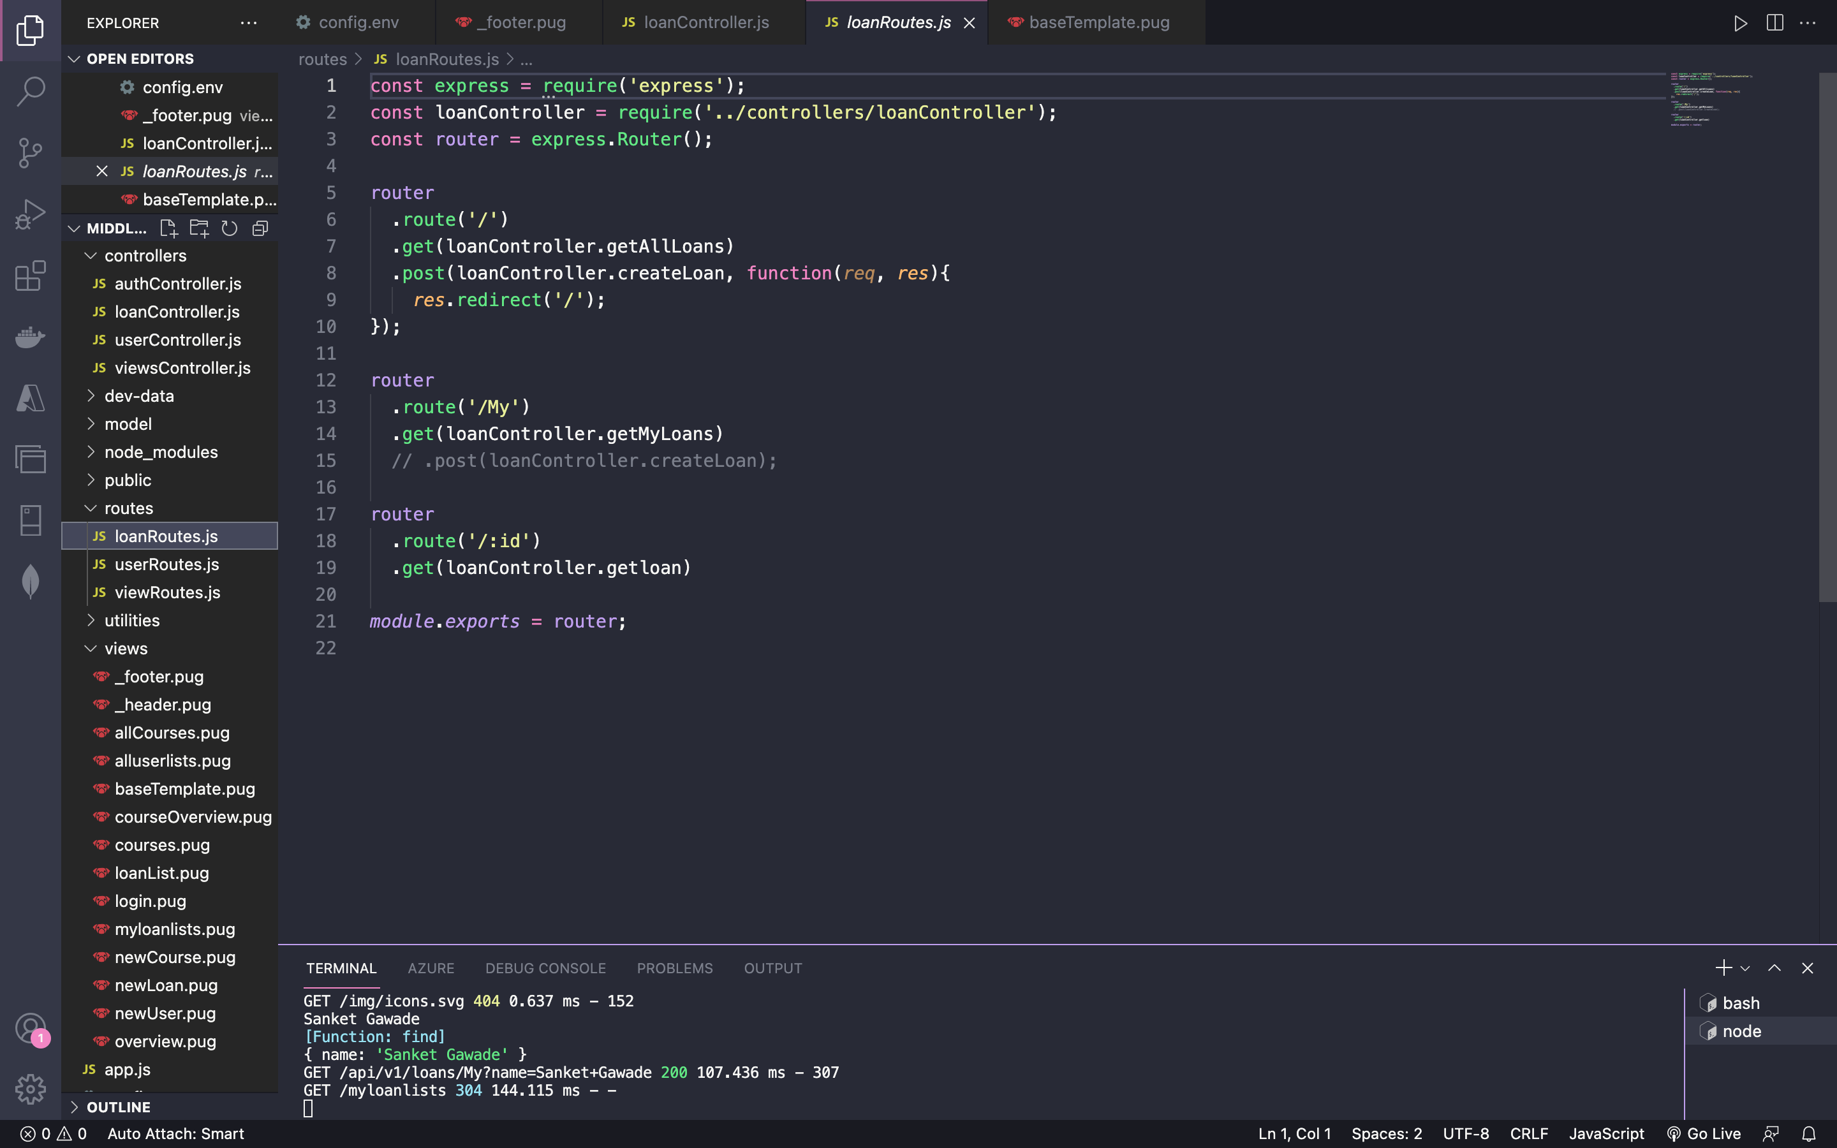

loanController.js for listing all loan types

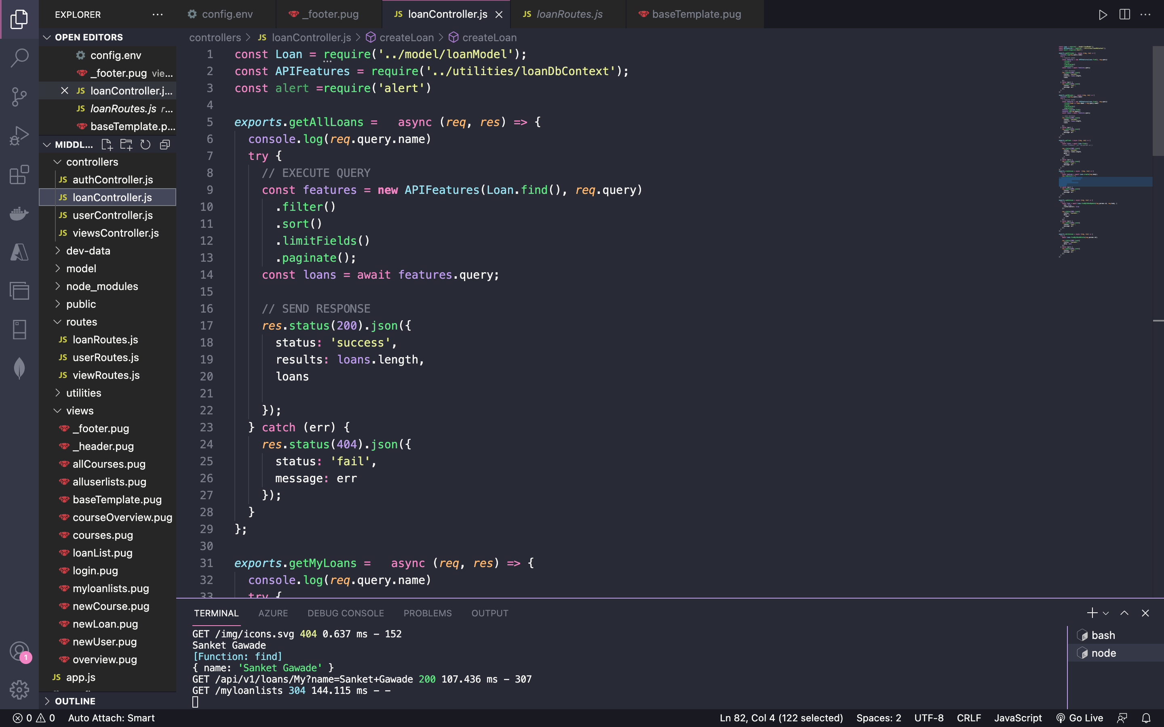

**C: Back end**

1. **Loan Database**

Database of the loansDB MongoDB database

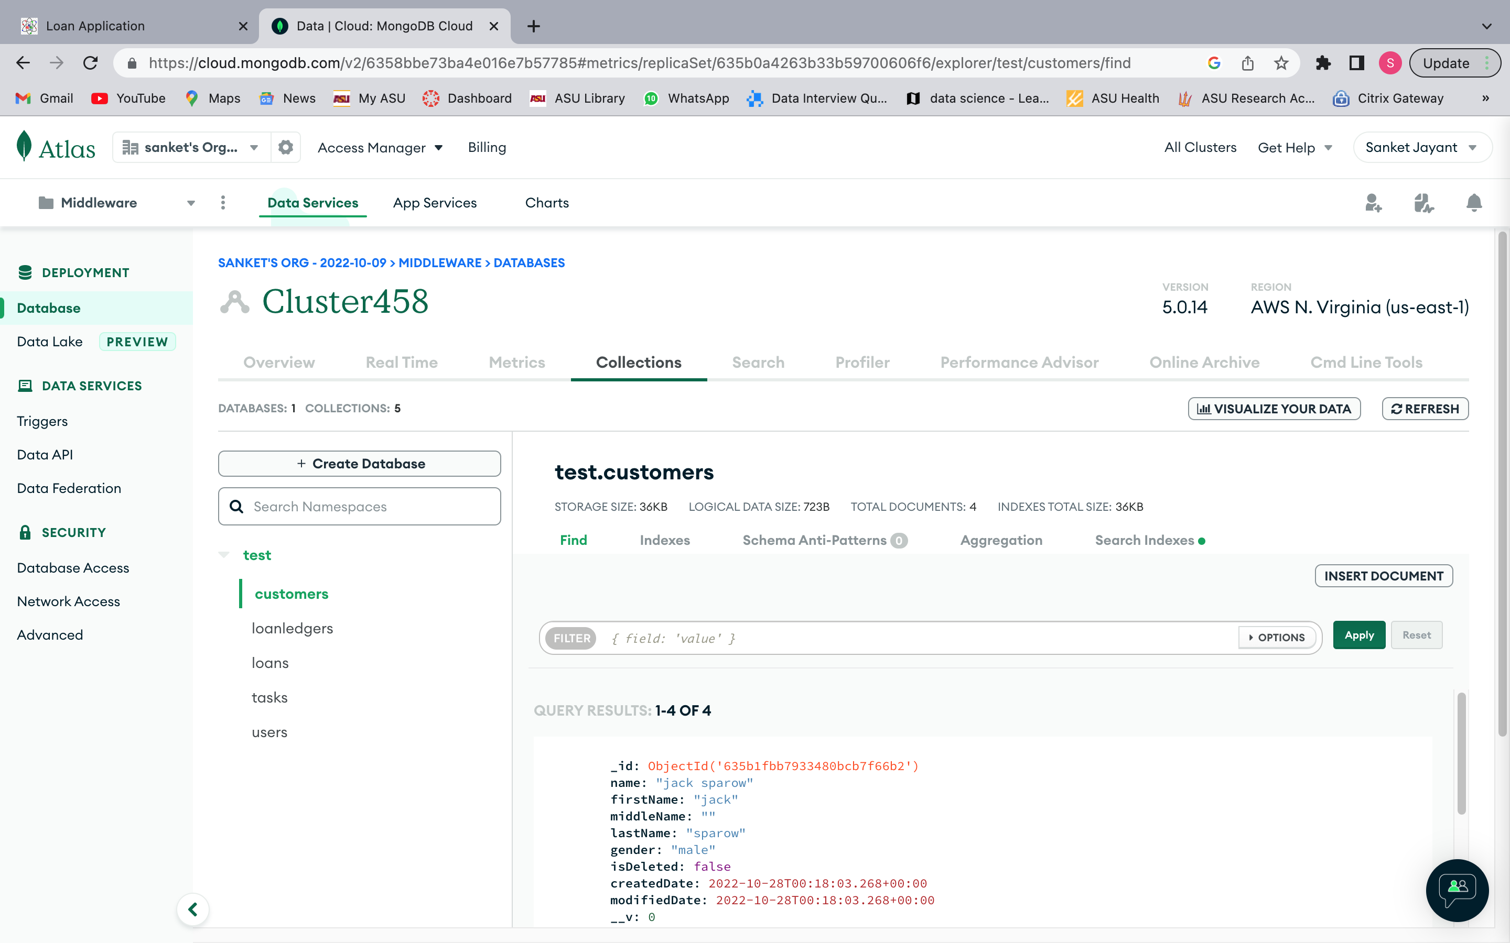

1. **User collection**

User collection having 3 users

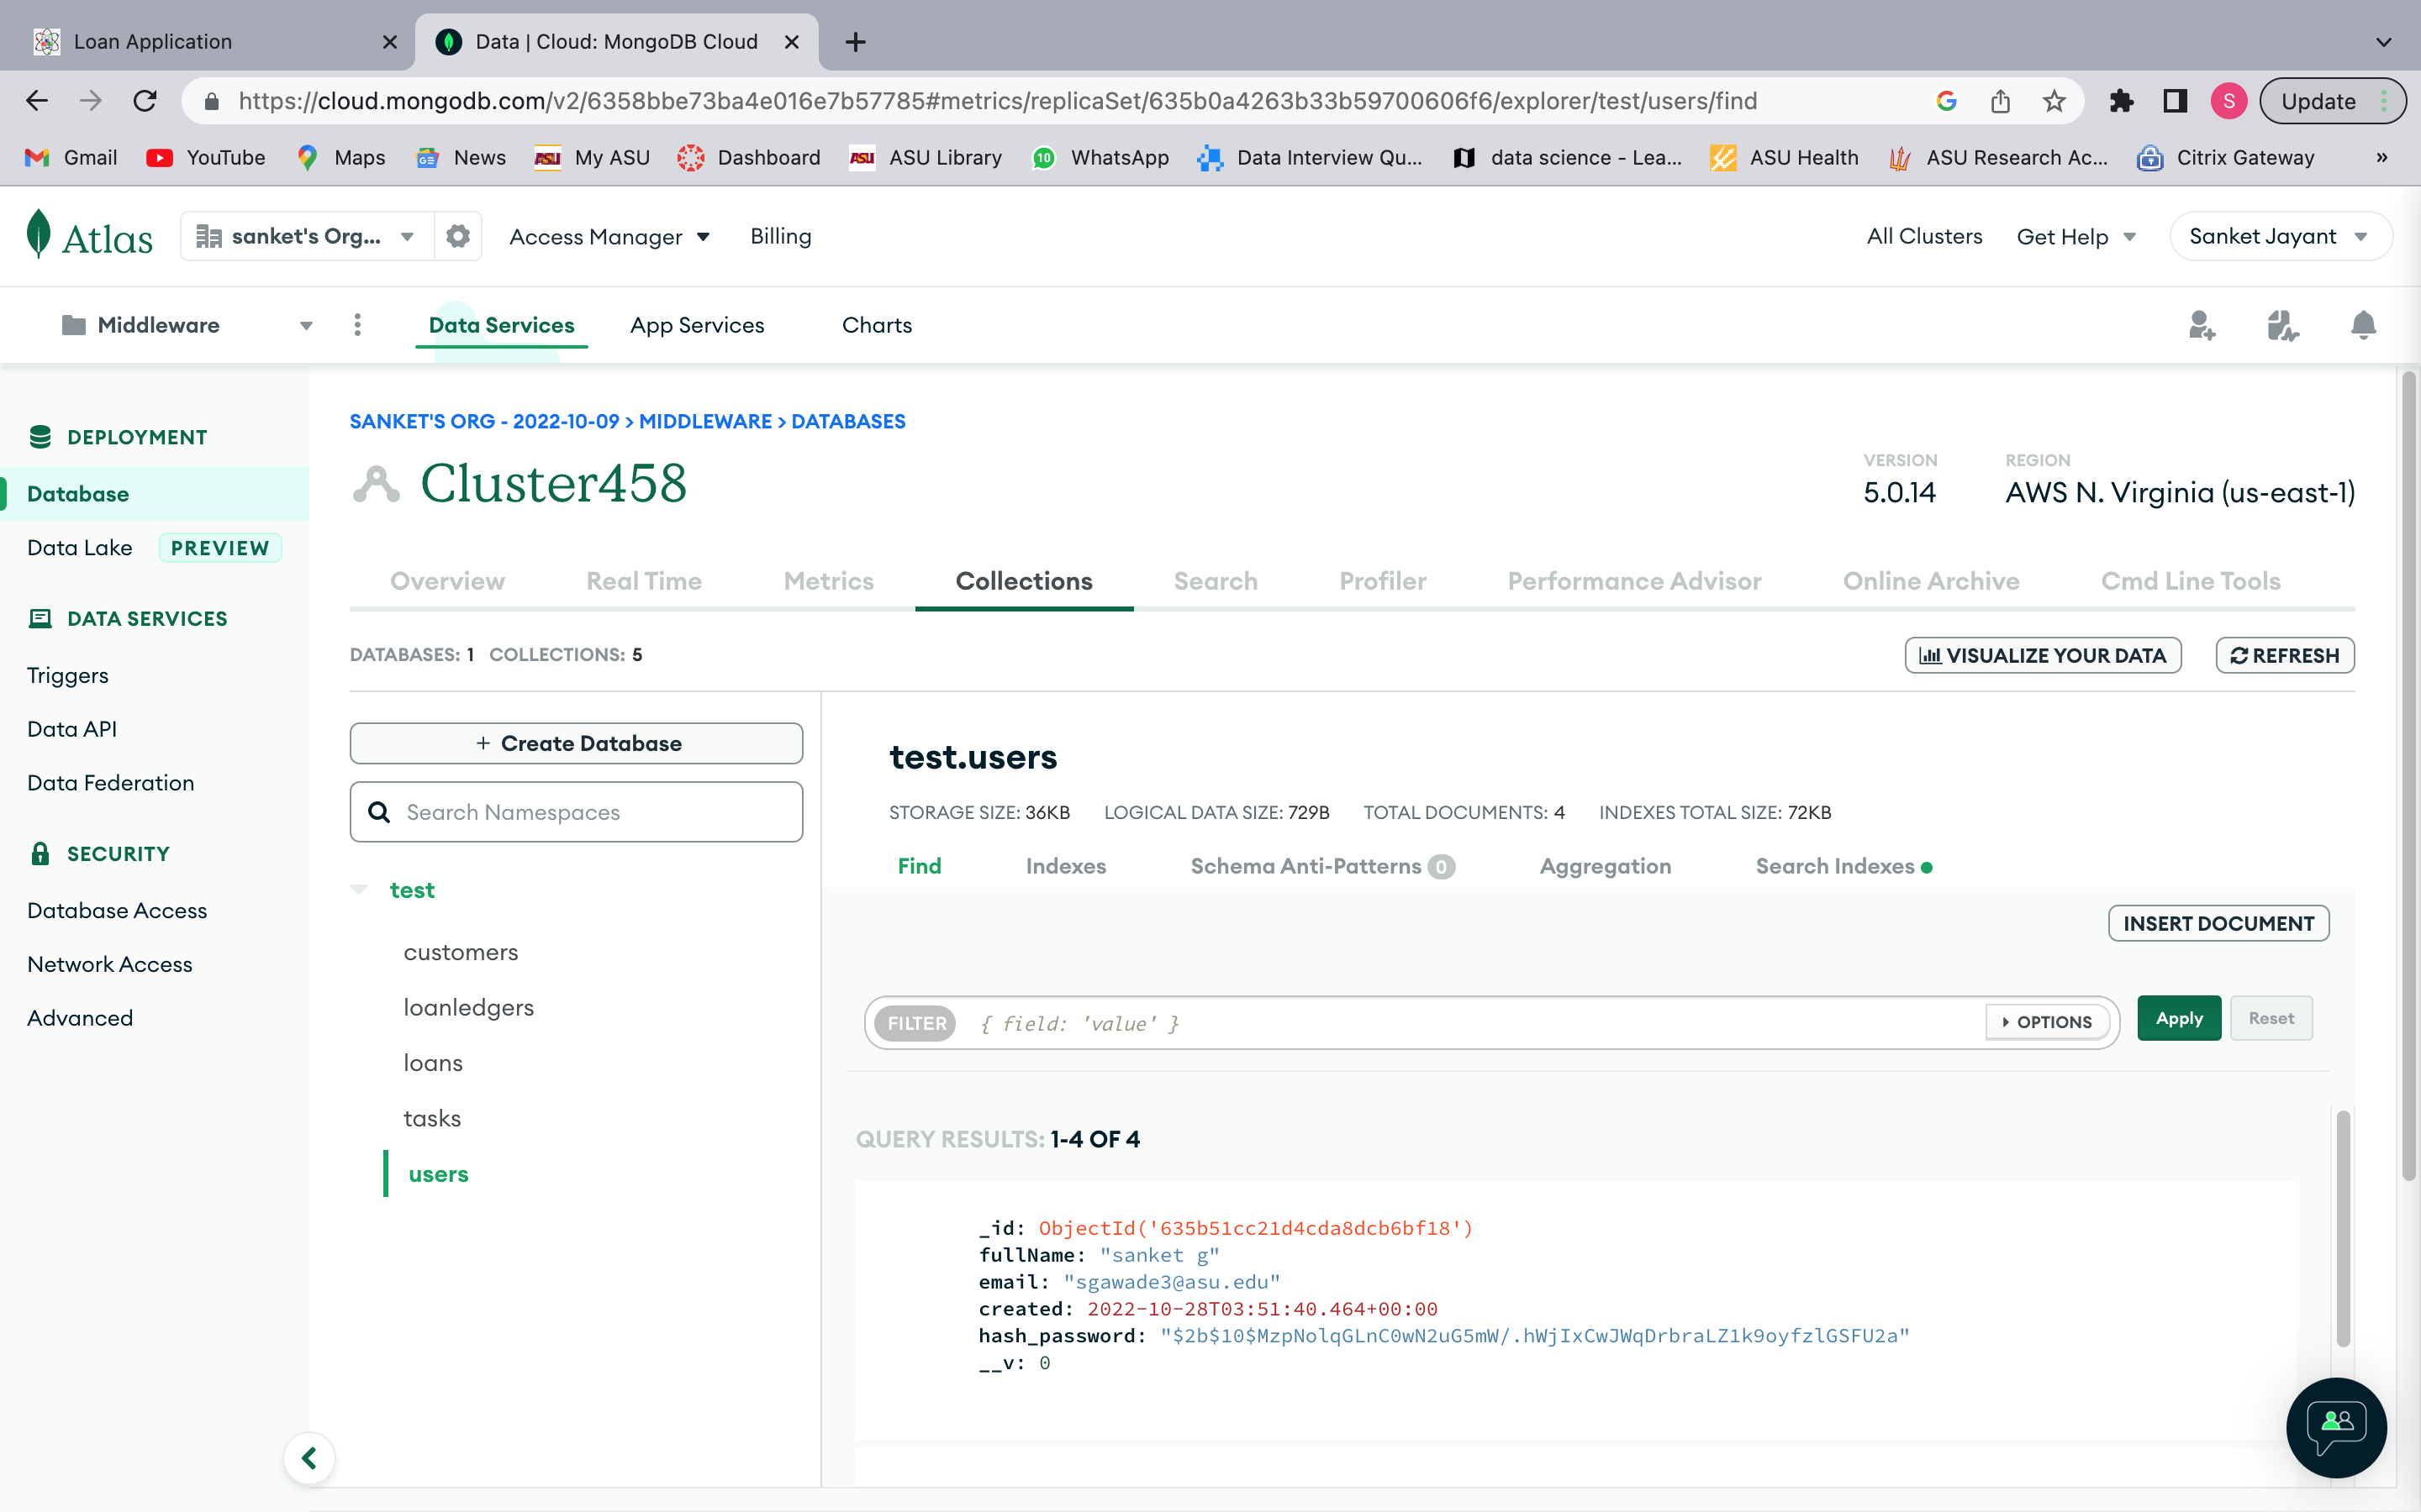

userModel.js

**Code:**

const mongoose = require('mongoose');

// import bcryptjs

const bcrypt = require('bcryptjs');

const userSchema = new mongoose.Schema({

  name: {

    type: String

  },

  email: {

    type: String,

    unique: true,

    lowercase: true

  },

  photo: String,

  role: {

    type: String,

    enum: ['user', 'staff', 'student', 'admin'],

    default: 'user'

  },

  password: {

    type: String,

    minlength: 8,

    select: false

  },

  passwordConfirm: {

    type: String,

    // validate will only work on save or creating the user

    validate:{

      validator: function(pwd){

        return pwd === this.password;

      },

      message: " the password confirmation did not match"

  }

  },

  passwordChangedAt: {

    type: Date,

    default: Date.now

  },

  passwordResetExpires: {

    type: Date,

    default: Date.now

  },

  active: {

    type: Boolean,

    default: true,

    select: false

  }

});

// add encrypting the password middleware

userSchema.pre('save', async function(next){

  if(!this.isModified('password')){

    return next;

  }

  // if new and modified

  this.password = await this.password; // how intensive the CPU will be

  this.passwordConfirm = undefined; // we dop not want to store in database

  next();

});

userSchema.methods.correctPassword = async function(

  candidatePassword,

  userPassword

) {

  console.log(candidatePassword)

  console.log(bcrypt.compare(candidatePassword, userPassword))

  return await bcrypt.compare(candidatePassword, userPassword);

};

userSchema.methods.changedPasswordAfter = function(JWTTimestamp) {

  if (this.passwordChangedAt) {

    const changedTimestamp = parseInt(

      this.passwordChangedAt.getTime() / 1000,

      10

    );

    return JWTTimestamp < changedTimestamp;

  }

  // False means NOT changed

  return false;

};

userSchema.methods.createPasswordResetToken = function() {

  const resetToken = crypto.randomBytes(32).toString('hex');

  this.passwordResetToken = crypto

    .createHash('sha256')

    .update(resetToken)

    .digest('hex');

  // console.log({ resetToken }, this.passwordResetToken);

  this.passwordResetExpires = Date.now() + 10 * 60 * 1000;

  return resetToken;

};

const User = mongoose.model('User', userSchema);

module.exports = User;

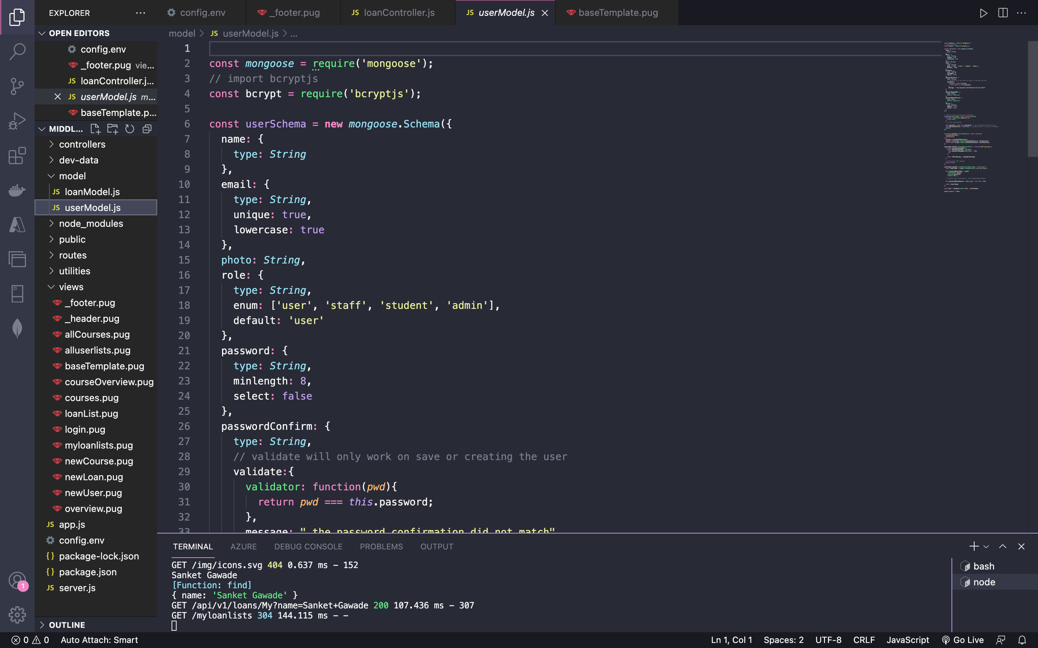

1. **Loan collection**

Loan collection having 4 loans

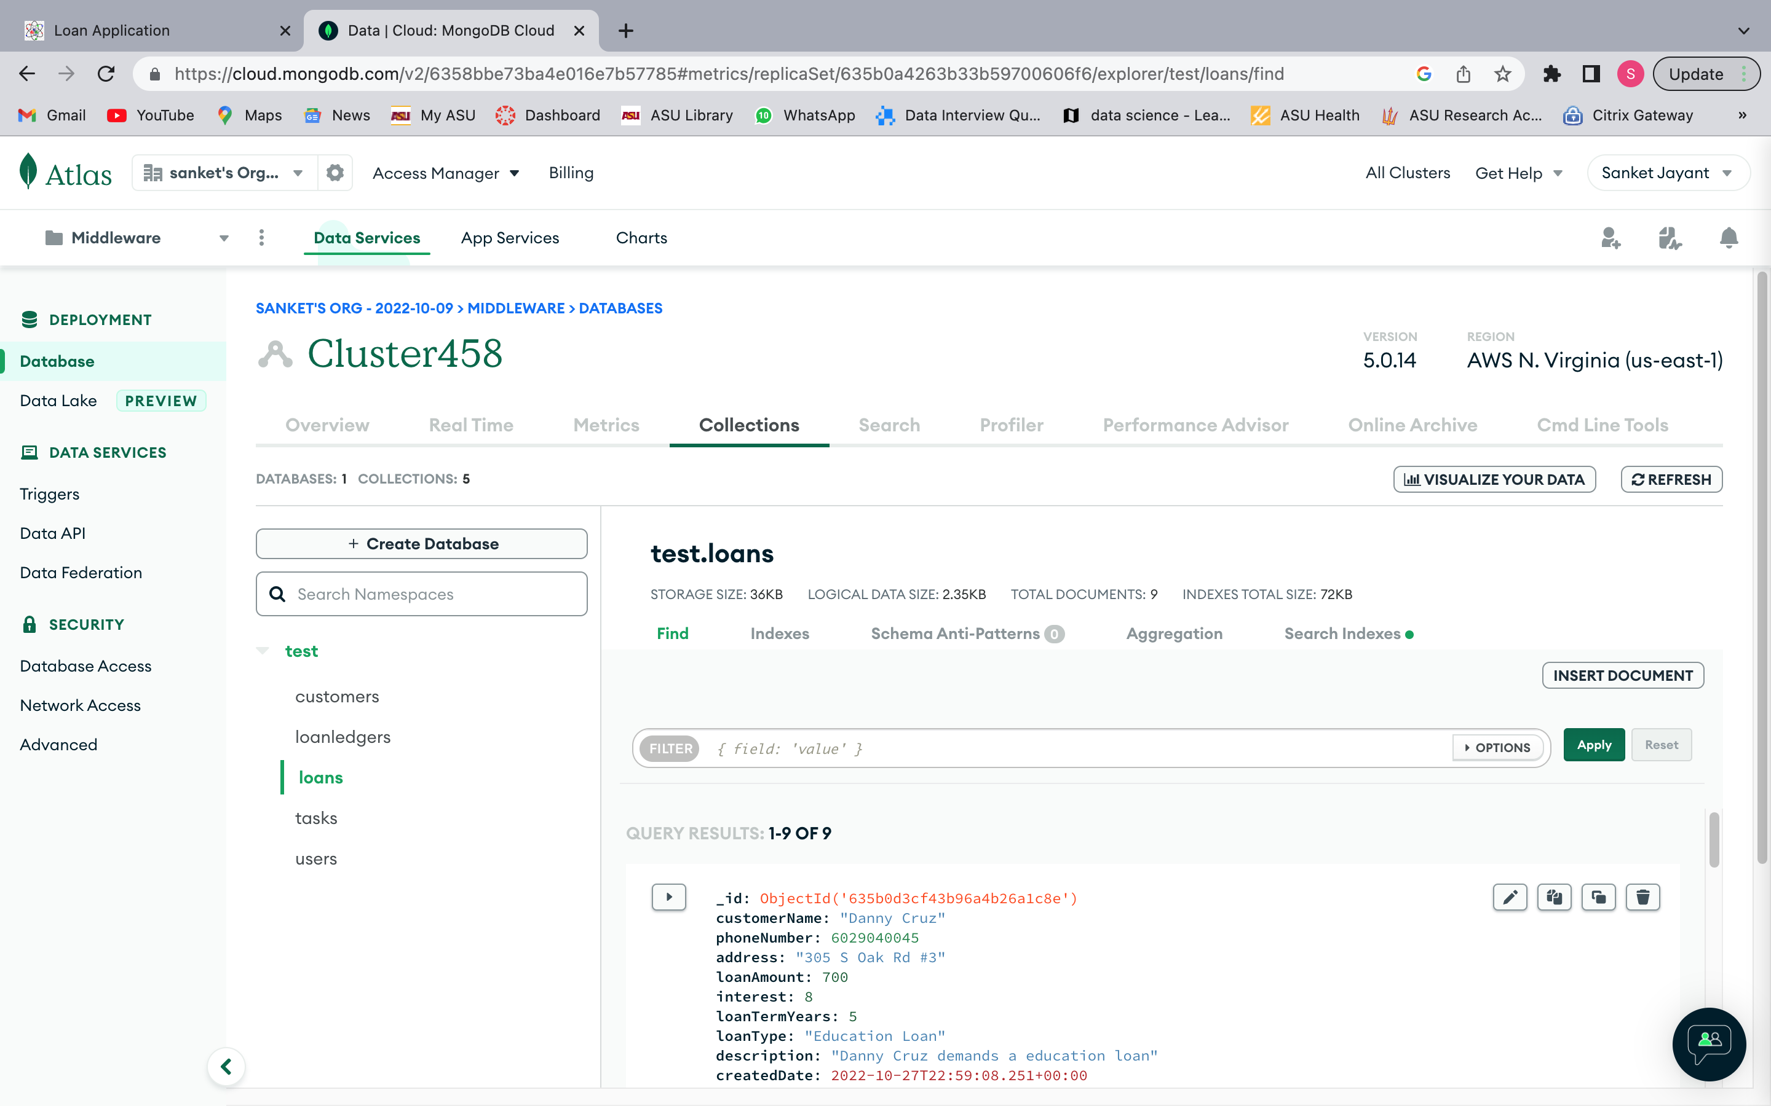

loanModel.js

**Code:**

const mongoose = require('mongoose');

const loanSchema = new mongoose.Schema(

  {

    name: {

        type: String,

        required: [true, 'A customer must have a name'],

        trim: true,

        maxlength: [40, 'A customer name must have less or equal then 40 characters'],

        minlength: [10, 'A customer name must have more or equal then 10 characters']

    },

    phoneNumber:{

        type: Number,

        validate: {

            validator: function(value){

                return value.toString().length === 10;

            }

        }

    },

    address: {

        type: String,

        trim: true,

        maxlength: [70, 'An address  must have less or equal then 70 characters'],

        minlength: [10, 'A from  must have more or equal then 10 characters']

    },

    loanAmount: {

        type: Number,

        required: [true, 'A loan should have loan amount']

    },

    interest: {

        type: Number,

        required: [true, 'A loan should have loan interest'],

        validate: {

            validator: function(value){

                return value.toString().length < 4;

            }

        }

    },

    loanTermYears: {

        type: Number,

        required: [true, 'A loan should have loan term years'],

    },

    loanType: {

        type: String,

        required: [true, 'A loan must have a type'],

        enum: ['Car', 'Home', 'Personal', 'Education']

    },

    description: {

        type: String,

        trim: true,

        maxlength: [100, 'A description  must have less or equal then 100 characters'],

        minlength: [5, 'A description  must have more or equal then 5 characters']

    },

    startDate: {

        type: String,

        required: [true, 'Loan should have a start date']

    },

    createdDate: {

        type: Date,

        default: Date.now

    },

    insertedDate: {

        type: Date,

        default: Date.now

    }

});

const Loan = mongoose.model('Loan', loanSchema);

module.exports = Loan;

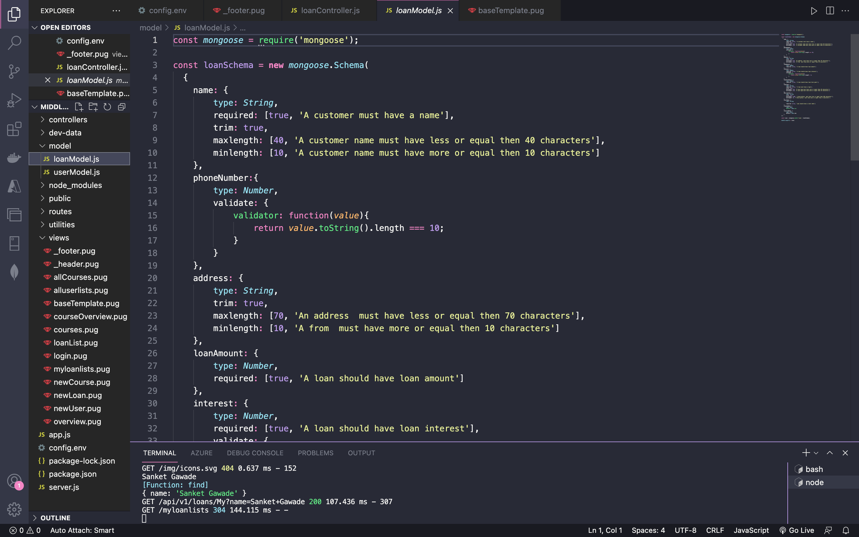

**Project output showing end to end application flow**

Landing page

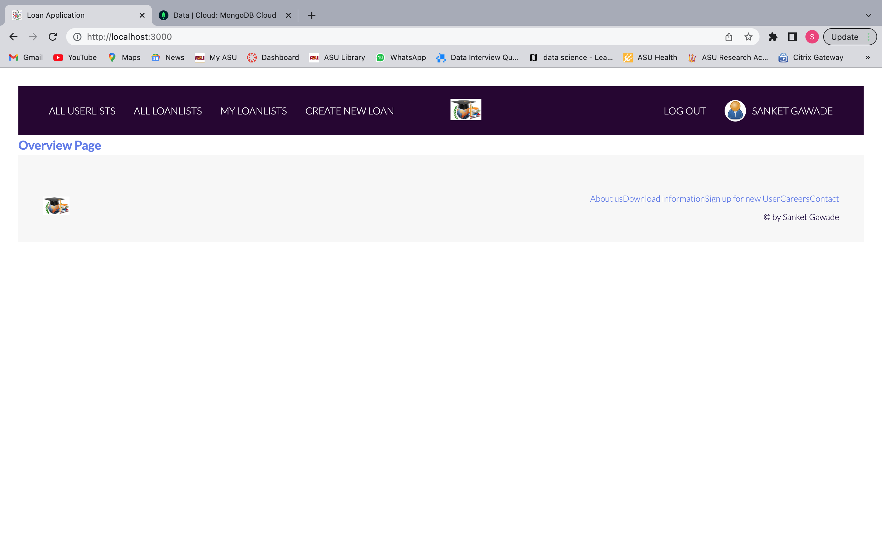

Sign up

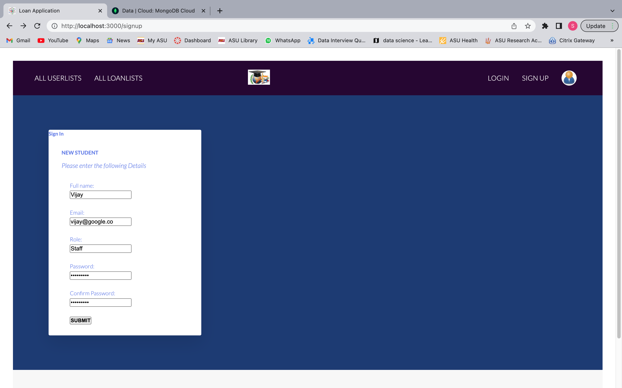

Successfully log IN

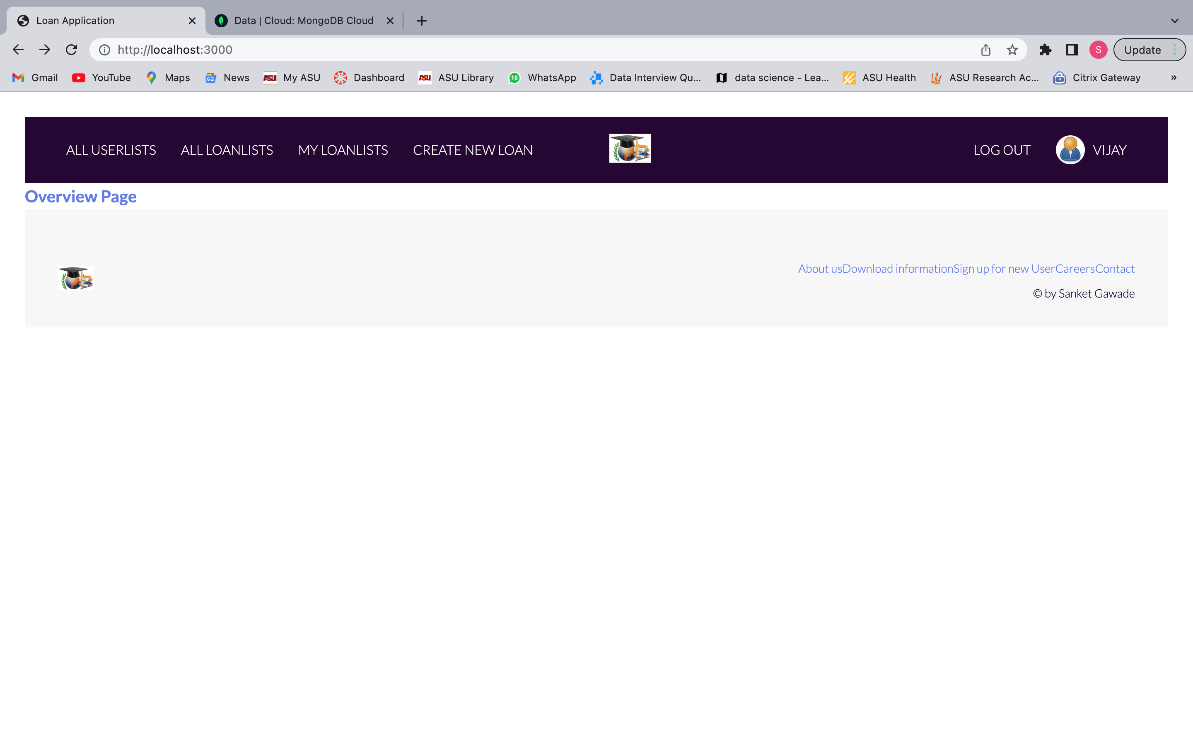

MongoDB collection showing new user

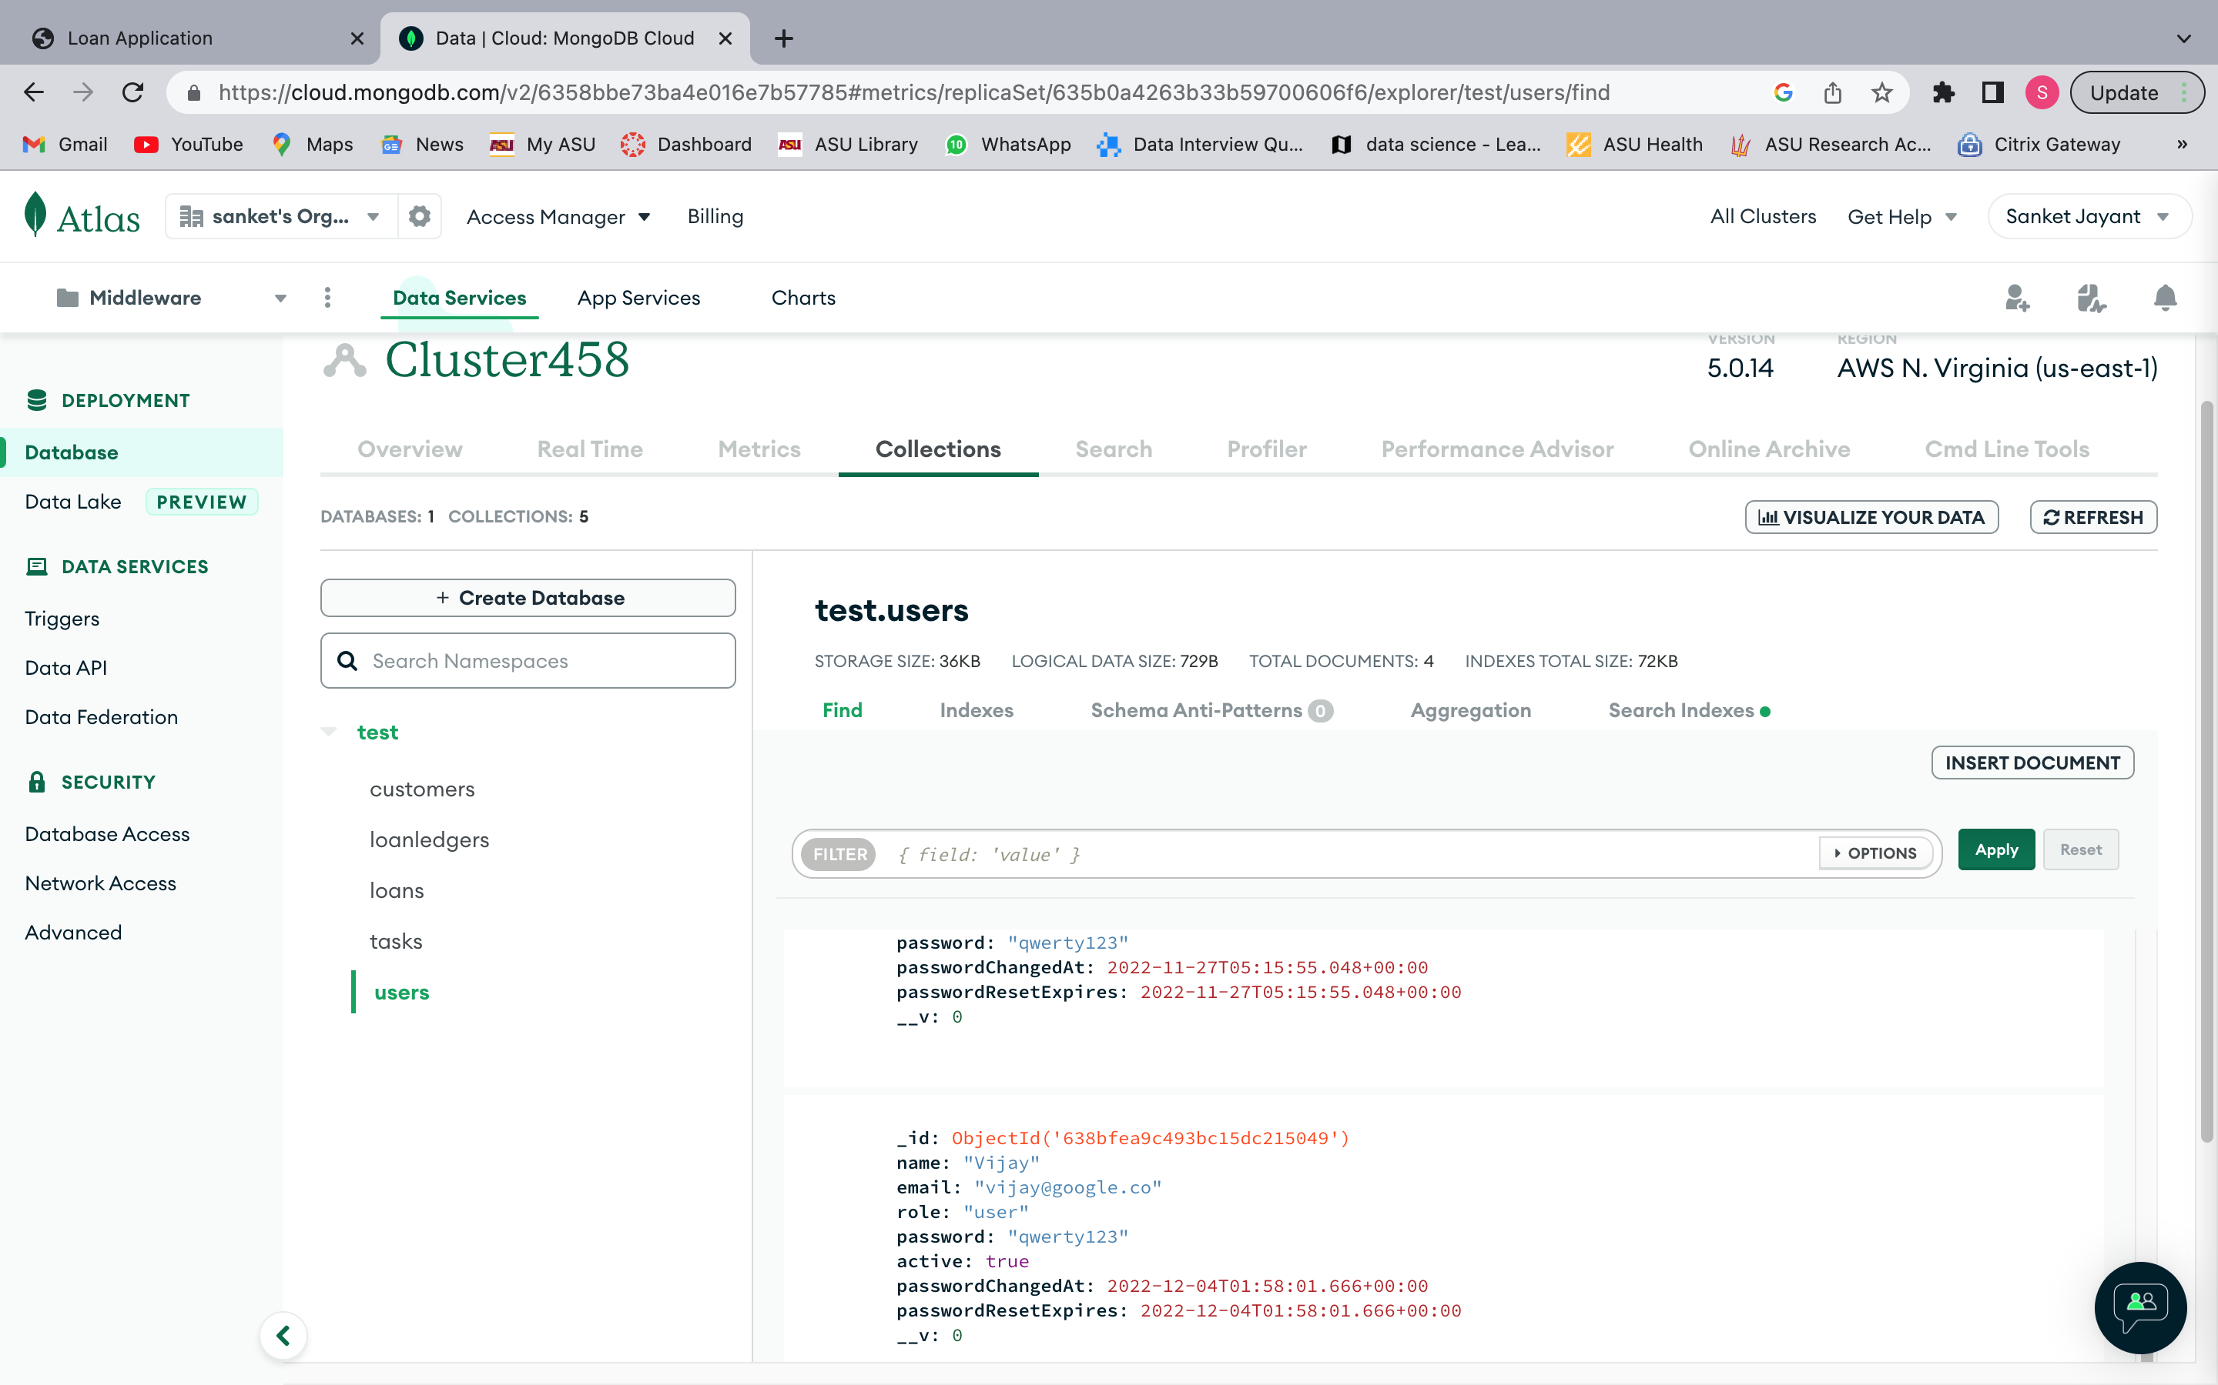

Create a new loan

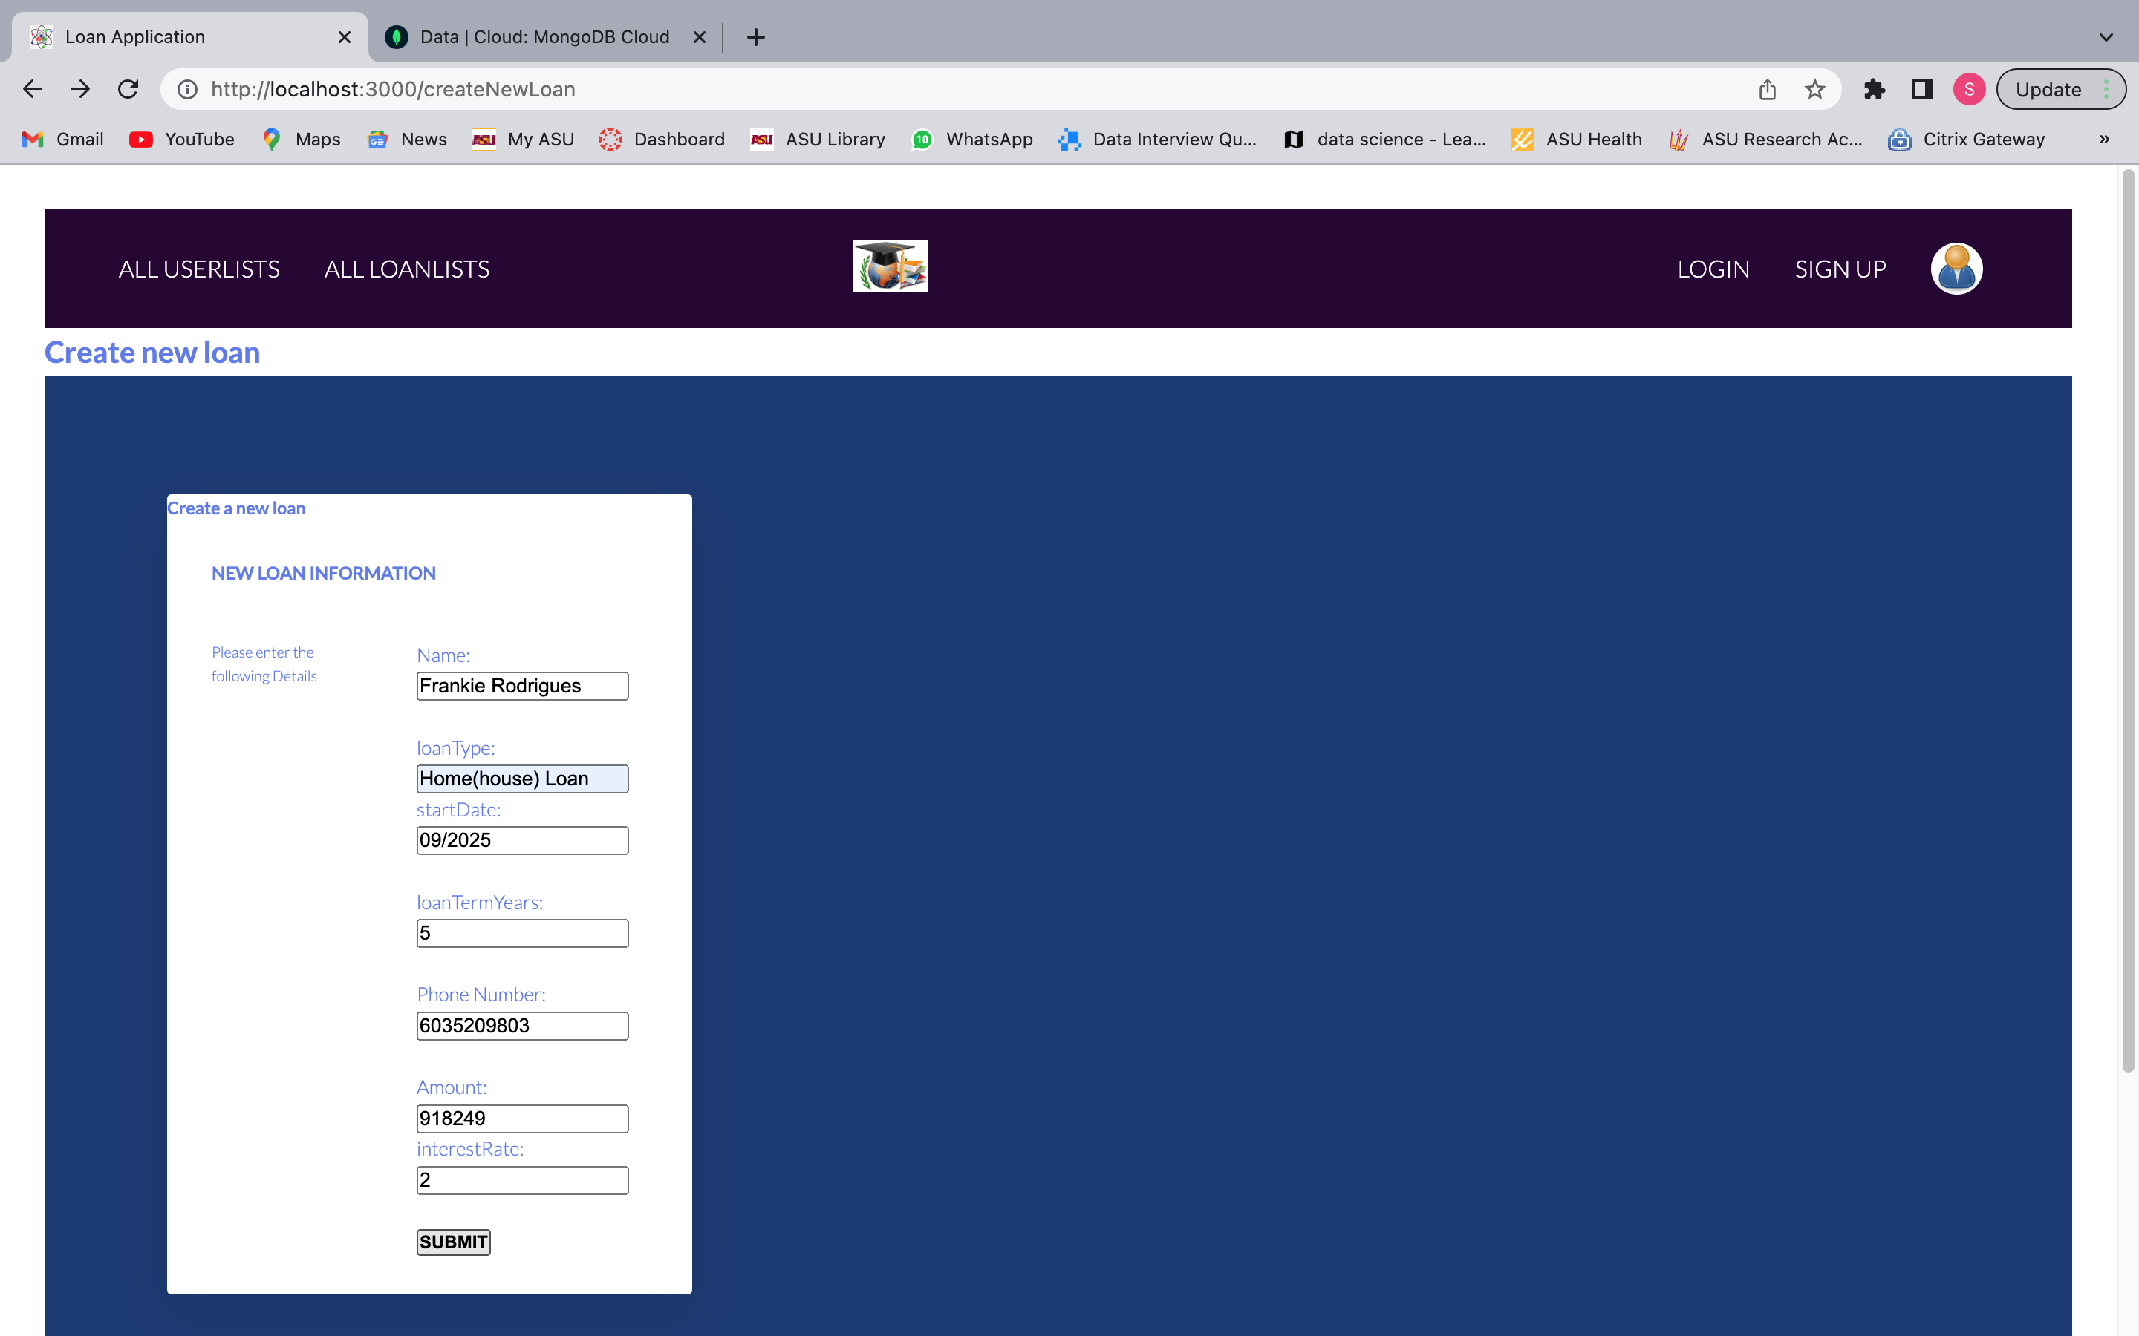

MongoDB collection showing new loan

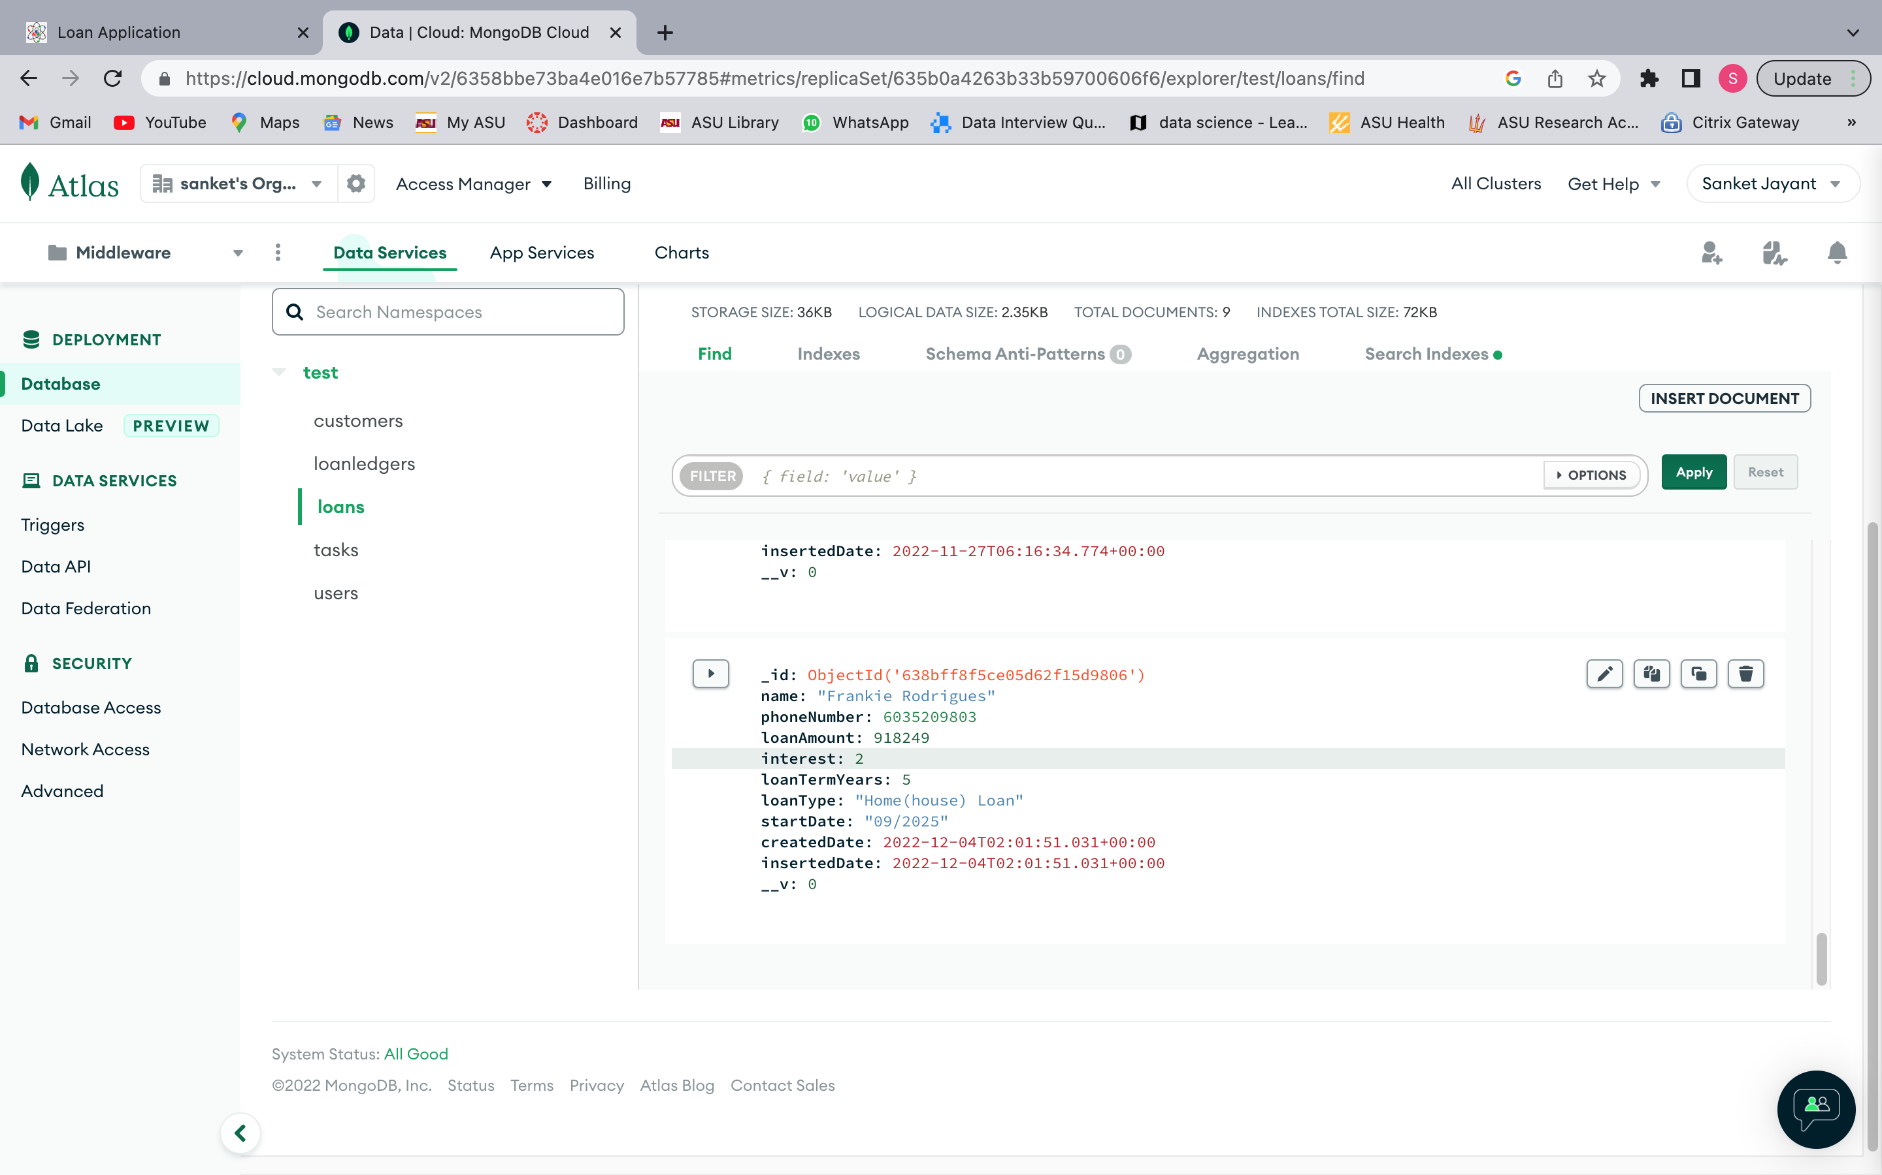

Loans of the Log In user

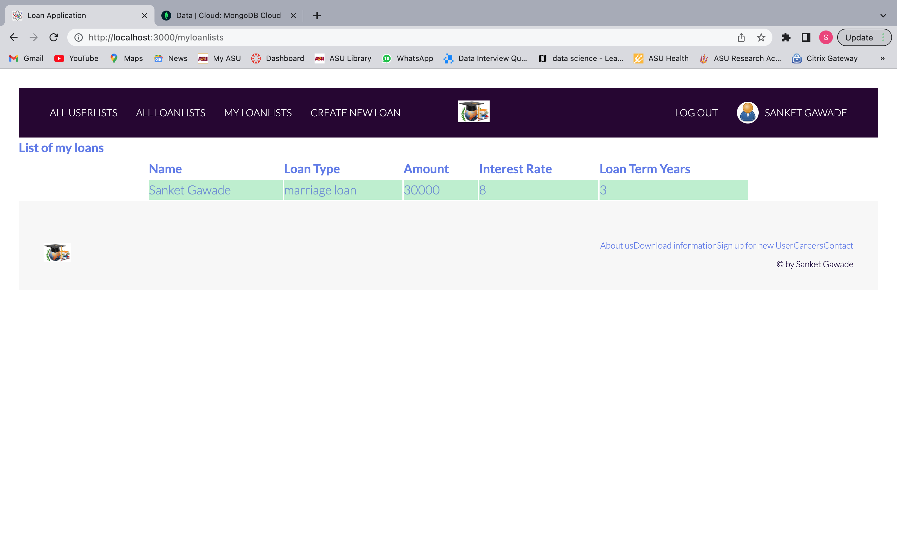

Listing all the loans

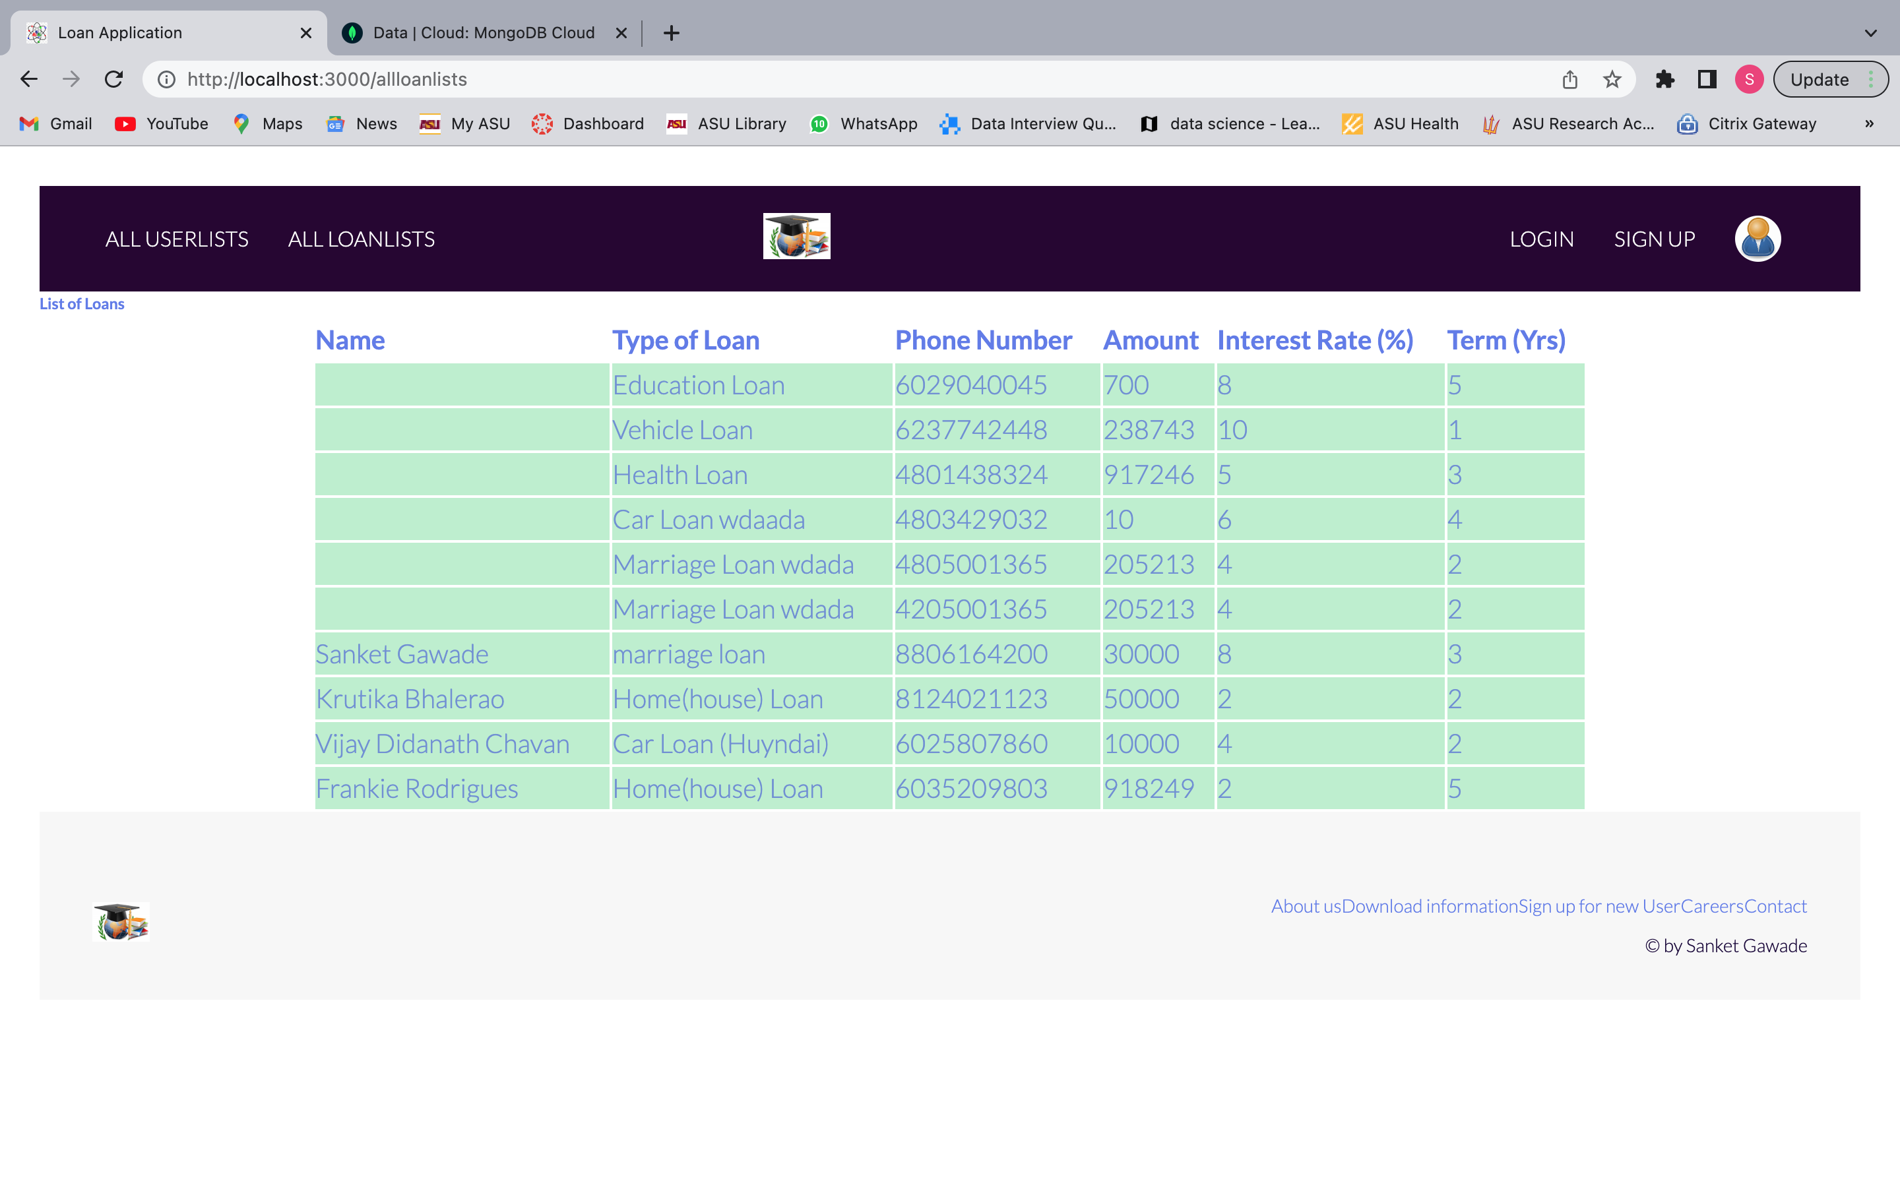

**Testing with POSTMAN**

POSTMAN collection for signing up new user

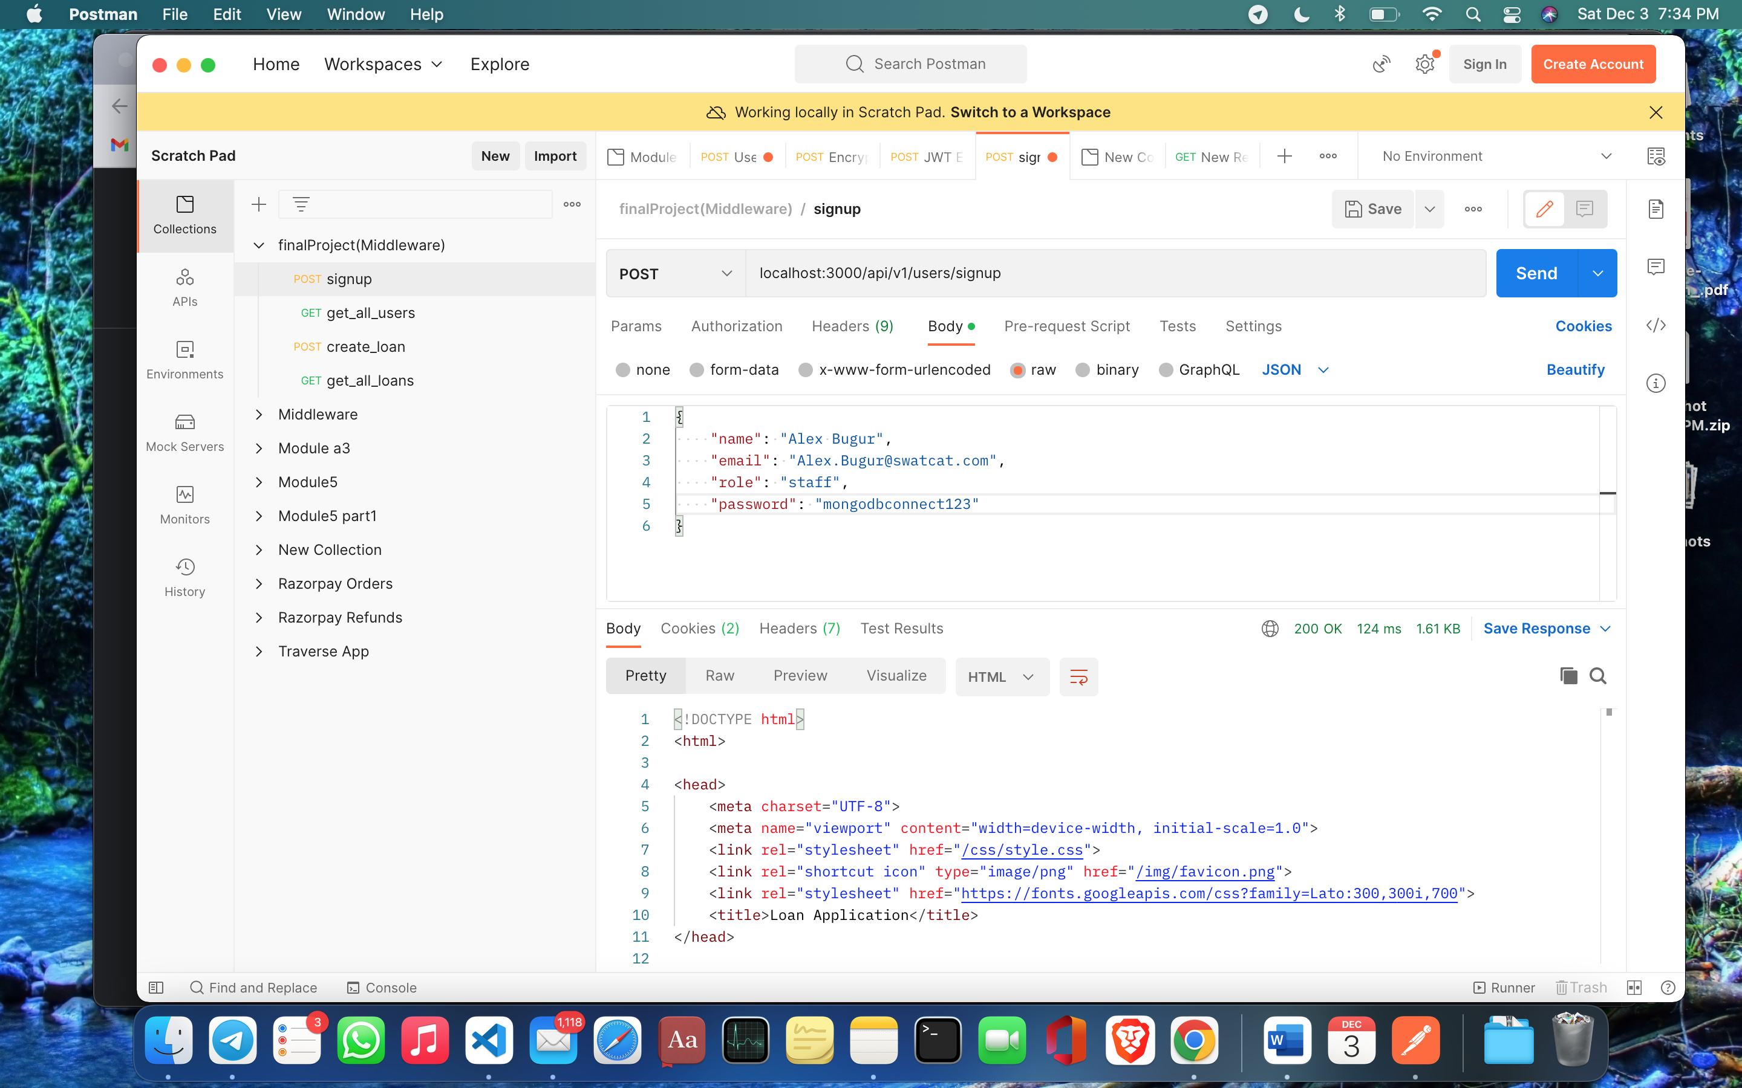

Database

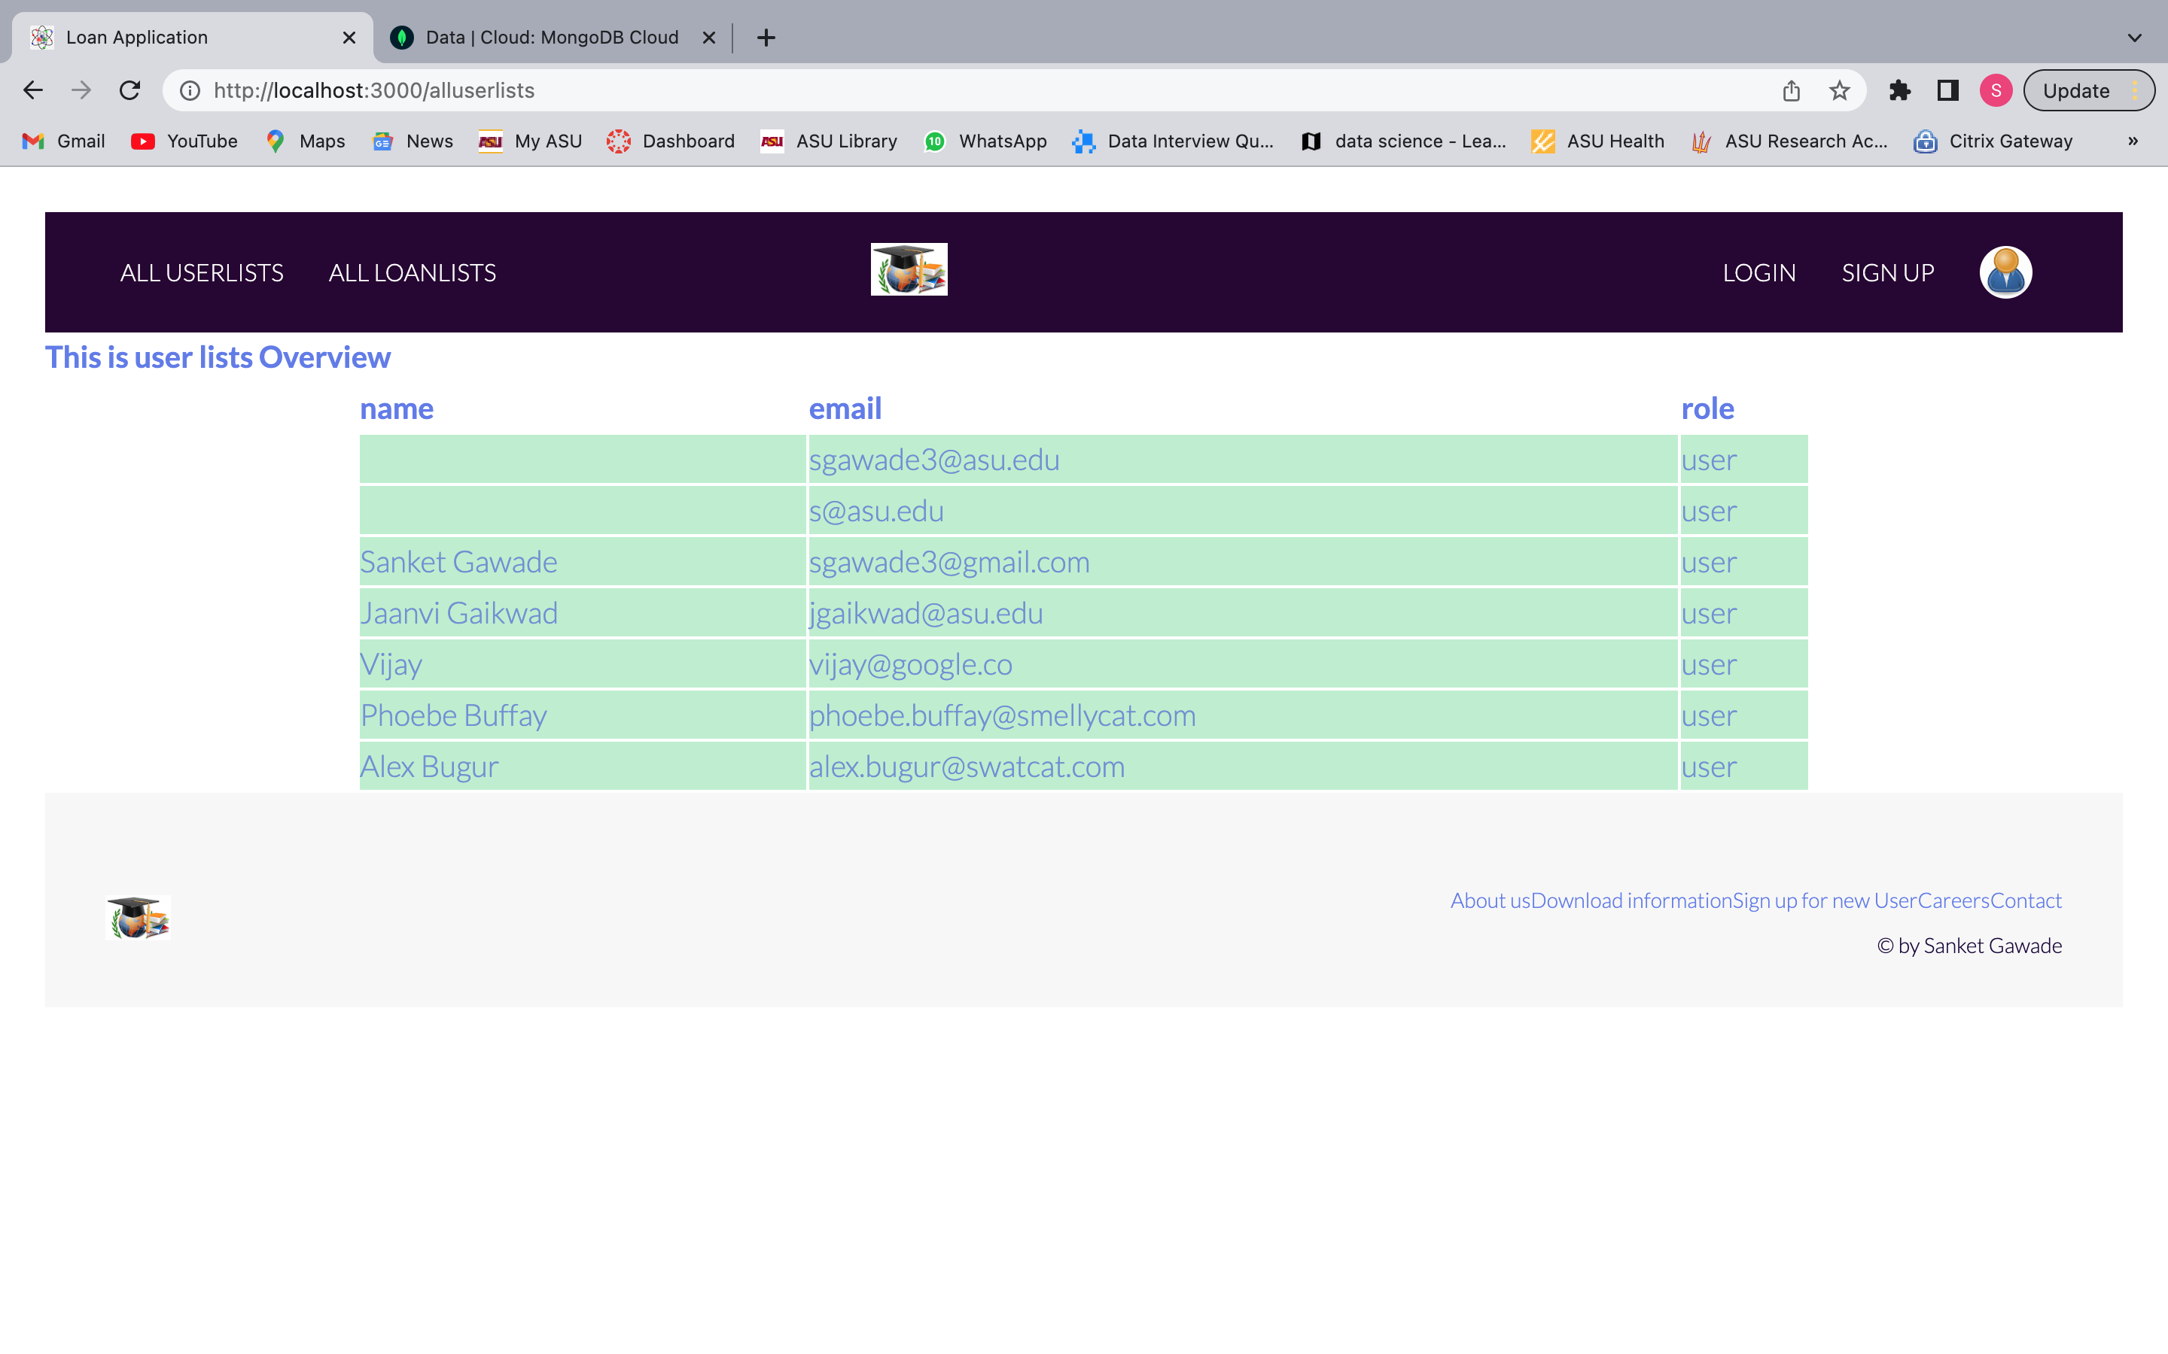

Listing all the users

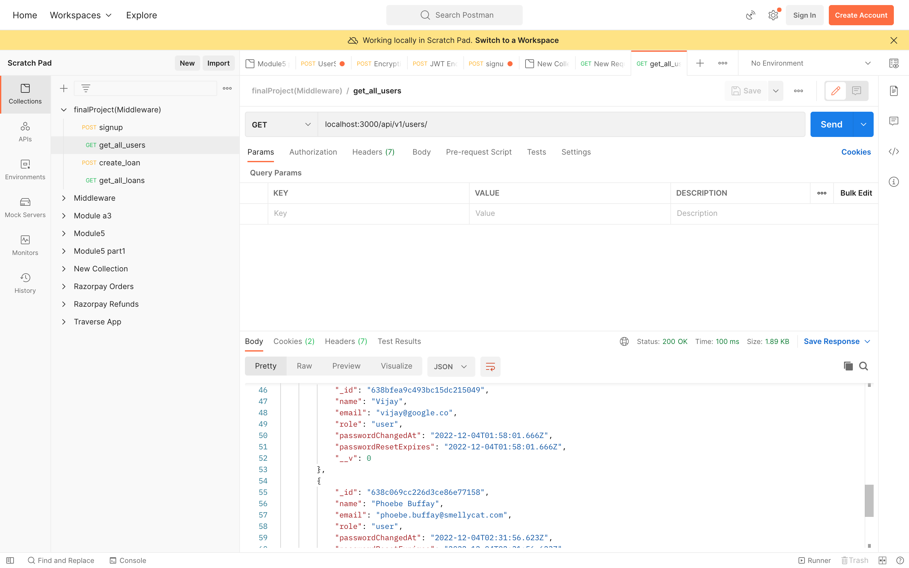

Creating a new loan for an existing user

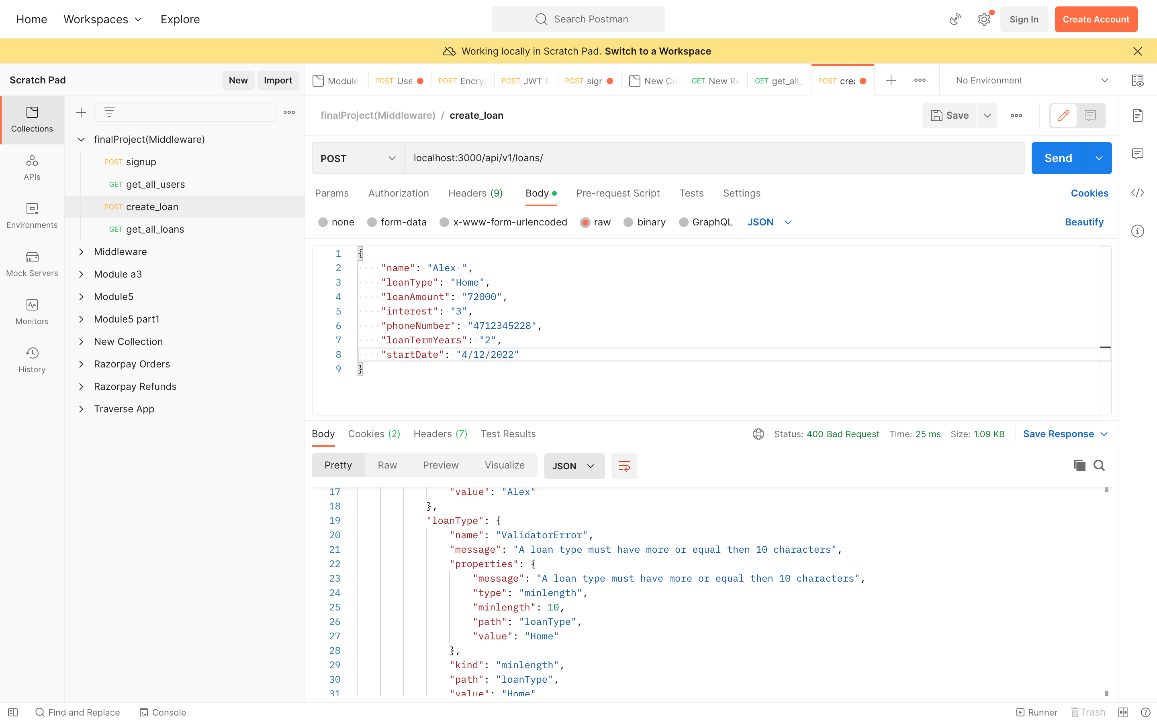

Get all the loan

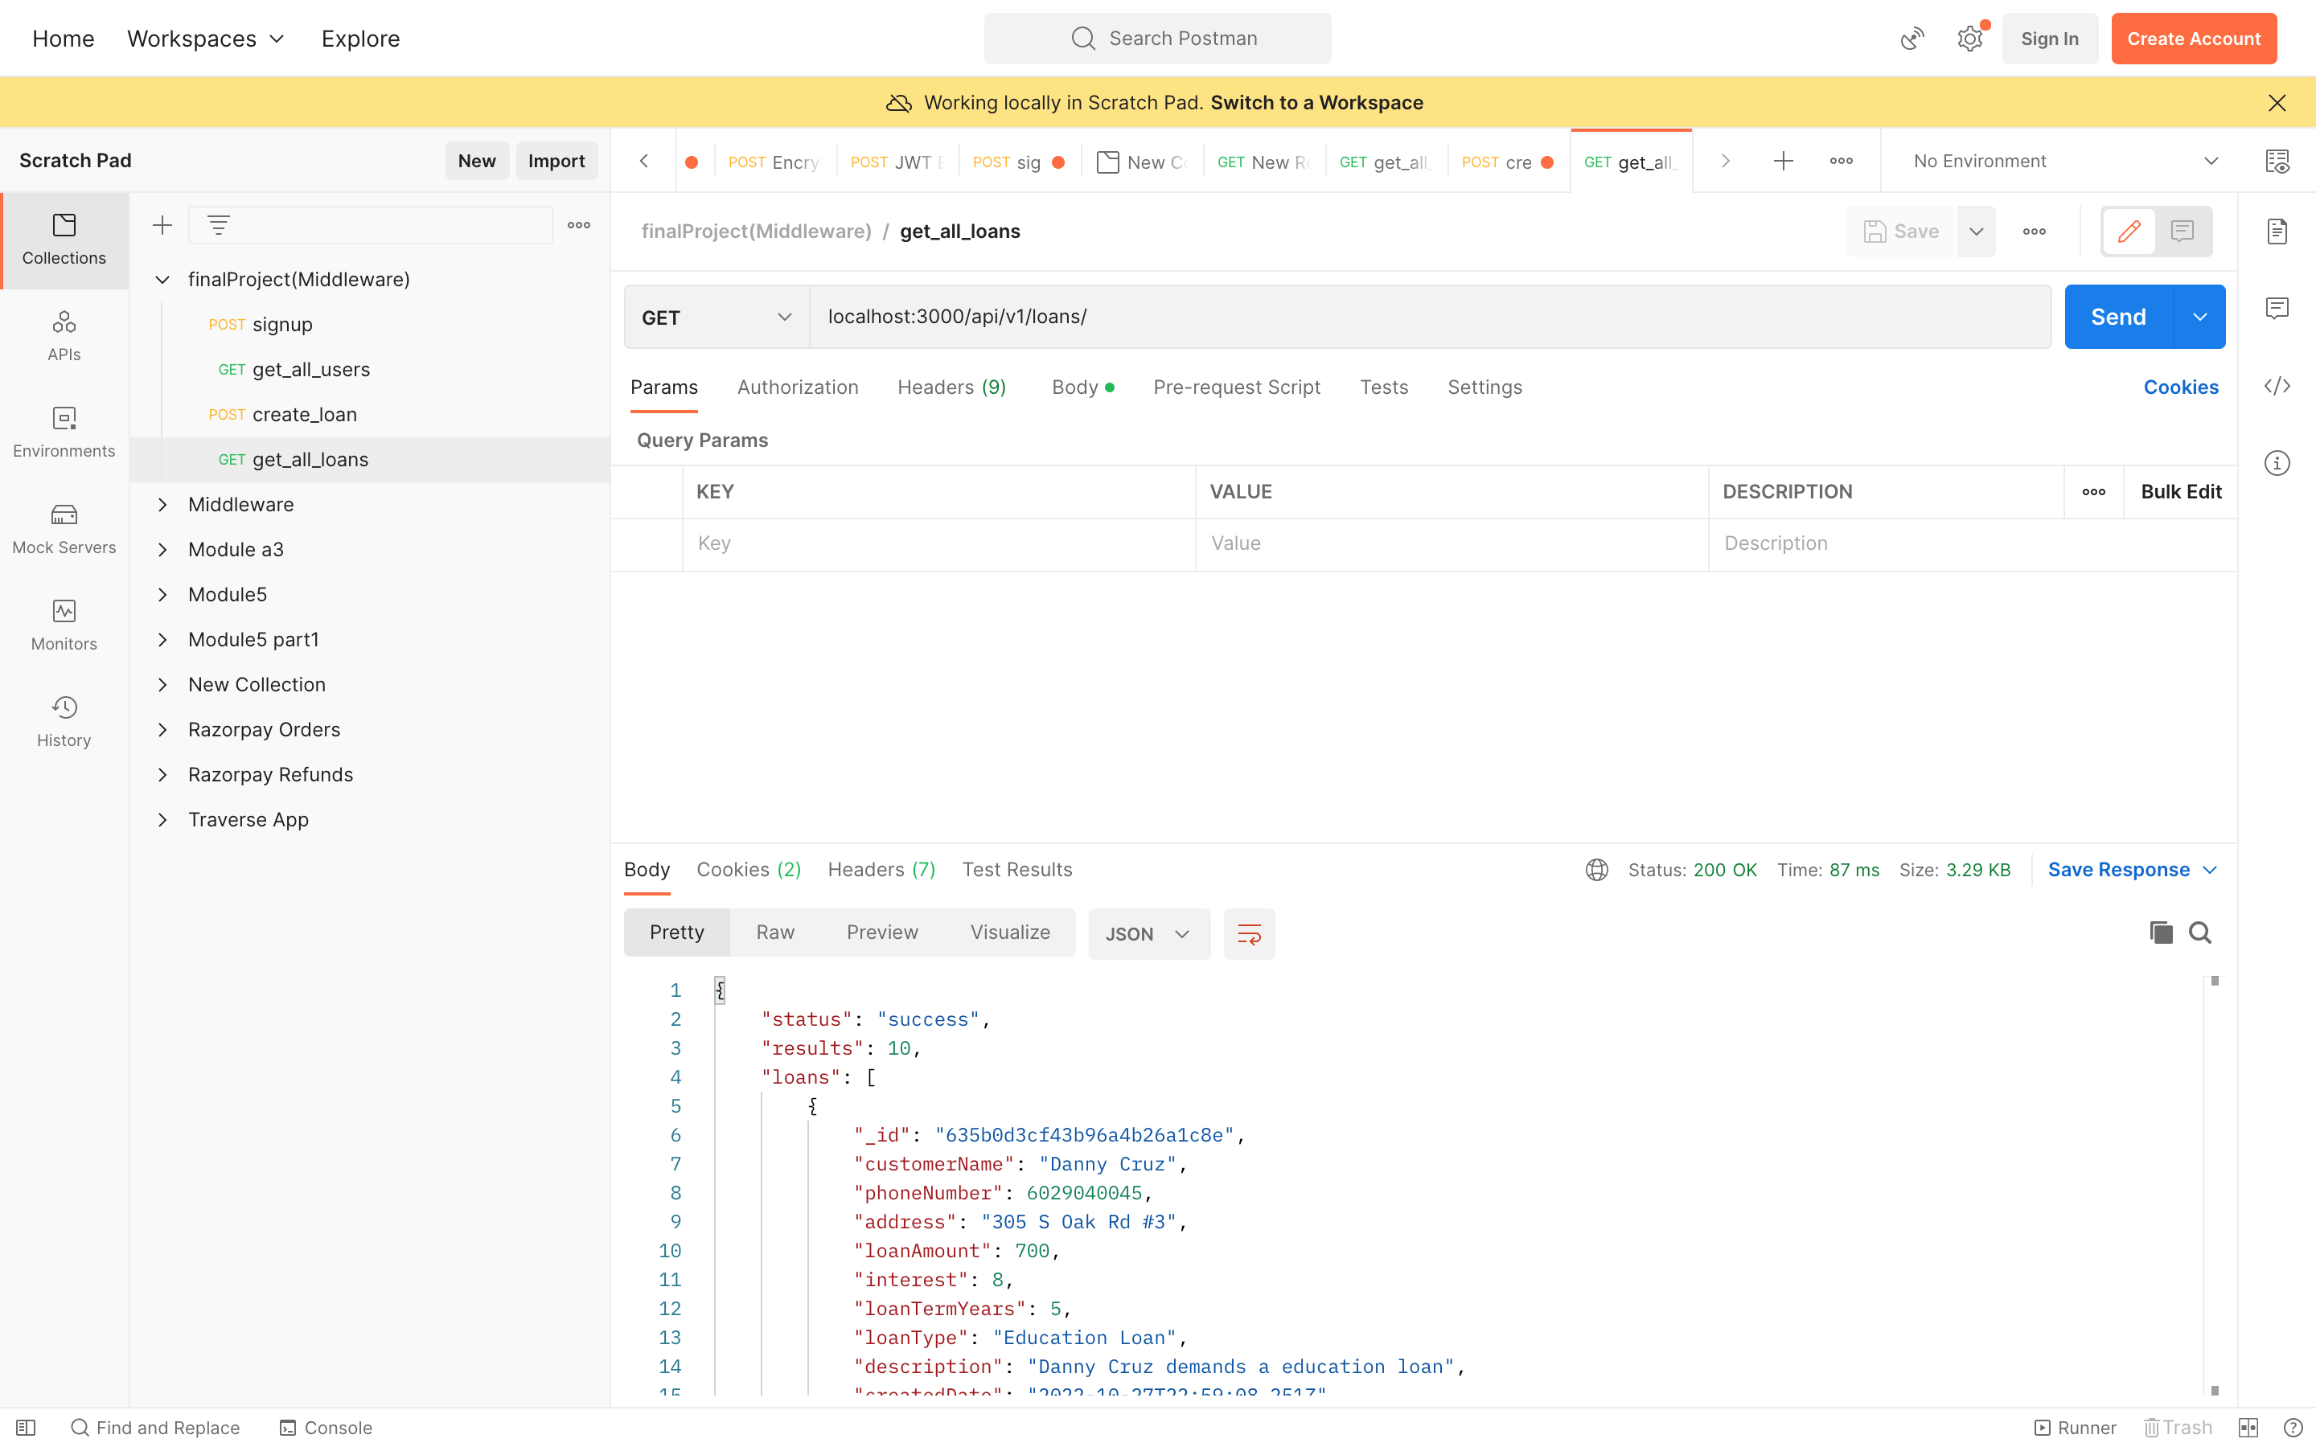

**Project Design**

This project includes a complete web application connected to a MongoDB database. The front-end user interface includes a dashboard, with registration and login features. The app also allows users to create new loans themselves, meaning they have applied for a new loan from a bank. To track the loans they have made and verify their loan information, they can access their loans. Users who are not logged in can also view all loans.

The project includes a main file that starts the application and connects to the database (server.js). app.js includes initiating routes that redirect the backend to the front end. The middleware includes routes and controllers that control the implementation of each page that the application redirects the route to. In the routes there is a viewRoutes.js file that redirects the client to the middleware application and renders the HTML to the client. After the customer selects the options on the screen, if the options include user related options like user registration etc. it redirects it to userRoute.js routes. If loan related, it will be redirected to loanRoutes.js. userRoutes.js redirects the route implementation to authController.js, which implements user authentication on login, new creation, and user logout.

The UI is coded with PUG files for each HTML route and the CSS for each page is modularized in a CSS folder. All skins images are contained in images folder and whenever needed PUG files access it.

The MongoDB database includes the Loans DB database that includes the user and loan collections. The user collection includes user information such as the user's name, email, password, and role. The loan collection includes information about a user's loan based on their name. Loan collection includes loan type, loan amount, loan interest, etc.

Risks

• The project could take a more sophisticated approach to make the authentication process more secure when the user logs in or any application related changes that could affect the database.

• After the user has logged in, better session management should be applied to restore the login time.

Project estimate

The project estimate for this project can be based on the requirements gathered from the company. This project can take up to 8 weeks, assuming the developers are experienced with their chosen technology. It can be broken down into 8 weeks to finalize the design, deploy the full stack, add validation and security, and complete all of the testing.

Learning Experiences

Module 1 was an introductory module that introduced me to JavaScript and how to connect the backend to the frontend. I learned how to read JSON data and output it to the front end. It helps me understand how the server works and how the UI is connected to the UI.

Module 2 helped me better understand JavaScript syntax and data types. I have created a function in JavaScript. In module 3, I learned about different data formats in JavaScript, external modules, and content mediation. I also learned how to connect SQL Server to JavaScript. I learned how to create complex ER diagrams.

Module 4 helped me understand how MongoDB works in the cloud. I followed the teacher's instructions, it helped me understand the MongoDB database framework better. I learned how to create an efficient database design, set up MongoDB in the cloud, and create a NoSQL database in MongoDB Atlas.

Module 5 helped me understand how to test code efficiently using POSTMAN and I tested Java Web Token validation flow. I learned the importance of security when encrypting a password when saving it in a database with a JWT token.

Module 7 showed me how to create PUG files and how to make HTML code more modular. PUG files should have a more modular design than online documentation. I created a signup and login page in PUG and tested the whole page.

Module 8 helped me to collect all that I have learned and accumulate all the code from all the modules and develop a complete web application for users in the banking sector.

**GitHub repository:**

**References**

<https://mongoosejs.com/docs/api.html>

<https://developer.mozilla.org/en-US/docs/Web/JavaScript>

<https://pugjs.org/api/getting-started.html>